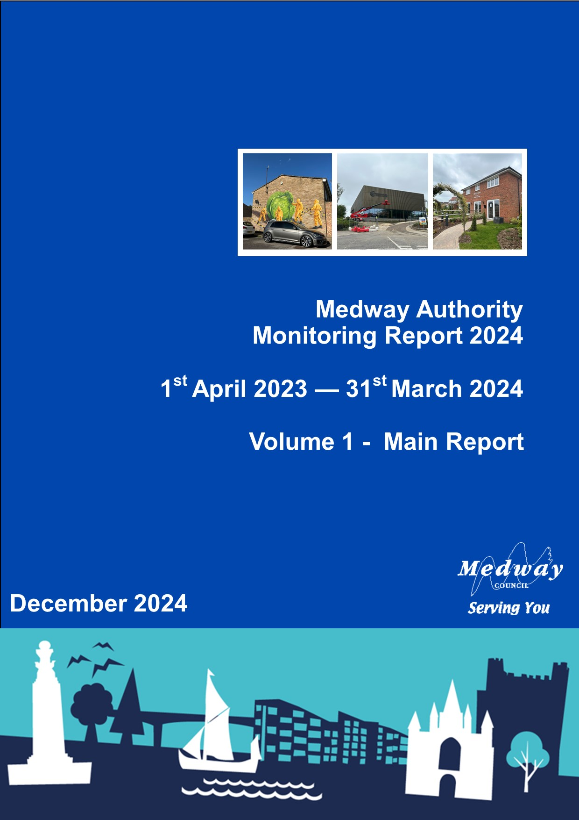

Excecutive Summary..………………………………………..…………………………………….5

Introduction 7

Planning Context 9

Local Development Scheme 9
Regulation 18 Consultation Summer 2024 9
Local Plan Evidence Base 9
Land Availability Assessment 10
Strategic Transport Assessment 10
Developer contributions and obligations 11
Design Codes, Development Briefs and Masterplans 11
Local Development Order (LDO) for Innovation Park Medway 12
Development Needs 12
Neighbourhood Plans Update and Neighbourhood Development Orders 12
Cliffe and Cliffe Woods adopted Neighbourhood Plan 12
Arches (Chatham) adopted Neighbourhood Plan 13
Hoo St Werburgh and Chattenden Neighbourhood Plan 13
Frindsbury Extra Neighbourhood Plan 13
Local Aggregate Assessment 13
Waste Needs Assessment 14

Duty to Cooperate 15

Delivering Development 18

Development and Regeneration 21

Local Enterprise Partnership Funding 21
Brownfield Land Register 23
Regeneration Sites - update 24
Development Management Planning Statistics 29
Population 31

Mid-year estimate 2023 31
Population by broad age group – 2023 32
Components of population change 33
Indices of Deprivation 38
Housing 39

Net additional dwellings a) in previous years b) for reporting year c) in future years 39
Number of new and converted dwellings on previously developed land 39
Housing Trajectory 2023/24 – 2038/39 40
Map showing large sites (5+ dwellings) with planning permission as at 31/3/2024 42
Property prices 43
Housing affordability 44
House price to earnings 44
Affordable Housing 45
Gross affordable completions (count) 45
Affordable completions as proportion of all completions 45
Residential completions by property type and size 47
Lodgement Completions - Energy Performance Certificates (EPCs) 47
‘Other’ 49
New Homes Bonus 50
Gypsies, Travellers and Travelling Showpeople 51
Net additional pitches (Gypsy and Traveller) 51
Self-Build and Custom Housebuilding Register 52
Economy and Employment 55

Amount and type of completed employment floor space 55
Amount and type of employment floor space coming forward on Previously Developed Land (PDL) 56
Amount and type of employment land available 56
Amount of floor space for town centre uses 56
Job Seekers Allowance and Universal Credit claimant rate 57
Employment 58
Employment by industry 59
Income and employment deprivation 60
Fuel Poverty 61
The River Medway - Port cargo traffic 62
Retail and Town Centres 64

Town Centre (TC) and Non-Town Centre GROSS retail floor space completions 19/20 - 23/24 65
Net completions in town centres 66
Town centre development – 2023/24 66
Non Town Centre Activity 66
Natural and Built Environment 67

Greenspace regeneration projects 67
Green Flag Awards 69
Making Space for Nature 69
Areas of Outstanding Natural Beauty rebranding 69
Air Quality 70
Climate Change 71
Ultra Low Emission Vehicle Licensing 72
Built Environment - Heritage at Risk 72
Health and Communities 74

Life expectancy 74
Mortality 75
Hot food takeaway guidance 76
Health Deprivation 79
Infrastructure 80

Education 80
GCSE attainment scores 80
Education, Skills and Training Deprivation 82
Developer Contributions 83
Transport 84

Local Transport Plan 84
External Funding 84
Estimated traffic flows for cars and all vehicle types 86
Passenger journeys on local bus services 87
Railway Stations 88
Minerals, Waste and Energy 89

Minerals 89
Waste 92
Energy 93

Glossary 96

Please note that this Volume was updated in March 2025 due to a post Cabinet approval to correct a factual error relating to floorspace figures at Kingsnorth Power Station (planning permission MC210979). Relevant tables have also been corrected in Volume 2.

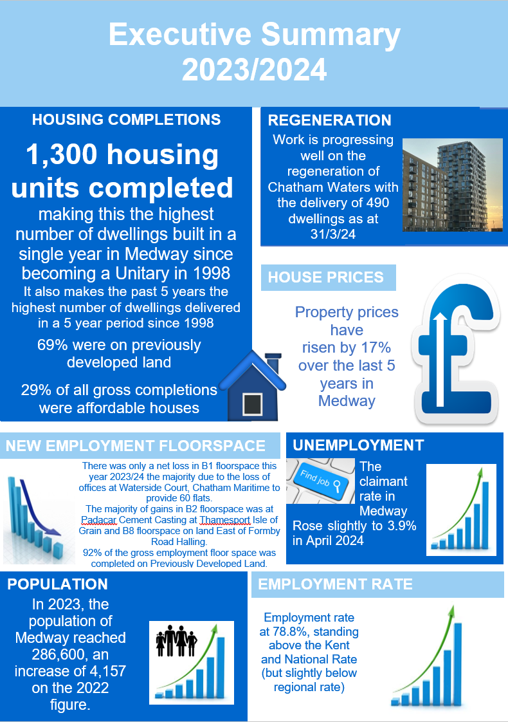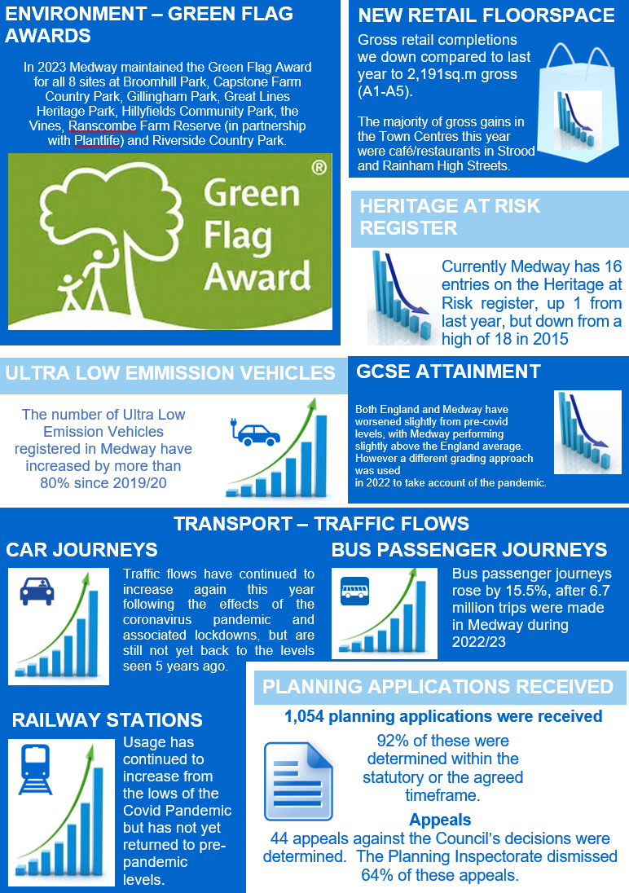

Introduction

This report has been prepared in late 2024, presenting monitoring information for the period April 2023 to March 2024.

Medway has changed significantly over the past few decades, with regeneration and new infrastructure contributing to the development of a modern city. The Council is preparing a new Local Plan to manage Medway’s growth up to 2041. The emerging plan is being developed in the context of pressures on the housing market, infrastructure and key services, cost of living crisis, the need to address the climate emergency, structural changes in retail and employment, and increasing awareness of links between health and the built environment.

This monitoring report demonstrates good progress in several aspects of sustainable development in Medway. High rates of housebuilding have been sustained in 2023-24, with the highest number of completions in a year since Medway became a Unitary authority in 1998, helping to meet housing needs and contributing to regeneration. This is notable in the context of market uncertainty in the last year, and wider pressures on the development industry, including labour shortages and supply chain issues.

This Authority Monitoring Report is produced on an annual basis to provide an overview of the context of development in Medway. It gives details of economic, social and environmental data to measure how Medway is performing as an area and understanding its needs. It is a key mechanism for the Council’s Planning Service in assessing the progress being made towards achieving its goals for economic growth, protecting the natural and historic environment, and meeting the needs of its communities. It provides information for the Council and those interested in Medway to assess how we are performing in meeting the aims of our local plan, and our ambitions for sustainable development. It is a reference point in identifying the key issues that the new local plan must address to secure successful growth.

The Council has followed the established protocol for producing this Monitoring Report on an annual basis in December for the preceding financial year. This report provides monitoring information and statistical data for the period April 2023 – March 2024, with references to previous years for comparison purposes. The report has been informed by data gathered from planning applications determined at 31st March 2024. The sections on Planning Context, Duty to Cooperate, and Development and Delivery take account of information available up to November 2024.

The report is presented in two volumes. This is Volume 1 of the report which provides an overview of the key indicators of development and contextual issues in Medway. This includes short reports on the progress made in preparing the new Local Plan, and how the Council has engaged with other authorities in planning for cross border strategic matters through the Duty to Cooperate. It also outlines the Council’s work in supporting development in Medway, and its actions to promote housing delivery and investment locally.

Detailed data on development statistics, such as the supply of land for housing and employment uses, is set out in Volume 2. This forms an important aspect of the evidence base for key planning measures, such as defining the authority’s position on housing land supply and monitoring detailed changes in land use that inform policy in the new Local Plan.

Also included at the end of Volume Two is the Medway Local Aggregate Assessment for 2023, which specifically considers the supply of minerals for the aggregates sector and supports the strategic planning for industrial minerals. This is prepared in conjunction with the South East England Aggregates Working Group.

These reports are available at:

Authority Monitoring Report | Local Development Scheme and monitoring | Medway Council

Local Aggregates Assessment | Local Development Scheme and monitoring | Medway Council

Planning Context

This section of the report considers updates in policy up to November 2024. This extends beyond the standard reporting period of April 2023 to March 2024, to take account of key changes in government planning policy and guidance that are relevant to the preparation of the Medway Local Plan.

Following updates to National Planning Policy Framework (NPPF) in 2018, 2019, 2021, and 2023, the new government is progressing its ambitions for the reform of the planning system. These are being considered through the Levelling Up and Regeneration Act, and further updates to the NPPF. The Act includes a range of measures that will impact on the planning system. The Council will reflect any changes to the planning system in its work, but at this stage continues to prepare the new Local Plan under the current planning legislation and guidance, noting the extension to December 2025 for submission of draft plans for examination under the current system. The government carried out a consultation on potential changes to the NPPF between July and September 2024. This may have implications for the review of Green Belt designations and the level of Local Housing Needs to be addressed through local plans. At the time of writing, we are still awaiting the outcome of the consultation on revisions to the NPPF. This is anticipated before the end of December 2024.

Local Development Scheme
The Local Development Scheme sets out the programme for the production of the new Medway Local Plan. The new plan will comprise of strategic level policies, including provision for waste and minerals; targeted development management policies; land allocations and a policies map. On adoption it will replace the saved policies of the Medway Local Plan 2003.
In December 2024, the Cabinet will consider an update to the Local Development Scheme. This latest update to the Scheme programmes the publication of the draft plan in June 2025, with submission to the Planning Inspectorate for independent examination to follow later that year.

Regulation 18 Consultation Summer 2024
The Council published a Regulation 18 consultation document in July 2024 to gather comments on draft policies and spatial strategy options. The consultation ran between 15 July and 8 September 2024. The consultation document included details on potential sites in urban, suburban and rural locations to meet development needs. Interim Sustainability Appraisal and Habitats Regulations Assessment reports were published as part of the consultation, as well as a number of evidence base documents. These included work on landscape, gypsy and traveller and travelling showpeople accommodation needs, transport and open spaces. 408 representations were received to the consultation, including statutory organisations, charities, developers and local residents. The responses to the consultation are now being assessed to inform further work on the local plan. They are available to view on the council's website.

Local Plan Evidence Base
The council continues to maintain and update a comprehensive evidence base to inform the new local plan. Details of evidence base documents are available on the council’s website at:

https://www.medway.gov.uk/localplan

The council published a number of additional documents with the Regulation 18 consultation in summer 2024.

These documents can be found at:

https://medway.oc2.uk/document/20

There is ongoing work on further technical evidence base documents to support the draft Local Plan, including an update to the Local Housing Needs Assessment, and an Employment Land Needs Assessment. The council is also updating the Strategic Flood Risk Assessment to inform the draft local plan. A number of other key work streams progressed over the last year, detailed below.

Land Availability Assessment

The Land Availability Assessment (LAA) will comprise iterative reports to identify a future supply of land in Medway which is suitable, available and achievable for all land uses up to 2041.

An up-to-date assessment of land availability is needed as part of the plan-making process. The LAA supersedes previous iterations of the Strategic Land Availability Assessment, which did not provide a source of sites.

In September 2023, the Council published an interim LAA. The interim report sets out the LAA process and describes how sites have been identified and considered in an initial survey. The final section sets out the next steps. The appendices include large scale maps and site-specific information. Further information is available at:

https://www.medway.gov.uk/info/200542/medway_local_plan_2040/1686/land_availability_assessment

A ‘call for sites’ is an important information-gathering exercise as part of the LAA. The Council issued a call for sites between November 2022 and February 2023. The call for sites was for all land uses. In total, 146 valid submissions were received through the call for sites.

The LAA has taken a proactive and comprehensive approach in identifying as wide a range of sites as possible. In total, 447 sites have been identified, although in some instances alternative submissions for the same site were received through the call for sites.

Work is currently being carried out to determine which of these sites are suitable, available and achievable for development. The LAA will not determine whether a site will be allocated for development; rather, it provides information about land supply. The selection of sites to be allocated will be informed by the wider evidence base and the spatial strategy.

Strategic Transport Assessment
The Strategic Transport Assessment (STA) is a key component of the transport evidence base. The STA involves testing future scenarios in a traffic model to support the preparation of the new Local Plan.

The aim of the STA is to provide a proportionate evidence base on the cumulative transport impacts of and mitigations for site allocations in the new Local Plan.

Highways schemes will be identified, phased and costed; they will need to be effective at mitigating the traffic impacts of sites to be allocated for development.

The Council commissioned a new traffic model in 2022. The new model is part of the Kent Strategic Transport Model. In July 2024, the Council published four technical reports to support the Regulation 18b consultation.

The Council continues to engage with National Highways, Kent County Council and neighbouring local planning authorities.

Developer contributions and obligations
The Council is updating its evidence base on infrastructure needs as part of the preparation of the Local Plan. This includes consideration of the development contributions to providing for sustainable growth. The Infrastructure Delivery Plan and the Viability Assessment will provide an updated evidence base to support the Council’s policy and will be published with the draft Local Plan.

The Medway Developer Contributions and Obligations Guide was revised and adopted in May 2018, with updates to charges made in April 2024. This is a Supplementary Planning Document which summarises the requirement for developer contributions to ensure that the impacts of growth on services are adequately mitigated as set out in the Local Plan. This is available to view at:

https://www.medway.gov.uk/downloads/file/2746/medway_guide_to_developer_contributions_and_obligations_2018

The Council has published its fifth Infrastructure Funding Statement in December 2024. This reports on how S106 contributions were spent on upgrading infrastructure in 2023/24. It also provides information on contributions received and agreements entered into in that year. The statement indicates future infrastructure funding priorities, based on emerging information on the Local Plan evidence base and spatial strategy. The Statement can be found here:

https://www.medway.gov.uk/info/200149/planning_policy/597/local_development_scheme_and_monitoring/5

Design Codes, Development Briefs and Masterplans
Medway has a well-established urban regeneration programme and much of the development in the last year has taken place on brownfield sites in town centres and urban waterfront sites. The Council recognises that regeneration sites can be complex to develop. The Council supports measures that can provide greater certainty to the market. It has led on the preparation of supplementary planning documents and wider planning guidance to promote available development opportunities and set out additional guidance on design. The council has published a Star Hill to Sun Pier Conservation Area Appraisal and adopted a Supplementary Planning Document for this area, aligned to the Heritage Action Zone in Chatham Intra. A key piece of work has been the adoption of the Chatham Design Code as part of a high profile pilot programme supported by central government. A task group and community stakeholder panel have also been set up focus on economic and social regeneration in Gillingham.

Further information on design codes, development briefs and masterplans are available on the council’s website at:

https://www.medway.gov.uk/chathamdesigncode

https://www.medway.gov.uk/info/200149/planning_policy/146/current_planning_policies/4

https://www.medway.gov.uk/info/200177/regeneration/1218/heritage_action_zone

Local Development Order (LDO) for Innovation Park Medway
Following adoption of the Local Development Order (LDO) for the Rochester airport site in December 2020, delivery of infrastructure on the northern and southern sites has taken place.

Medway Council has taken a decision to pause development at Innovation Park Medway (IPM) and explore the best options for its future. Councillors agreed the decision at a meeting of the council’s Cabinet on Tuesday 13 February 2024, to enable a thorough review of proposals for IPM, for both northern and southern sites.

The decision to pause development at IPM factored in the changes to the cost of construction, which has risen significantly in the current financial climate with higher interest rates and the impact nationally of inflation. Construction has also been impacted following the coronavirus pandemic, as has the way many businesses now work.

Work to explore and agree the best long-term opportunities for Innovation Park Medway, and to ensure the most sustainable future for both sites, is ongoing. A report will go to Cabinet with the recommended options in early 2025.

Further details are available on the Council’s website:

https://www.medway.gov.uk/info/200177/regeneration/738/innovation_park_medway_plans

See also the Innovation Park Medway dedicated webpage:

https://www.innovationparkmedway.com/

Development Needs
The Council jointly commissioned, with Gravesham Borough Council, an update to the Gypsy and Traveller Accommodation Assessment to align with the extended plan period. The update was published in July 2024.

Neighbourhood Plans Update and Neighbourhood Development Orders
A neighbourhood plan is a community led framework for guiding future development, regeneration, and conservation of an area. Neighbourhood Plans were introduced in the Localism Act in 2011. Neighbourhood plans must be in general conformity with the strategic policies of the adopted local plan and have regard to any emerging local plans or relevant development plan documents. Communities in Medway have shown increased interest in preparing neighbourhood plans for their local areas. Once the plans are ‘made’, or adopted, they will form part of the development plan for Medway.
Currently there are six Neighbourhood Areas designated in Medway, for the purpose of producing a neighbourhood plan:

- Hoo St Werburgh and Chattenden - designated December 2018
- Cliffe and Cliffe Woods - designated June 2015
- High Halstow - designated June 2018
- Arches (Chatham) - designated August 2019
- Frindsbury Extra – designated May 2022
- Stoke – designated July 2024

Cliffe and Cliffe Woods adopted Neighbourhood Plan
The Cliffe and Cliffe Woods Neighbourhood Plan was adopted as part of the development plan for Medway at the Annual Council Meeting on 24 May 2023 and the plan is used along with the Medway Local Plan to determine planning applications in the parish of Cliffe and Cliffe Woods.

Arches (Chatham) adopted Neighbourhood Plan
The Arches (Chatham) Neighbourhood Plan was adopted as part of the development plan for Medway at the Annual Council meeting on 15 May 2024, following support at referendum. The plan is used along with the Medway Local Plan to determine planning applications in the defined Neighbourhood Area of Arches (Chatham).

Hoo St Werburgh and Chattenden Neighbourhood Plan
The examination of the Hoo St Werburgh and Chattenden neighbourhood plan took place in Spring/Summer 2024. The Examiner’s report was considered by the council’s Cabinet in August 2024. Cabinet agreed to send the plan, including the modifications recommended by the Examiner to referendum. The referendum took place on 7 November 2024, and the plan was supported.

High Halstow
High Halstow Neighbourhood Plan was submitted to Medway Council for Regulation 16 Consultation after a period of consultation on their draft neighbourhood plan. It progressed to examination, but following comments from the examiner, the Parish Council withdrew the plan. There is current work on revising and updating the plan.

Frindsbury Extra Neighbourhood Plan
Frindsbury Extra Parish was designated as a neighbourhood area to prepare a neighbourhood plan in May 2022. The Council continues to support the parish in the next stages of the planning process by providing advice and relevant materials.

Stoke Neighbourhood Plan
The Stoke Neighbourhood Area was designated in July 2024. Initial meetings have been held and the group is collating information for its plan.

There are no Neighbourhood Development Orders in Medway.

Further information is available at:

https://www.medway.gov.uk/info/200149/planning_policy/142/neighbourhood_planning

Local Aggregate Assessment
In line with the requirements of the National Planning Policy Framework and the Planning Practice Guidance on the Managed Aggregate Supply System, the Council is preparing a Local Aggregate Assessment covering operations and sales in 2023. The Local Aggregates Assessment is an annual report that monitors the supply and demand for aggregate in Medway.

The supply of aggregates in Medway is currently sufficient, with the existing importation facilities providing a high percentage of aggregates for the wider London and South East area. The council will plan positively for the steady and adequate supply of aggregate through the emerging Local Plan in order meet the needs of the local and regional markets.

The Medway Local Aggregate Assessment 2023 is to be considered by the South East England Aggregates Working Party. The latest Local Aggregate Assessment will be published with wider work on the AMR.

Waste Needs Assessment
In July 2024, the Council published an updated Waste Needs Assessment to support the Regulation 18b consultation. The Waste Needs Assessment considers the waste management capacity and needs for the different waste streams over the plan period. The Waste Needs Assessment will ensure that the need for waste management facilities is considered alongside other spatial planning concerns. The Council is following up on this work with neighbouring waste planning authorities through the Duty to Cooperate.

Duty to Cooperate

LPA/Public Body | Date of meeting
National Highways | 21/04/2023
Tonbridge & Malling Borough Council | 12/06/2023
Kent County Council and Gravesham Borough Council | 10/08/2023
National Highways | 18/08/2023
Maidstone Borough Council | 16/10/2023
Tonbridge & Malling Borough Council | 16/10/2023
Gravesham Borough Council | 26/10/2023
Natural England | 02/11/2023
Maidstone Borough Council | 09/11/2023
National Highways | 17/11/2023
National Highways | 19/01/2024
Tonbridge & Malling Borough Council | 25/03/2024
Maidstone Borough Council | 19/04/2024
National Highways | 19/04/2024
Gravesham Borough Council | 22/04/2024
Swale Borough Council | 29/04/2024
Natural England | 30/04/2024
Maidstone Borough Council | 11/07/2024
National Highways | 18/07/2024
Environment Agency | 15/07/2024
Tonbridge & Malling Borough Council | 12/08/2024
National Highways | 16/08/2024
Gravesham Borough Council | 19/09/2024
National Highways | 04/10/2024
Gravesham Borough Council | 18/10/2024

From the outset of its work in preparing a new Medway Local Plan, the council has built in the need to meet the ‘duty to cooperate’, as integral to a legally compliant development plan. The duty to cooperate requires the council to ‘engage constructively, actively and on an ongoing basis’ with other Local Planning Authorities and Public Bodies to address ‘strategic matters’. In particular the duty to cooperate requires the Council to work with neighbouring authorities, including Kent County Council, to address strategic issues that ‘cross administrative boundaries’ for example the provision of infrastructure or meeting housing needs.

Medway Council has collaborated with neighbouring authorities, where there have been opportunities, in the preparation of evidence base documents. The Council has gathered information from neighbouring local planning authorities to inform its evidence base documents, such as the Strategic Transport Assessment. Medway Council has also provided information to neighbouring authorities to assist their plan-making processes.

The Council has taken steps to progress strategic cross border working through constructive engagement with neighbouring authorities and statutory consultees. It has participated in strategic working at the north and mid Kent area on transport and development matters, notably the Lower Thames Crossing.

Officers also regularly attend meetings of Transport for the South East, the Kent Planning Policy Forum, and the Kent Planning Officers Group. The Council is also a member of the regional planning groups for waste and minerals.

Plan-Making
The Council has continued to engage with neighbouring authorities both at key stages in plan-making, and on an ongoing basis in relation to strategic projects, and through sub-regional working groups and committees. During the last year, meetings have been held with neighbouring local planning authorities and statutory consultees to address strategic planning matters.

The Council has provided representations on cross boundary matters, including impacts for Medway arising from proposed development allocations close to its administrative boundary. The proposed strategic allocation of the Lidsing Garden Community on the border of Medway in the Maidstone Local Plan Review has been a key matter. Officers have provided comments on Maidstone’s and Dartford’s respective local plans through to the examination stage and main modifications. The Council will continue to engage with neighbouring authorities.

Engagement with neighbouring authorities and other public bodies takes place through a variety of different established forums and processes:

Bespoke Duty to Cooperate meetings
Meetings have been arranged to specifically discuss strategic matters, evidence base work and plan-making with neighbouring planning authorities in Swale, Gravesham, Maidstone, Tonbridge and Malling, and Kent County Council. The Council has also held a number of meetings with Natural England, National Highways, and the Environment Agency in relation to the preparation of the new Medway Local Plan. A key area of work for Medway Council over the year continues to be transport, and the Council has continued to engage with National Highways through the process of the Strategic Transport Assessment and major schemes.

Improving health and wellbeing is a key objective of the emerging Local Plan. The Council has therefore continued its contact with the NHS Foundation Trust and the Kent and Medway Integrated Care Board, to strengthen links between the Local Plan, service planning, and improved health outcomes.

Consultations & Representations
Officers monitor publications and consultations by neighbouring authorities and other public bodies, making formal representations where appropriate.

Regular Partnership and Project Meetings
Regular liaison meetings take place with our neighbours through the Kent Chief Planners Group and the Kent Planning Policy Forum, which take place every other month. As well as providing a formal forum for debate, these meetings also provide an important opportunity for sharing information and holding discussions with officers from neighbouring authorities.

Waste and minerals are of particular significance to strategic planning. The Council is a member of the South East England Aggregates Working Party (SEEAWP) and the South East Waste Planning Advisory Group (SEWPAG). These provide a basis for exchange of information on minerals and waste planning matters, and in establishing consistent and coordinated approaches to minerals and waste planning. SEEAWP has a role in the production of the annual Local Aggregates Assessment (LAA) and has provided a formal sign off for Medway’s LAA. The Council has progressed Duty to Cooperate activities with neighbouring waste planning authorities following up on the Medway Waste Needs Assessment, which forms part of the Local Plan’s evidence base.

On environmental issues, the Council participates in the North Kent Environmental Planning Group, which seeks to develop shared evidence and integrated best practice in planning for the internationally important estuaries and marshes of the Thames, Medway and Swale. This led to the development of the Bird Wise programme. A Management Board with representatives of councils and voluntary organisations across north Kent, oversees the implementation of the North Kent Strategic Access Management and Monitoring scheme (SAMMS). This works on a strategic approach to managing and mitigating the potential impact resulting from recreational disturbance to the Special Protection Areas and Ramsar sites of the Thames, Medway and Swale estuaries and marshes.

The Council is also a member of the Kent Downs National Landscape Joint Advisory Committee, and has adopted the Kent Downs AONB Management Plan 2021-26, This forms part of a statutory duty to conserve and enhance the designated landscape of the Kent Downs.

In addition, Medway Council participates in work coordinating planning for the natural environment, such as the Kent Nature Partnership. This has included work in preparing for the implementation of Biodiversity Net Gain. A strategic approach to the natural environment will be further strengthened through work on local nature recovery networks, Green and Blue Infrastructure Frameworks, and Medway Council will work with statutory bodies, neighbouring authorities and community and voluntary groups to progress related biodiversity initiatives.

Medway Council engages in wider collaboration across the Thames Estuary, such as the Thames Estuary Production Corridor, and has worked with the Thames Estuary Growth Board in lobbying for solutions and investment in strategic transport infrastructure in north Kent.

The council has continued to work with Tonbridge and Malling on cross border planning issues for Innovation Park Medway.

Delivering Development

The council published an updated Housing Delivery Test Action Plan in July 2024. The action plan was produced in response to the Housing Delivery Test (HDT) results published in December 2023 because delivery was below the 95% threshold. There was a delay of a year in publishing the HDT result.

The HDT is a measure of the number of homes delivered in the preceding three years compared with the defined local housing need. It was introduced to encourage local authorities to take action to address the causes of low rates of housing delivery.

 | 2019-20 | 2020-2021 | 2021-2022 | Total | Percentage result
Number of homes required | 1,550 | 1,110 | 1,586 | 4,246 | 79%
Number of homes delivered | 1,181 | 1,067 | 1,124 | 3,372

This action plan:

- Considers Medway’s development context and reviews historic performance on housing delivery.
- Explains measures the council has already adopted to monitor and encourage housing delivery.
- Reviews actions supporting delivery from the last plan and their impact
- Has gathered evidence on strategic sites with planning permission to understand the build out rate and the barriers that are preventing these homes being built (and at a quicker rate).
- Proposes measures to contribute to increasing the amount and speed of delivery of new housing.
- Sets out measures to continue monitoring housing delivery and understanding factors influencing delivery rates.
- Includes a timetable to review the plan.

The council has recognised the importance of housing delivery for many years and works with stakeholders to encourage the delivery of homes. The council is working corporately towards maximising regeneration and economic growth, and this includes progressing the local plan and engaging with developers and landowners. The council is also delivering sites through Medway Development Company (MDC) and via its Housing Service. The preparation of this action plan has been informed by the work the Planning Service has been undertaking on housing delivery and the preparation of the new local plan.

The action plan considers Medway’s context. Regeneration and new infrastructure have contributed to significant change to the area. Much of the development potential is on brownfield sites and whilst successful at transforming the urban landscape, has taken longer to build out. The council continues to promote regeneration and reuse of brownfield sites but has recognised the need to deliver greenfield sites outside the current Local Plan boundaries to meet the identified local housing need.
2020 | 2021 | 2022 | 2023 | 2024 | 2025 | 2026
55% | 67% | 79% | 72% | 74% | 79% | 84%
Action plan and 20% buffer | Action plan, 20% buffer and presumption in favour of sustainable development | Action plan and 20% buffer | Action plan, 20% buffer and presumption in favour of sustainable development | Action plan, 20% buffer and presumption in favour of sustainable development | Action plan and 20% buffer | Action plan and 20% buffer

The report also considers how Medway will perform in future HDTs based on the housing trajectory published in the 2022/23 AMR. This shows consistent delivery but not yet at a level to pass the HDT. As work progresses on the new Local Plan, the prediction is likely to change. However, it is clear that the efforts to permit larger greenfield sites has left Medway well placed to continue delivering new homes, this is evidenced by a step change in the number of homes being delivered each year.

It is clear the efforts to permit greenfield sites has left Medway well placed to continue delivering new homes and this has contributed to a step change in the number of homes being delivered each year.

The report details progression of actions in the 2022 Action Plan, as well as other activities the council has undertaken this year that will support housing delivery.

There is a detailed examination of areas of direct and indirect influence. It reviews the internal processes in the Planning Service, covering both policy and development management. The report then looks at wider factors affecting housing supply and demand. It considers how the council can encourage leadership, improve the attraction of Medway and other possible entrepreneurial actions it could take to promote the housing investment in the area.

In many of these areas, the council has been proactive in taking steps that help promote housing delivery. There is much to be applauded and continued but we have also identified some areas with scope for improvement where the council can take action to address under delivery of housing. Some actions will see immediate results. Others will take longer to show impact but are essential for medium to long term delivery.

Key conclusions from the analysis
There has been an increase in the number of planning permissions for dwellings in recent years, but this is still not at a high enough level to deliver the level of identified local housing need. The defined local housing need has increased significantly, and the council has taken action to permit more schemes including larger schemes on greenfield sites. This is now having a positive effect on the number of new homes being built. This needs to be sustained to increase the rates of delivery and pass the HDT in coming years.

A key action is the publication of the new local plan as it will provide the spatial strategy to meet the local housing need. There has been detailed work carried out on site assessment to demonstrate that development can be delivered, is viable and can come forward in a timely way to provide for a five-year housing land supply. This is shown in the Land Availability Assessment (LAA) and in the Brownfield Land Register.

The analysis shows that communication with stakeholders through ongoing engagement activities is an important part of Medway’s influence over the delivery of housing.

There is a breadth of work happening across the council that will have a positive impact on the delivery of housing including within the Planning Service. The delivery of regeneration projects and wider investment in infrastructure will ensure the council can continue to meet its own regeneration aspirations and housing delivery whilst supporting the development sector to continue delivering in Medway.

Many of the factors influencing housebuilding are external to the Planning Service and Medway Council, such as mortgage rates and lending criteria. The implementation of the action plan will be monitored with more work being done to understand how to increase housebuilding. The council continues to promote Medway as a successful and attractive place in which to live, work, learn and visit.

Development and Regeneration

Medway is a leading conurbation in the south east and has a high profile regeneration programme that is transforming redundant brownfield sites. This is most notable in the Chatham Maritime/Chatham Waters area and the wider urban waterfront areas, such as Rochester Riverside and Temple Wharf. However, there are also clear signs of redevelopment in more central areas including Chatham, as an important component of establishing Medway’s contemporary urban character. The council champions this growth that is delivering investment in new homes, jobs and services and opening up opportunities for residents. There is increasing confidence in the market, attracted by the spectacular settings of our waterfront sites and the leadership and investment provided by the council to bring forward key locations. The council’s regeneration strategy sets out our further ambitions for the area’s successful future. Strategic brownfield sites can take longer to develop and are more costly. Many sites in Medway have benefitted from investment, such as land decontamination and flood defences, to facilitate delivery. The council has led on this work over the last 20 years and continues to establish the conditions for successful development.

The Council is committed to securing investment that can deliver its vision for Medway, as a leader in the regional. Funding has been secured through the South East Local Enterprise Partnership to improve infrastructure and boost the economy.

Medway Council has been working in partnership to address the wider and longer term impacts arising from Covid and wider structural changes. This work links to corporate strategies, including the new Local Plan, and programmes such as the Future High Streets Fund, that is focused on managing change and development in Chatham. The council secured support from the Department for Levelling Up, Housing and Communities to develop a new design code for central Chatham as part of a national pilot programme. The council also secured High Street Heritage Action Zone funding from Historic England for regeneration in the Chatham Intra (Star Hill to Sun Pier) area.

Local Enterprise Partnership Funding

From 2014 to 2022 Central Government allocated funding for various projects to Local Enterprise Partnerships across the UK. Medway’s funding was issued and managed by the South East Local Enterprise Partnership (SELEP). Medway has been granted investment for schemes through the Local Growth Fund, Getting Building Fund and Future High Street Fund (this includes the Getting Building Fund investment at Britton Farm Mall and Innovation Park Medway and the Future High Street Fund at Chatham).
In October 2021 it was announced that the council was successfully awarded £14.4m Levelling Up Fund (LUF) across its Chatham package of three cultural projects which aim to address the income, productivity and skills challenges Medway faces through investment in the cultural and creative industries, strengthening an existing cluster within Medway. The Fitted Rigging House, awarded £2.2m, has been delivered by the Chatham Historic Dockyard Trust and completed in February 2023 is the second phase of a project that has brought back into use a Grade 1 listed building, delivering a mix of larger format office floorplates, aiming to create a pathway for growth for creative industries to establish and upscale in Chatham. The modernisation and refurbishment of the Brook Theatre, awarded £6.5m, will deliver affordable creative workspace to sit alongside digitally enhanced and upgraded accessible performance and rehearsal space. The Docking Station project, awarded £5.7m, will creatively repurpose an historic asset through delivering an innovative business incubation, research and teaching facility, and will promote collaboration between industry and academia, delivered by the University of Kent. These two projects are progressing, and work on the funding agreements with Department for Levelling Up Housing and Communities (DLUHC), as well as with partners, is underway.

Schemes:

Chatham Town Centre Regeneration £9.49m
£9.49m is being invested through Government’s Future High Street Fund to inject investment to revitalise the High Street and improve visitor experience. Projects include:

- The Paddock improvements (the greenspace between the bus station and the Pentagon centre) are now complete and the space has now officially opened to the public; Key design principles draw upon the area’s heritage as well increasing accessibility, biodiversity, lighting, and seating to increase dwell time in the town centre. The amphitheatre tiered seating and engraved feature provides a central focal point.
- Alongside the Future High Street Fund grant The Brook Theatre received additional Levelling up Funding of £6.5m. The project will see the Grade II listed building comprehensively repaired, refurbished and upgraded to a state-of-the-art, accessible, inclusive, digitally upgraded, and sustainable modern theatre complemented by the creation of over 400 sq.m of digitally enhanced creative workspace. Subject to Cabinet in November 2024, commencement of the remaining works are expected to start in January 2025 with an estimated duration of approximately 93 weeks.
- St John’s Church, the Grade II* listed church will be restored, in partnership with the Diocese of Rochester, to provide facilities for the local community to use for events and classes, flexible meeting spaces for businesses, a café area and continue as a place of worship. Works are progressing on site, with a phased opening from spring 2025.
- Plans are being reviewed for the former Debenhams building that will create jobs, activate the High Street, and increase footfall in the town centre.
- Medway are working jointly with the NHS to deliver the James Williams Healthy Living Centre on the first floor of the Pentagon. The centre is due to complete in Autumn 2025.
- The Ascend Innovation Hub will deliver SME-focused employment workspace with business support service, leading to increased employment opportunities, providing 242 jobs within 3 years of operation. A third-party operator, Edgility has been appointed to run the facility once it is fully operational this Autumn 2024 and will bring much needed footfall to the town centre.

Plans are being reviewed for the former Debenhams store that will create jobs and increase footfall in the town centre whilst supporting residents’ needs. The diversification of the first floor in the Pentagon Centre will provide NHS services, as well as an Innovation Hub that will deliver SME-focused employment workspace with business support services, in a highly accessible town centre location. The Innovation Hub will deliver increased employment opportunities, the provision of space to allow local businesses to start and grow, increased economic output, and increased footfall and activation to support the diversification, vitality and viability of Chatham town centre.

Medway City Estate Connectivity Improvement Measures £2m
This project to improve movement to, from and within Medway City Estate is now complete

Strood Town Centre Journey Time and Accessibility Enhancements £9m
This project to improve journey time and accessibility enhancements to the town centre is now complete.

Medway Cycling Action Plan £2.5m
This project to improve access to cycling in Medway has been completed. Further funding (thorough the Active Travel Fund) has been received to build upon this – please see the Transport Section for more details.

Innovation Park Medway (Rochester Airport Technology Park) – four schemes £11.6m
Medway Council has taken a decision to pause development at Innovation Park Medway (IPM) and explore the best options for its future. A report will go to Cabinet with the recommended options in early 2025.

Strood Civic Centre Flood Defences £3.5m
The majority of the flood mitigation works at the former Civic Centre site in Strood are now complete, with the completion of the former flood gate to be undertaken in summer 2025.

Britton Farm – Learning, Skills and Employment Hub £1.99m
The Hub is now open following a transformation of the disused supermarket mall. It is run by Medway Adult Education (MAE) and focuses on supporting adults to retrain, upskill and access employment opportunities.

Brownfield Land Register
The regeneration of brownfield sites forms the core of Medway’s development strategy. The council supports the effective use of land that has been previously developed to promote sustainable development and meet the wider objectives of ambitions for Medway’s growth. As well as seeking investment to bring forward key regeneration sites, the council promotes greater awareness of the availability of brownfield sites for development.

Local Planning Authorities are required to publish and maintain a Brownfield Land Register. The purpose of the register is to encourage use of previously developed land and help boost the supply of housing. The Register is published every winter – the list published in February 2024 consisted of 62 sites, with capacity for just over 2,400 homes. 39 of these sites already had planning permission for just over 1,300 dwellings.

The current Medway Council Brownfield Land Register is available to view at:

https://www.medway.gov.uk/info/200149/planning_policies/140/brownfield_land_registers

Regeneration Sites - update
Chatham Waters
A mixture of development on this 14.6 ha site has already been completed in recent years (Waterfront University Technical College, Asda store and petrol filling station and the Mast & Rigging restaurant). Work is complete on the first phase of 392 residential flats. The next phase of 237 affordable homes is underway and has delivered 98 dwellings this year with the remainder expected to be delivered by 2025. The rest of the site is expected to be completed by 2027. When finished, the site will have delivered 950 new homes in total, along with other leisure, conference and events facilities, consolidating this area as a new urban quarter, alongside St Mary’s Island and Gillingham Waterfront (Victory Pier).

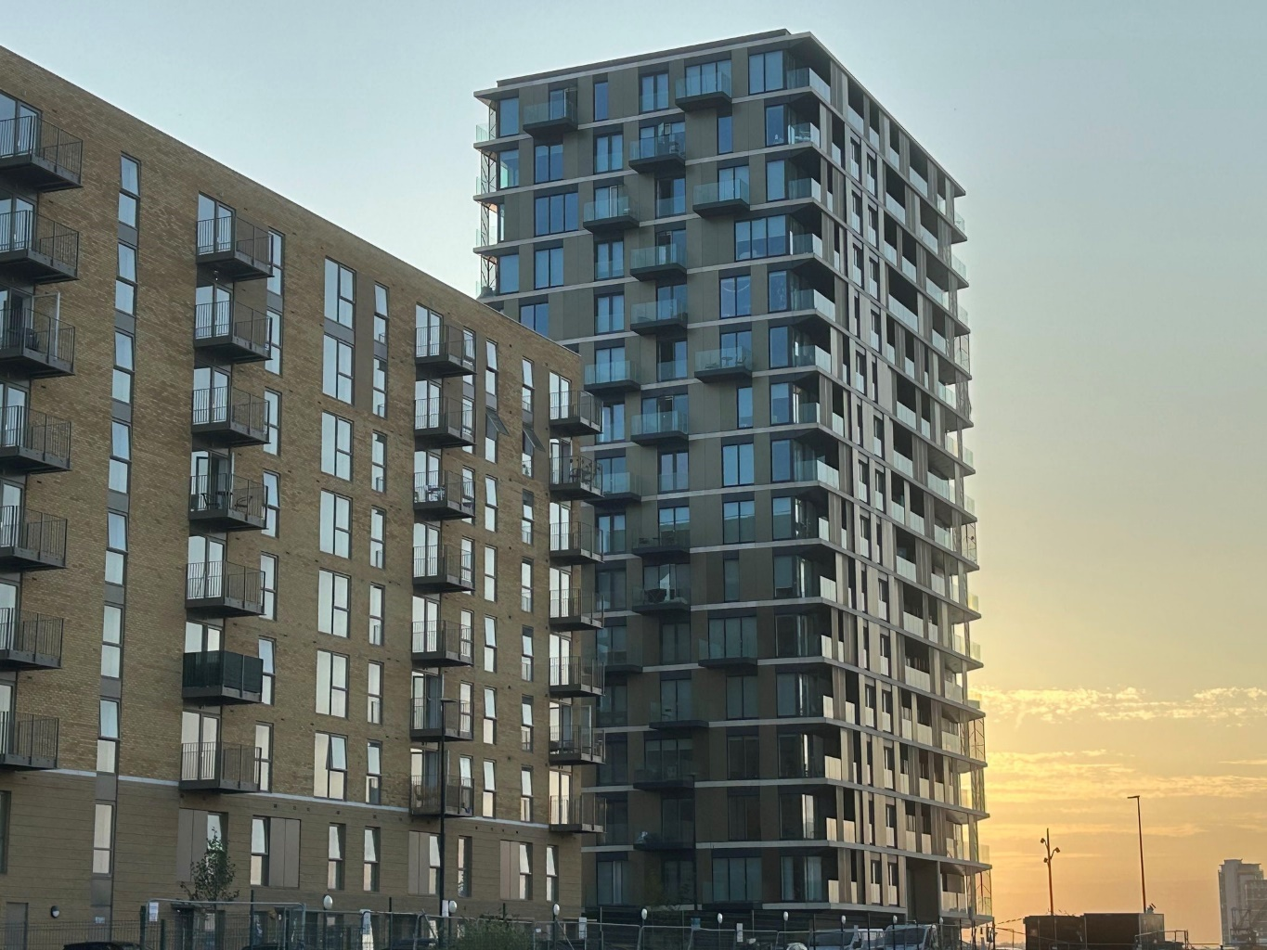

Further details are available at:
http://www.chathamwaters.co.uk/

https://www.medway.gov.uk/info/200177/regeneration/460/regeneration_in_chatham

Chatham Maritime
The regeneration of St Mary’s Island finally completed this year 2023/24; since construction started in the late 1990s, the site has delivered 1,760 dwellings as well as providing a Primary School, doctor’s surgery, play areas and a community centre.

Further details are available at:
https://www.countrysideproperties.com/all-developments/kent/azure

The former Colonial Mutual site (Colonial Wharf at Chatham Quayside) of 200 dwellings has also completed 2023/24.

Further details are available at:
https://www.persimmonhomes.com/new-homes/south-east/colonial-wharf

Two former office buildings were converted to residential with 45 units at Royal Sovereign House completed last year 2022/23 and a further 27 units at Prince Regent House completed this year 2023/24.

Waterside Court on Maritime Way, another office building, received prior notification approval to convert to 60 flats in August 2022; works are now underway and expected to complete 2024/25.

Chatham
113 dwellings in total have been delivered at the former Kitchener Barracks as at 31/3/2024. When complete, 264 new homes will be provided, both by refurbishing the barracks building alongside new modern methods of construction with a move-in ready standard. Completion is expected to be by 2026.

More details available at:

https://kitchenerbarracks.com/

After delays in recent years the former Southern water site ‘Capstone Green’ developed by L&Q has now been completed providing. For more information see:

https://lqhomes.com/capstonegreen/

The conversion under prior notification at Anchorage House has now been completed with 81 one and two bed flats delivered.

21 flats on vacant land to the rear of 5-13 New Road fronting The Paddock have been completed.

Permission has been granted for 2 residential blocks comprising 50 flats at 3 New Road and are expected to be delivered by 2026.

Permission for 179 units granted on land bounded by The Brook car park and Queen Street and outline permission for 175 units at the former Trafalgar Centre and Multistorey car park are expected to be delivered within the next 5 years.

Medway Development Company (MDC) sites

MDC’s Garrison Point project to redevelop the former car park at Whiffen’s Avenue with 115 flats was completed this year 2023/24.

Chatham Waterfront (pictured below) is a mixed-use development comprising 175 apartments and over 1,000 sq.m of commercial floorspace, along with significant public open space enhancements. Construction of this commenced in 2020/21 and will transform the waterfront of Chatham’s town centre when it has been completed, which is expected to be by 2025.
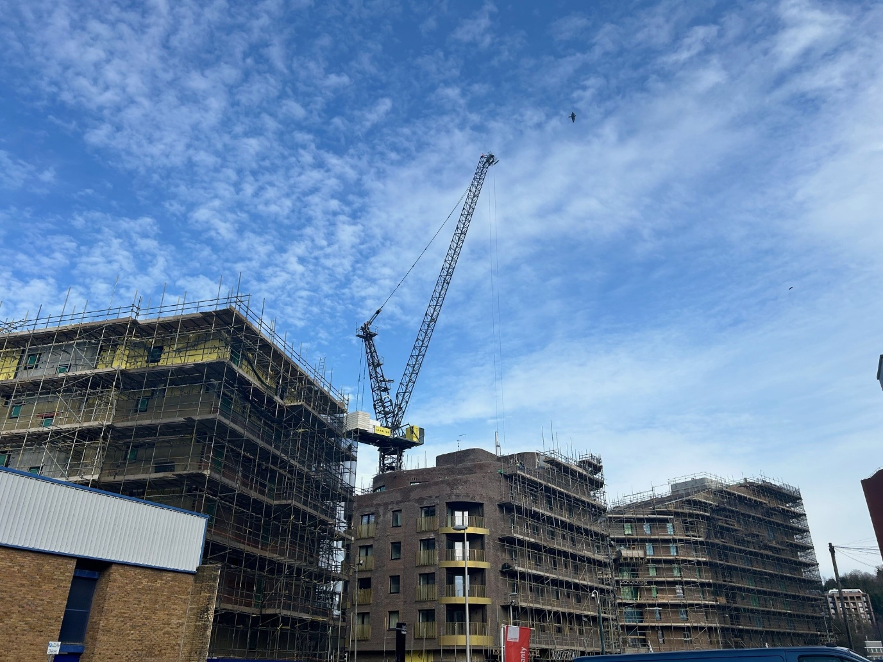

A third MDC project at Mountbatten House in the centre of Chatham is expected to deliver a further 164 residential flats by 2027.

Further details are available at:
https://www.medwaydevelopmentcompany.co.uk/

Rochester
Rochester Riverside is a flagship regeneration scheme for Medway. Medway Council and Homes England signed an agreement with Countryside and the Hyde Group to deliver a £400m development consisting of 1,400 new homes, a primary school, workspace, retail, leisure and health care facilities over the next 10 years.

The landmark and award-winning regeneration site is now well underway with 575 dwellings delivered so far. The Primary school was completed in September 2023 and officially opened on Wednesday 20th March 2024.

Further details are available at:
https://www.countrysidepartnerships.com/all-developments/london/parkside-quarter

Work has progressed well to construct new buildings and to convert the former St Bartholomew’s Hospital into 155 dwellings and an 88sq.m community space; this is expected to be completed by 2025 with 86 dwellings complete as at 31st March 2024.

Further details are available at:
https://www.wardsofkent.co.uk/new-homes/development/1150/st.-bartholomews-place-rochester/

Bardell Terrace received a new permission in November 2023 for 374 new homes and commercial floorspace however a new application is expected which will bring the numbers of new homes down to just under 270.

The construction of 64 one and two bed flats at Pullman House is underway, with commercial space on the ground floor. This is expected to be completed during 2024/25.

44 dwellings (23 net) are expected to be complete during 2024/25 in the regeneration of existing flats at St Clements House, Corporation Street.

The construction of 22 new one and two bed flats on a former commercial premises at 259-261 High Street is underway, with completion expected 2024/25.

Strood
Medway Development Company carried out a consultation which finished 31 January 2024 on proposals for a mixed use development. Permission was granted for the creation of site access and entrance into the site at Planning Committee in February 2024. More details can be found here:

https://www.medwaydevelopmentcompany.co.uk/news/2024/january/strood-civic-site-consultation-is-now-closed/

Redrow Homes completed their Temple Wharf development of 232 new homes at the Temple Waterfront site last year 2022/23. They are now developing the Temple Woods phase of 132 dwellings expected to be completed by 2027.

Further details are available at:

https://www.redrow.co.uk/developments/temple-wharf-strood-212375
https://www.redrow.co.uk/developments/temple-woods-strood-212803

Gillingham
The construction on a 5 storey block of 44 affordable flats at Britton Farm Car Park in Jeffery Street is well underway and are expected to be completed in 2024. These are being built by Medway Development Company as the offsite affordable housing contribution from the Chatham Waterfront Development.

The site which housed the former NHS Walk in centre at the top of Canterbury Street has been completed, delivering 24 two bed flats.

Permission to convert the former Canada House hospital into 21 flats has not yet commenced.

Permission has been granted for two new blocks of 24 flats for specialised supported social housing for adults with learning and special needs on land currently occupied by 5-7 Mill Road and 4 Fox Street. Works have not yet started.

The former Dog and bone pub at Jeffery Street was demolished in 2020 to make way for 24 flats with commercial floorspace on the ground floor. Works are well underway and expected to be complete 2025.

The former nightclub at 22-32 Canterbury Street has been demolished to make way for 14 flats, construction has not yet started.

New permissions granted this year include conversion of the former Snooker hall at Green Street into 57 flats, a rooftop extension at 120-122 High Street to provide 24 flats and the conversion of Pear Tree House 68 West Street to 18 flats, 6 of these via prior notification.

Hoo Peninsula
Much land is being promoted through the Local Plan, and a number of planning applications have also been approved in and around Hoo St Werburgh and villages across the wider peninsula. The majority of these are on greenfield, and many are already complete or currently under construction.

Rainham
Bond Lodge at High Street Rainham was completed this year providing 55 (net 51) retirement flats.

Contractor Willmott Dixon Construction Limited was appointed in December 2022 to develop the new Splashes, now known as Cozenton Park - Medway’s state of the art leisure centre (pictured below). The new facility has two swimming pools: a children’s fun pool with flume, wave pool and beach area and a training pool for lane swimming and lessons as well as a fitness gym and room for exercise classes and children’s parties – it opened in July 2024.

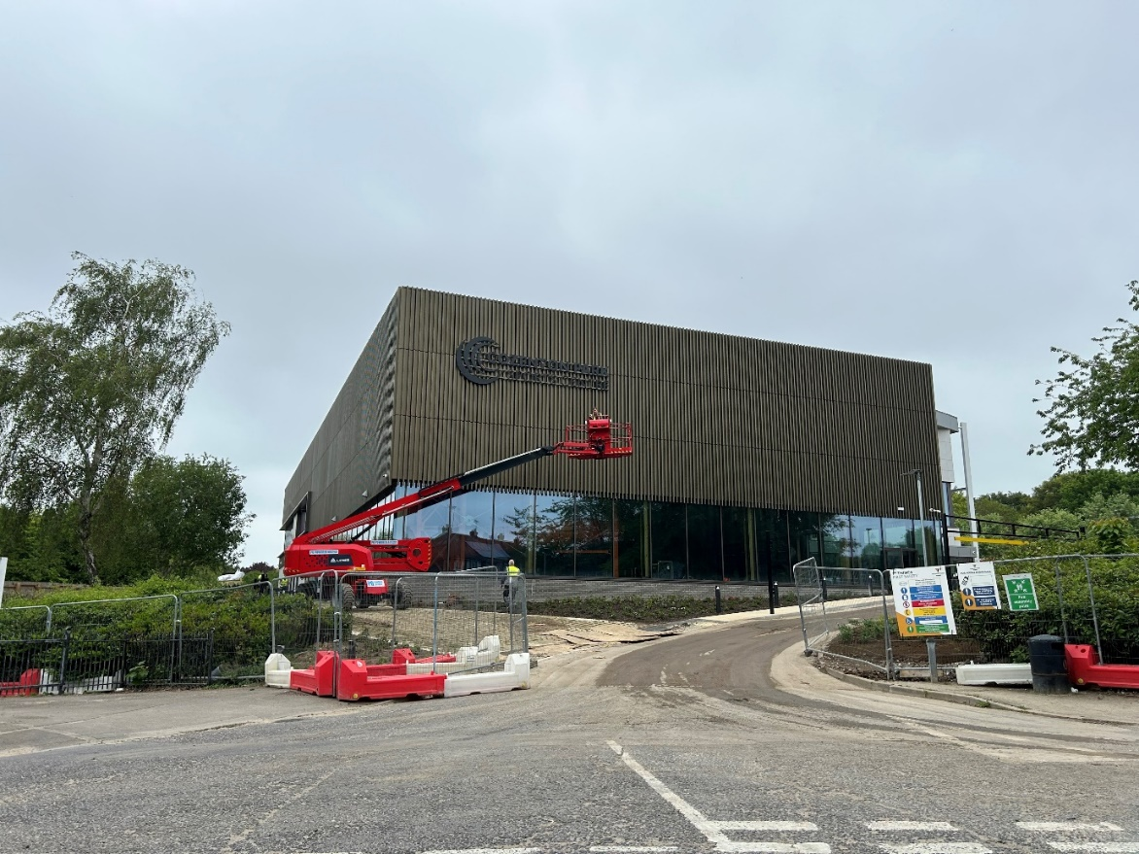
Construction at Cozenton Park Rainham nearing completion

Development Management Planning Statistics
In 2023/24 1,054 planning applications were determined.
Table: Number of applications determined and percentage processed within the statutory timescale or the agreed timeframe

 | 2019/20  Nos | 2019/20  % | 2020/21  Nos | 2020/21  % | 2021/22 Nos | 2021/22 % | 2022/23  Nos | 2022/23  % | 2023/24  Nos | 2023/24  %
Major | 62 | 98% | 67 | 90% | 65 | 94% | 51 | 94% | 44 | 95%
Minor | 356 | 96% | 299 | 87% | 301 | 86% | 294 | 89% | 261 | 84%
Other | 989 | 96% | 944 | 95% | 1,251 | 97% | 893 | 95% | 749 | 96%
TOTAL | 1,407 |  | 1,310 |  | 1,617 |  | 1,238 |  | 1,054

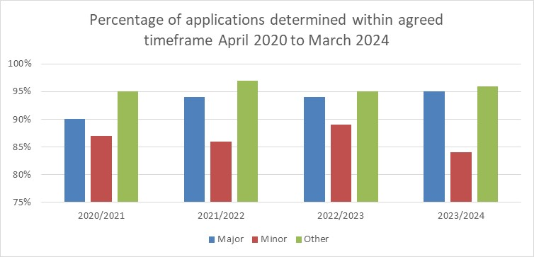

Major
- Large-scale major developments - where the number of residential units to be constructed is 200 or more or 1,000 square metres of industrial, commercial or retail floor space.
- Small-scale major development - where the number of residential units to be constructed is between 10 and 199 inclusive.

Minor
Is where the number of dwellings to be constructed is between 1 and 9 inclusive. A site area of less than 0.5 hectares should be used as the definition of a minor development. For all other uses, a minor development is one where the floor space to be built is less than 1,000 square metres or where the site area is less than 1 hectare.

Other
Covers minerals processing, change of use, householder developments, advertisements, listed building consents, conservation area consents, certificates of lawful development and notifications.

Extensions of time
The general view when processing planning applications is to focus on achieving a positive, pro-growth planning system. It is considered better to take extra time and get a better quality result, than to rush the decision and get a poor result. The Government introduced the use of Planning Performance Agreements (PPA’s) and Planning Extension Agreements (PEA’s), whereby applicants and Local Planning Authorities can agree an appropriate timeframe for the determination of an application, subject to there being a programme and clear end date for the determination.

Planning Performance Agreement (PPA)
A PPA is a framework agreed between a local planning authority and a planning applicant for the management of complex development proposals within the planning process. A PPA allows both the developer and the local planning authority to agree a project plan and programme, which will include the appropriate resources necessary to determine the planning application to an agreed timetable.

Planning Extension Agreements (PEA’s)
A PEA is used to develop a bespoke timetable, whereby the timetable can be extended beyond 8, 13 or 16 weeks so long as the council and the applicant agree. Provided the council is able to meet the new agreed date, an application will be counted as satisfying the timeliness requirement for applications.

Appeals against planning decisions
During the year 2023/24, 44 appeals against the Council’s decisions were determined.
The Planning Inspectorate dismissed 64% of these appeals.

Table: Percentage of Dismissed Appeals

Year | Percentage Dismissed
2019-2020 | 63%
2020-2021 | 80%
2021-2022 | 60%
2022-2023 | 67%
2023-2024 | 64%

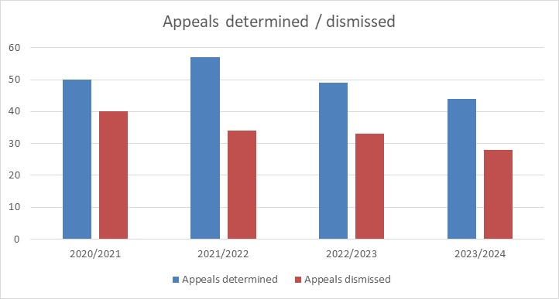

Population

Mid-year estimate 2023

In 2023, the population of Medway reached 286,600, an increase of 4,157 on the 2022 figure.

Medway’s growth rate in 2023 at +1.5% is the highest level seen on record. Medway saw a significant growth rate after the 2011 Census, with a 1.2% increase in 2012.

Over the past ten years Medway has seen a varying annual growth rate – on average just +0.6%.

Medway has had generally a downward growth trend since 2014, until 2022 with a more significant increase seen.

Chart: Population growth trend – annual percent change

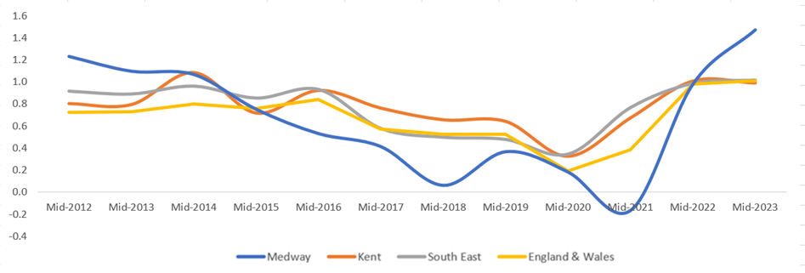

Table: Population growth

Year | MYE numbers | Medway numbers | Medway percent change | Kent Percent change | South East percent change | Eng & Wales percent change
2012 | 268,144 | 3,259 | 1.2 | 0.8 | 0.9 | 0.7
2013 | 271,084 | 2,940 | 1.1 | 0.8 | 0.9 | 0.7
2014 | 273,977 | 2,893 | 1.1 | 1.1 | 1.0 | 0.8
2015 | 276,037 | 2,060 | 0.8 | 0.7 | 0.9 | 0.8
2016 | 277,504 | 1,467 | 0.5 | 0.9 | 0.9 | 0.8
2017 | 278,652 | 1,148 | 0.4 | 0.8 | 0.6 | 0.6
2018 | 278,827 | 175 | 0.1 | 0.7 | 0.5 | 0.5
2019 | 279,852 | 1,025 | 0.4 | 0.6 | 0.5 | 0.5
2020 | 280,364 | 512 | 0.2 | 0.3 | 0.3 | 0.2
2021 | 279,903 | -461 | -0.2 | 0.7 | 0.8 | 0.4
2022 | 282,643 | 2,740 | 1.0 | 1.0 | 1.0 | 1.0
2023 | 286,800 | 4,157 | 1.5 | 1.0 | 1.0 | 1.0

Source: Mid 2023 Population Estimates, Office for National Statistics.

Population by broad age group – 2023

Medway has a younger population than nationally, with proportionally more younger people and fewer older people. Just under twenty-one percent of Medway’s population is aged under sixteen – representing just under sixty thousand 0-15s - and sixteen percent are over retirement age. Medway has a relatively younger aged population when compared to the national breakdown.

Chart – Population by broad age group (%)
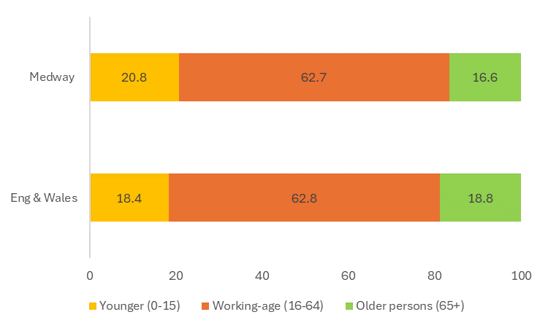

Table: Population by broad age group - 2023
 | 0-15 | 16-64 | 65+
Medway Numbers | 59,551 | 179,740 | 47,509
Medway Percent | 20.8 | 62.7 | 16.6
England & Wales Percent | 18.4 | 62.8 | 18.8

Source - Mid-Year Estimate 2023, Office for National Statistics licensed under the Open Government Licence. © Crown copyright 2024.

Further information on population estimates is available at:

https://www.ons.gov.uk/peoplepopulationandcommunity/populationandmigration/populationestimates

Components of population change

Natural growth has traditionally been Medway’s main source of growth, peaking in 2012 at +1539. However significant migration inflows - both from within the UK (internal) but particularly internationally - in recent years, has led to more significant growth since 2022.

A shift in balance between natural growth and international migration occurred over the past two years, as highlighted in the revised figures published in 2024.

International net migration into Medway in 2023 at + 3,155 was five times the average annual level seen between 2012-2021 (630 p.a.).

Recent migration trends at Medway level are reflected nationally. Research shows that in 2023 net migration nationally was unusually high, driven by an increase in non-EU citizens coming to the UK. In Medway some international migration can be accounted for by families entering Medway under the ‘Homes for Ukraine Scheme’. Many international migrant arrivals occur through work and study routes. In Medway local evidence indicates a number of migrants have come to Medway to work at the hospital.

Chart – Medway Annual Natural Change, Internal and International Migration (nos)

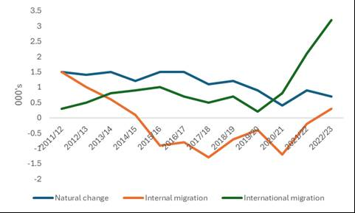

Table: Population trend – 2011/12 to 2022/23 (000’s)
(N.B. - All figures revised in 2024 with 2023 release*)

 | Previous  MYE | Live births | Deaths | Natural change | Internal  migration  (net) | Inter-  national  migration  (net) | Net migration & other changes | Annual change (numbers) | Annual change (running average) | Current  MYE
2011/12 | 264.9 | 3.6 | 2.1 | 1.5 | 1.5 | 0.3 | 1.7 | 3.3 | 3.3 | 268.1
2012/13 | 268.1 | 3.5 | 2.1 | 1.4 | 1.0 | 0.5 | 1.6 | 2.9 | 3.1 | 271.1
2013/14 | 271.1 | 3.6 | 2.1 | 1.5 | 0.6 | 0.8 | 1.4 | 2.9 | 3.0 | 274.0
2014/15 | 274.0 | 3.6 | 2.4 | 1.2 | 0.1 | 0.9 | 0.8 | 2.0 | 2.8 | 276.0
2015/16 | 276.0 | 3.6 | 2.2 | 1.5 | -0.9 | 1.0 | 0.0 | 1.5 | 2.5 | 277.5
2016/17 | 277.5 | 3.6 | 2.2 | 1.5 | -0.8 | 0.7 | -0.3 | 1.1 | 2.3 | 278.7
2017/18 | 278.7 | 3.5 | 2.3 | 1.1 | -1.3 | 0.5 | -1.1 | 0.2 | 2.0 | 278.8
2018/19 | 278.8 | 3.5 | 2.3 | 1.2 | -0.7 | 0.7 | -0.2 | 1.0 | 1.9 | 280.0
2019/20 | 280.0 | 3.3 | 2.4 | 0.9 | -0.4 | 0.2 | -0.4 | 1.5 | 1.8 | 280.3
2020/21 | 280.3 | 3.1 | 2.7 | 0.4 | -1.2 | 0.8 | -0.8 | -0.5 | 1.6 | 279.9
2021/22 | 279.9 | 3.4 | 2.4 | 0.9 | -0.2 | 2.1 | 1.7 | 0.5 | 1.5 | 282.6
2022/23 | 282.6 | 3.3 | 2.6 | 0.7 | 0.3 | 3.2 | 3.5 | 4.2 | 1.7 | 286.8
Total growth |  | 41.6 | 27.8 | 13.8 | -2.0 | 11.7 | 7.9 | 20.6 | - | -
(Numbers may not sum due to rounding)

Adjustments to this time-series have increased the significance of international migration, reduced the impact of UK migration, while increasing the impact of natural growth marginally.

In 2023, 15,450 people moved into Medway, which exceeded the outflow of 15,122. This resulted in a net gain of 328 residents via migration flows within the UK.

Table: Medway migration flows 2023

Internal Migration within UK to  Medway | Internal Migration within UK From  Medway | Internal Migration within UK Net | International Migration  To  Medway | International Migration  From  Medway | International Migration  Net
15,450 | 15,122 | 328 | 4,586 | 1,431 | 3,155

Migration Inflows (UK to Medway)

The main origin areas of movers to Medway were: Gravesham, Bexley, Maidstone, Swale then Dartford.

Table: Top 5 origins
Gravesham | 1,343
Bexley | 1,035
Maidstone | 941
Swale | 919
Dartford | 846

There was a significant flow of migrants from London, with 4,745 people moving to Medway from London. The largest flow to Medway were from areas of South East London.

Migration outflows (Medway to UK)

The main destinations for movers out of Medway in 2022 were to: Swale, Maidstone, Tonbridge & Malling, Canterbury and Gravesham.

Table: Top 5 destinations
Swale | 1,798
Maidstone | 1,452
Tonbridge & Malling | 909
Canterbury | 672
Gravesham | 619

Source: Mid-Year Estimate 2023 (2022 Origin/Destination, 2022 flows), Office for National Statistics licensed under the Open Government Licence. © Crown copyright 2024.
Migration flows by age group

Over half of in-migrants to Medway from other parts of the UK are young adults aged between 20 and 44 years. The number of young children moving into Medway is also notable. This is suggestive of families moving to Medway, as well as young adults for employment purposes as well as for higher education.

Chart: Medway migration flows by age

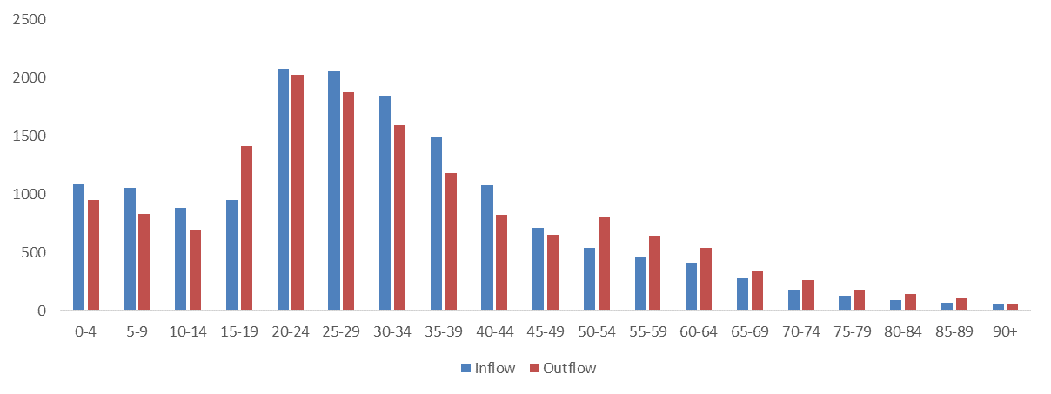
Flows out of Medway tend to be in the older age categories. There is still a significant outflow in younger adults, which may also be linked to moves for employment purposes, families moving, as well as for higher education purposes.

The largest net outflow by age group is of young adults (15-19) which is likely reflective of moves to other parts of the UK for study purposes at ages 18/19. After this, the next most significant group moving out of Medway were those aged in their fifties.

Population age profile

The age profile of the population of Medway is likely to change considerably by 2041.

The number of older persons in Medway will increase significantly, with an extra 10,500 older residents by 2041. By then a fifth of the population will be aged 65+.

Younger people see a decrease with around 2,600 fewer younger residents.

The working-age population will see a small increase in size over this period, to represent just under 61% of the population by 2041.

Chart: Population by broad age group – 2024 to 2041

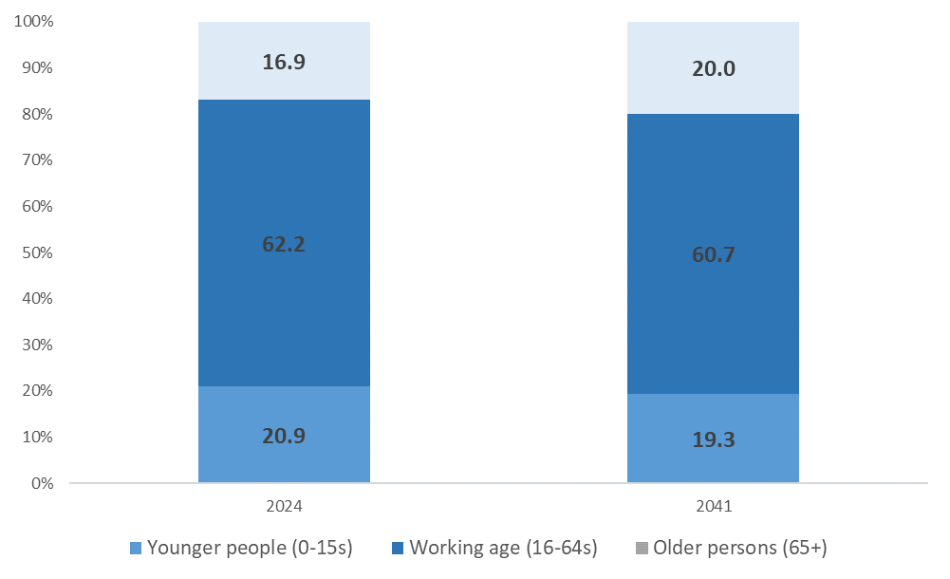

Chart: Population age profile change 2024 to 2041

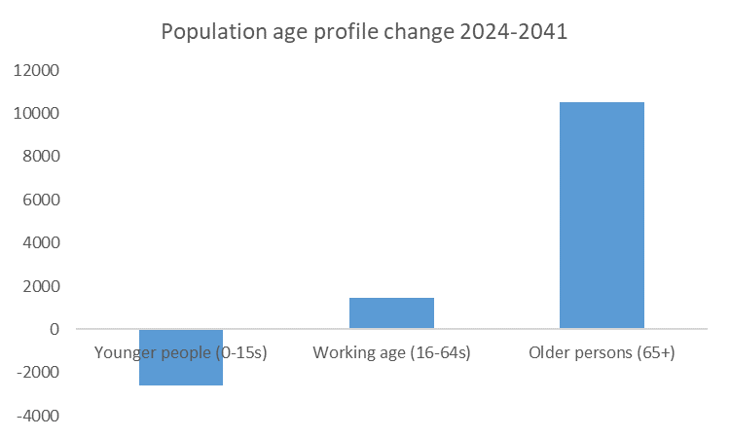

Indices of Deprivation

The Indices of Deprivation are a unique measure of relative deprivation at a small local area level (Lower-layer Super Output Areas) across England. These bring together a range of data sets and are published in a linked set every 3-4 years. The latest set of indices were published in 2019, with the next release expected late 2025.

The Indices of Deprivation consist of the following seven themes: Income, employment, education, health, crime, barriers to housing & services and the living environment. Full details of the Indices of Deprivation 2019, the themes and the different datasets, or indicators used to calculate these are available via on the MHCLG website:

https://www.gov.uk/government/statistics/english-indices-of-deprivation-2019

Medway is ranked in the 30% most deprived local authorities nationally in the 2019 Indices of Deprivation (IoD), in 2015 it was ranked in the 37% of most deprived local authorities nationally. Medway is ranked 93rd most deprived local authority of 317 in England in the latest indices.

Medway has fourteen neighbourhoods ranked in the 10% most deprived and thirty-seven in the 20% most deprived nationally.

Medway appears to fair worst in the crime domain, ranking in the most deprived 10% of local authorities nationally for crime.

Medway has an additional two areas in the most deprived 10% nationally and an additional five in the most deprived 20% nationally since the IoD 2015.

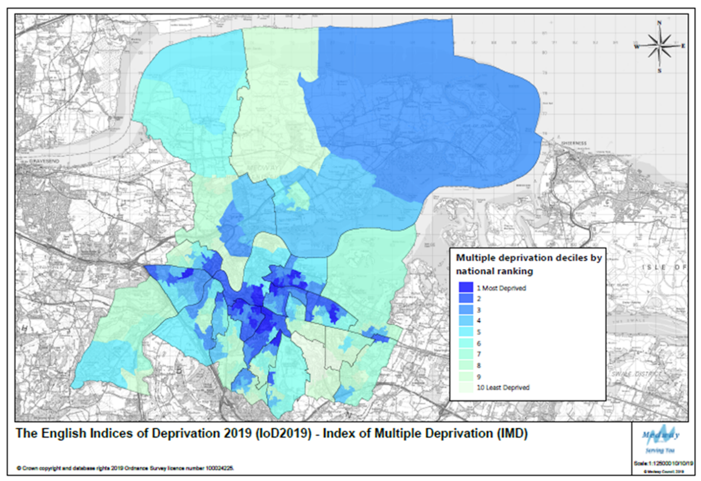

More information on the IoD can be found in the Economy & Employment, Health & Communities and Infrastructure (Education) sections of this report.

Housing

The preparation of the new Local Plan involves defining a housing target to address the development needs of Medway’s communities up to 2041. Government has stated that it expects local planning authorities to use its Standard Method with 2014 based household projections for calculating local housing needs.

The current Standard Method formula for calculating Local Housing Need indicates a need for 1,658 homes a year.
Please note since this AMR was sent to Cabinet in December 2024, Government updated the standard methodology calculation, changing the requirement as at 31/3/2024 from 1,658 dwellings per annum to 1,594 dwellings per annum.

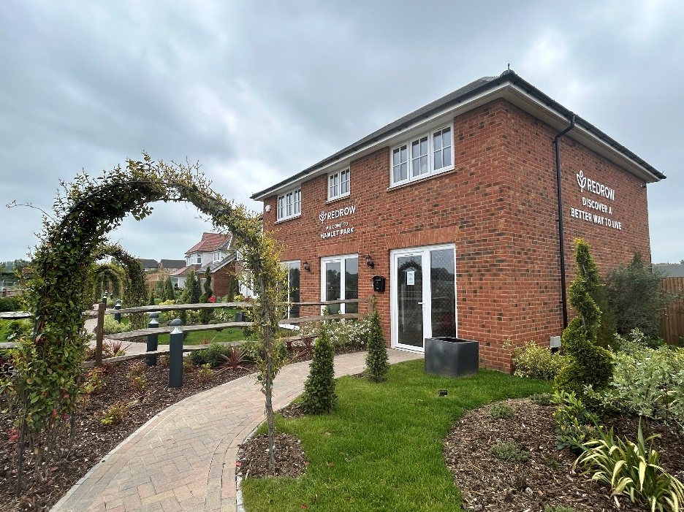
Hamlet Park development, Rainham

Net additional dwellings a) in previous years b) for reporting year c) in future years

In 2023/24 1,300 units were completed, making the past five years the highest number of dwellings delivered in a five year period since Medway became a Unitary in 1998. However, for 2023/24 it was still 358 dwellings below the requirement of 1,658.

Table: Net additional dwellings
 | Completions | *Requirement | Deficit
2019/20 | 1,130 | 1,662 | -532
2020/21 | 1,082 | 1,586 | -504
2021/22 | 1,102 | 1,675 | -573
2022/23 | 950 | 1,667 | -717
2023/24 | 1,300 | 1,658 | -358
*defined by the Government’s standard method of calculating local housing need

Number of new and converted dwellings on previously developed land

In 2023/24, 69% of all residential completions were on previously developed land (PDL).

Housing Trajectory 2023/24 – 2038/39
The housing trajectory shows phasing over the period 2023/24 - 2038/39 (15 years), as well as contributions from completions this year 2023/24 when the current housing target of 1,658 commenced. Phasing is made up of sites with planning consent and windfalls – a map of large sites with planning permission as at 31/3/2024 is shown on page 42 A new Land Availability Assessment was launched in November 2022 with a fresh call for sites which closed in February 2023. An interim report was published in September 2023 and work is currently being carried out to determine which sites are suitable, available and achievable for development. The results will not determine whether a site will be allocated for development – this will be established through the Local Plan process and once done will restore the gap currently shown in the trajectory chart below between demand and supply.

Planning officers consult with developers on large sites annually to check the projections on phasing for development. This information is then used to produce the development trajectory. Officers from Planning, Regeneration and Housing services meet to critically assess the realistic prospects of proposed trajectories on large sites, based on past performance rates and current market circumstances. There has again been a good level of input by developers this year and this was used alongside current knowledge on phasing to forecast housing supply.

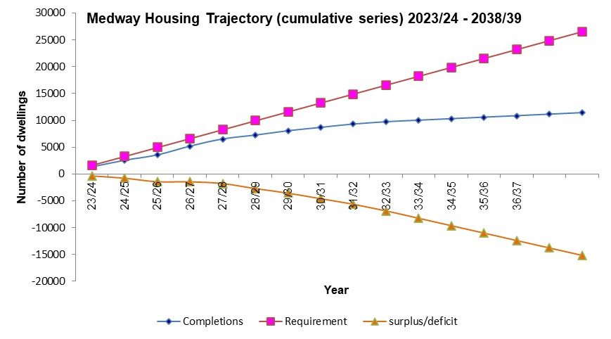

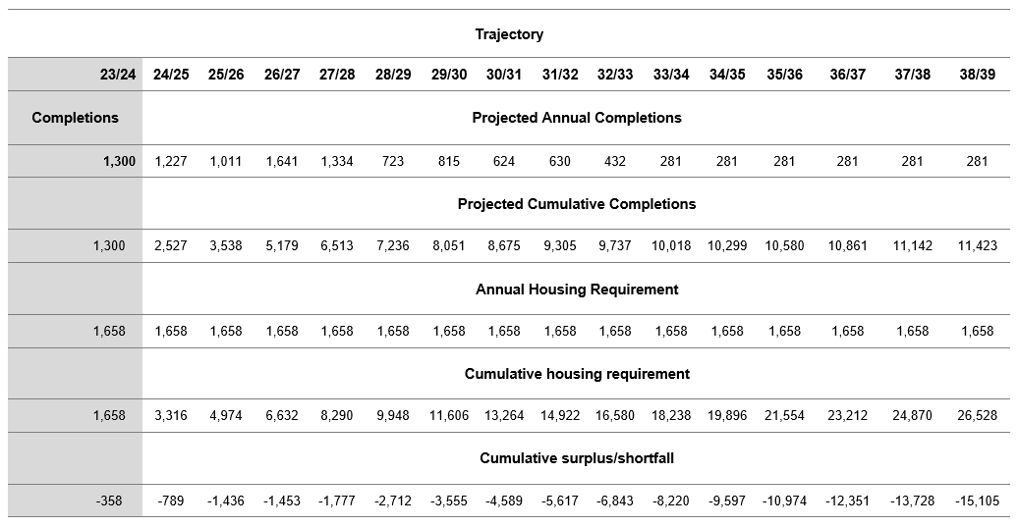

Map showing large sites (5+ dwellings) with planning permission as at 31/3/2024
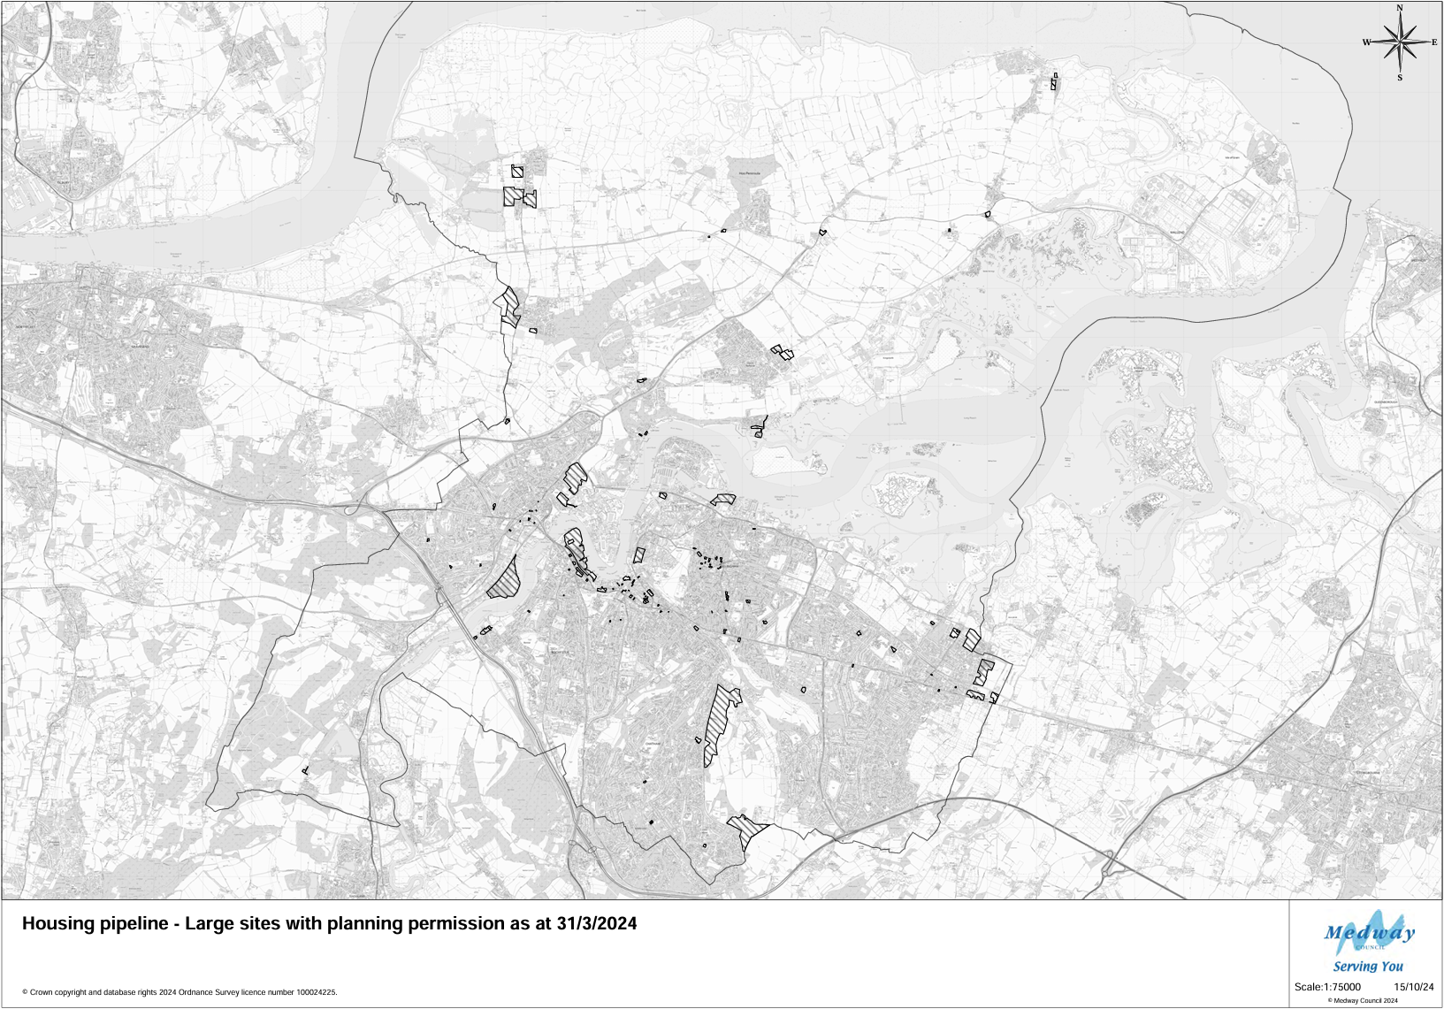

Property prices

Medway generally has a lower value development market than neighbouring districts, but there is marked variation in land values and residential property prices across the area.

In more recent years the rate at which house prices increased has slowed down, but this year 2023/24 they actually fell by (6.09% in Medway). In Kent, the South East and England prices also fell but by a lesser amount.

Despite this recent fall in house prices, over the last 5 years the average cost of buying a home in Medway has risen by nearly 17%.

Table: The percentage change in average prices of all properties

 | March 2020 | March 2021 | March 2022 | March 2023 | March 2024 | % Difference between March 2023 and March 2024
Medway | £239,359 | £257,587 | £282,459 | £298,031 | £279,856 | -6.09%
Kent | £291,603 | £309,000 | £337,079 | £352,417 | £335,481 | -4.08%
South East | £323,166 | £339,759 | £366,987 | £377,514 | £368,265 | -2.45%
England | £249,121 | £269,460 | £288,333 | £296,136 | £296,164 | -0.01%

Source: Crown copyright Land Registry Property Prices extracted from website 10th October 2023 – please note this data is subject to change and amendments which is why some figures may not match those published in previous AMRs
https://landregistry.data.gov.uk/app/ukhpi

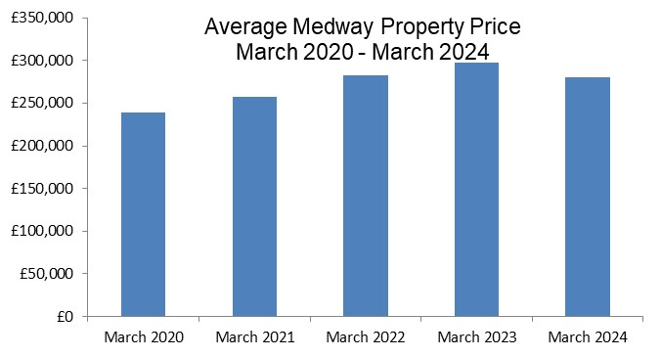

Housing affordability

House price to earnings

Housing affordability ratios provide an indication of the relative financial accessibility of an area’s housing market to local workers. It is calculated by dividing house prices by annual earnings and has been a key element used in the Government’s standard method for calculating housing need.

In 2023 the housing affordability ratio in Medway stood at 8.58, meaning that the average property in Medway costs just over eight and a half times the average annual salary. This is a slight fall from 2021 and 2022 when the average property was nearly 9 times the average annual salary. Medway remains more affordable than regionally which is just over 10 times the average annual salary and across the county of Kent which is nearly 11 times the average annual salary.

Housing affordability in 2023 has slightly improved from the previous year; this is also seen nationally, regionally and across Kent.

 | 2019 | 2020 | 2021 | 2022 | 2023 | 2022-2023 ratio change
Medway | 8.42 | 7.75 | 8.98 | 8.83 | 8.58 | -2.83%
Kent | 9.89 | 9.94 | 11.37 | 11.14 | 10.71 | -3.86%
South East | 10.05 | 10.01 | 11.12 | 10.87 | 10.39 | -4.62%
England | 7.88 | 7.86 | 9.06 | 8.47 | 8.26 | -2.48%

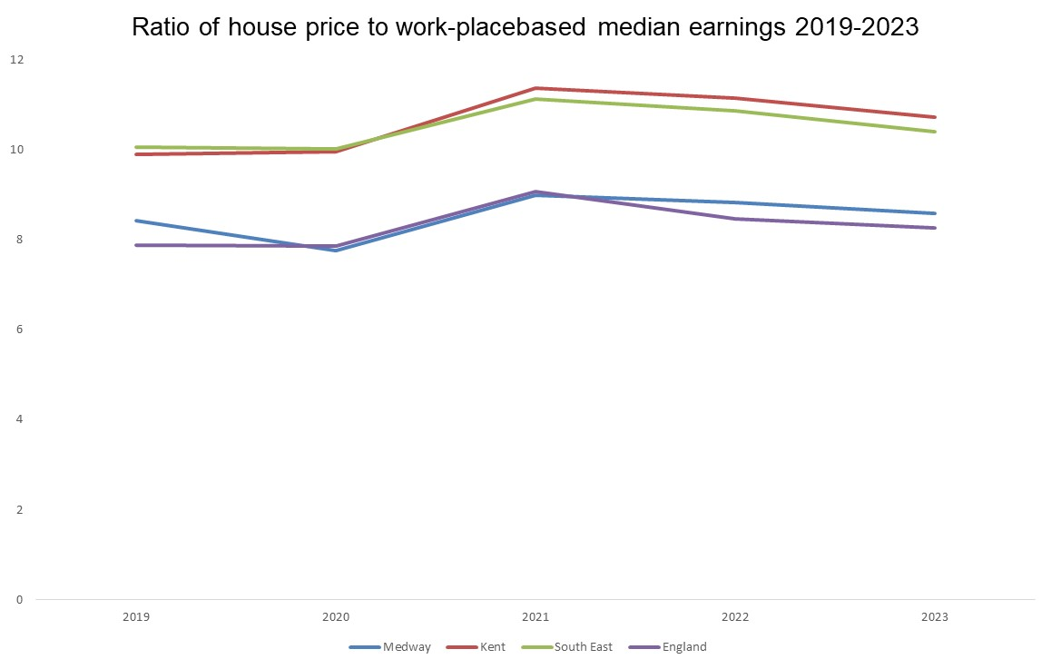
Source:
https://www.ons.gov.uk/peoplepopulationandcommunity/housing/bulletins/housingaffordabilityinenglandandwales/latest
Please note this data is subject to change and amendments which is why some figures may not match those published in previous AMRs

Affordable Housing

A significant proportion of the population is unable to afford the cost of purchasing a home outright. As such it is important to maintain an adequate supply of ‘affordable housing’ to ensure that the whole population has a satisfactory place to live. The Council’s current target is to seek at least 25% of homes to be affordable homes on any site meeting the Council’s size thresholds.

Gross affordable completions (count)

Affordable completions as proportion of all completions

Affordable housing data is collected and reported by the council’s Housing Service and is reported as gross numbers. Therefore, for consistency with our analysis they are compared to the gross total completions number and not the net (for which there is a difference - the net figure is lower because it counts dwellings that have been lost through demolition or conversion).

The number of affordable completions during 2023/24 was high at 29% of all gross completions. This included 56 First Homes. For more information on First Homes see:

https://www.gov.uk/guidance/first-homes

For sites built out in the year 2023/24 the breakdown of houses and flats by number of bedrooms is shown in the table below. This year more flats were completed (77%) than houses/bungalows (23%). The flats were for smaller households with the majority providing 2 bedroomed dwellings.

Table: Affordable Completions (gross) by property type and number of bedrooms 2023/24
Number of bedrooms | Houses/Bungalows | Flats
One | 0 | 130
Two | 9 | 169
Three | 74 | 0
Four or more | 5 | 0
Total | 88 | 299
Total % split | 23% | 77%

Table: Gross affordable completions
 | Gross affordable completions | Number of gross  completions | As % of all gross  completions
2019/20 | 333 | 1,222 | 27%
2020/21 | 216 | 1,114 | 19%
2021/22 | 192 | 1150 | 17%
2022/23 | 172 | 950 | 18%
2023/24 | 387 | 1,338 | 29%

Residential completions by property type and size

This was a milestone year for St Mary’s Island where, after being under construction for over 20 years, the final dwelling was completed and the site was finally finished. Combined with the rest of Medway there were more flats than houses delivered on fully built out large sites this year, the majority being 2 bedrooms. Most of these units were built on St Mary’s Island with the majority of the remainder on sites at Garrison Point Whiffen’s Avenue, the former Colonial Mutual and Anchorage House.

Table: Completions (gross) on large sites by property type and number of bedrooms 2023/24
Number of bedrooms | Houses | Flats
One | 204 | 413
Two | 411 | 815
Three | 545 | 399
Four or more | 275 | 0
Total | 1,435 | 1,627
Total % split | 47% | 53%
Please note, this table only shows large sites (5+ dwellings) which have been completely built out; it does not include sites where completions have occurred with the remainder still under construction.

Lodgement Completions - Energy Performance Certificates (EPCs)

A quarterly series of statistics is published by the Department for Levelling Up, Housing and Communities on the energy efficiency of domestic and non-domestic buildings in England and Wales that have been constructed, sold or let since 2008. This data comes from Energy Performance Certificates (EPCs) which are produced at the time of completion or sale.

Comparing EPC lodgement completions with Medway’s Annual Housing Completions

Each type of dwelling is referred to as a lodgement. The number of lodgements is different to the number of actual completions per year due to differences in the EPC requirements and definitions used when counting completions for the annual survey. Using the EPC figures can give an early indication as to what the housing completion figures might be for each year. On average, over the past 5 years, there was an overall 7% difference between the two, with the EPC certificates coming out slightly higher.

Year | Total Number of Lodgements | Annual completions | Difference | % Difference
2019/20 | 1,206 | 1,130 | 76 | 7%
2020/21 | 1,112 | 1,082 | 30 | 3%
2021/22 | 1,220 | 1,102 | 118 | 10%
2022/23 | 1,037 | 950 | 87 | 8%
2023/24 | 1,382 | 1,300 | 82 | 6%
Total | 5,957 | 5,564 | 393 | 7%
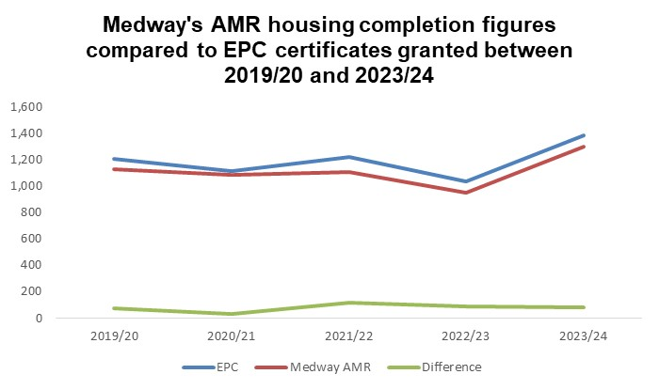

Annual Completions by property type

From Medway Council’s annual housing survey, it is usually not possible to monitor the completions of property types until the whole site is built out (see above). However, using the EPC statistics, it is possible to produce an approximate breakdown for each year, see the chart below:

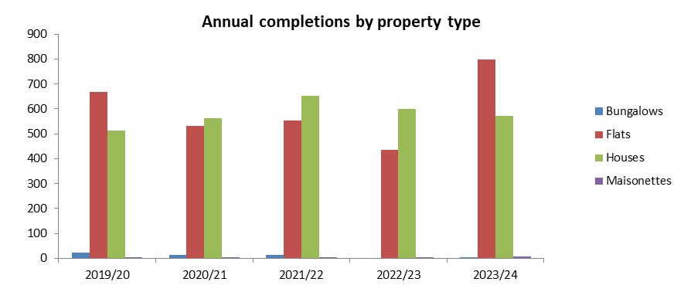

In 2023/24 just under 60% of the dwellings registered with an EPC certificate were flats, followed by houses at 41%. This makes a change to the previous three years where more houses than flats were completed and is mainly due to the completion of flatted developments at Chatham Waters, Garrison Point, Chatham Waterfront and Anchorage House.

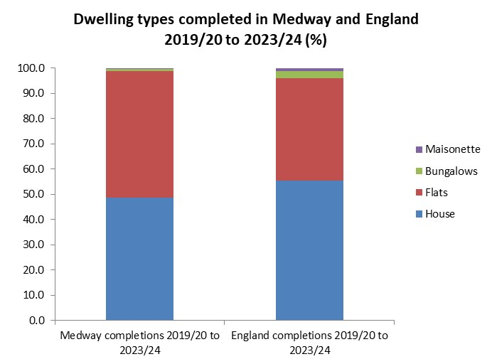

Since 2019/20, in Medway the average split of completions has been 49% houses, 50% flats, just under 1% bungalows and less than 1% maisonettes. National figures show that there was a larger proportion of houses delivered in the same time period (56%), but a lower proportion of flats (41%). This reflects on the regeneration achievements in Medway in recent years.

Table: Average floor space completed 2019/20 – 2023/24

Type of Dwelling | Medway (sq.m) | England (sq.m)
Bungalow | 79 | 94
Flats | 62 | 61
Houses | 111 | 111
Maisonettes | 92 | 78

The average floor space size for completions of houses and flats in Medway are generally around the same size as those completed nationally in England over the past 5 years. However, bungalows completed in Medway during this time period were slightly smaller than those built in England, although Medway maisonettes were slightly larger.

Source: https://www.gov.uk/government/collections/energy-performance-of-buildings-certificates

‘Other’
Houseboats
Using information gained from Council Tax records, during 2023/24, ten houseboats moved into marinas in Medway (Port Werburgh, Medway Bridge, Whitton Marina and Stargate Marina), and four moved out, leaving a net gain of six houseboats.

C2 accommodation (residential institutions)
Elderly person care home bedrooms
2023/24 saw the loss of 16 elderly care home beds at Agape House, Maidstone Road, Chatham following a conversion to an 18 person House of Multiple Occupation. Over the last five years 10 net elderly person bedrooms have been completed in Medway and it is expected that a further 210 (net) will be completed within the next five years.

Children’s home bedrooms
In the last five years, 42 children’s home bedrooms have been gained in Medway, in the areas of Gillingham and Walderslade.

Supported living bedrooms
Fifteen rooms have been gained in Medway over the last five years, providing support for adults with mental health concerns or learning difficulties.

Student accommodation
There were no new student rooms completed in 2023/24 however 94 student rooms are expected to be delivered in the next 5 years at locations in Chatham, Gillingham and Rochester.

New Homes Bonus

The New Homes Bonus is a grant paid by central government to local councils to reflect and incentivise housing growth in their areas.

It is based on the amount of extra Council Tax revenue raised for new-build homes, conversions and long-term empty homes brought back into use. There is also an extra payment for providing affordable homes.

Table: New Homes Bonus Allocations

2019/20 | 2020/21 | 2021/22 | 2022/23 | 2023/24
£2.0m | £1.2m | £0.99m | £1.98m | £2.0m

The New Homes Bonus is not ring-fenced and is treated as part of the overall Medway Council aggregate finance, alongside Revenue Support Grant, Council Tax and Business Rates.

Under the 2019 to 2022 Johnson Conservative government a consultation took place on the Future of the New Homes Bonus from 2022/23 onwards – feedback is still being analysed. More information on the consultation can be found here:

https://www.gov.uk/government/consultations/the-future-of-the-new-homes-bonus-consultation?utm_medium=email&utm_campaign=govuk-notifications&utm_source=bb718755-65e1-4d03-8c96-f5617b6df99e&utm_content=daily

Source:
https://www.gov.uk/government/publications/new-homes-bonus-final-allocations-2023-to-2024

Gypsies, Travellers and Travelling Showpeople

The council published a Gypsy, Traveller and Travelling Showpeople Accommodation Assessment (GTAA) to assess requirements from 2017-2035, as part of the evidence base for the new Local Plan. An updated version was published in July 2024, with the Regulation 18 consultation.

The report is available to view at:

https://medway.oc2.uk/docfiles/20/Gypsy%20and%20Traveller%20Accommodation%20Assessment.pdf

The new Local Plan is making provision to meet the needs for specialist forms of accommodation. The council has commissioned an update to the 2018 GTAA report, jointly with Gravesham Borough Council to align with the extended plan period. This update identified the need arising from households that meet the planning definition should be addressed through site allocation/intensification/expansion and through Local Plan Policies (e.g. criteria based policy).

Net additional pitches (Gypsy and Traveller)

Bi-annual counts of Gypsy and Traveller Caravans are made by the Planning Service, Housing Management and Strategic Housing every January and July, before being submitted to MHCLG and subsequently published. A count of Travelling Showpeople is also made annually each January.

In the latest data from January 2024, there were 77 caravans in Medway, of which 10 were socially rented, 38 on authorised sites with permanent/temporary permission and a further 5 on unauthorised sites without planning permission. In addition to this, there were 24 Travelling Showpeople caravans counted in January 2024.

Table: Gypsy and traveller count data between July 2018 and Jan 2024

Count date | Authorised sites with planning permission  Socially Rented | Authorised sites with planning permission (temp or full)  Private Caravans | Unauthorised sites (no planning permission) on Travellers own land | Unauthorised sites (no planning permission) on land not owned by Travellers | Total Caravans
Jul 2018 | 10 | 31 | 13 | 0 | 54
Jan 2019 | 10 | 32 | 19 | 0 | 61
Jul 2019 | 10 | 38 | 14 | 0 | 62
Jan 2020 | 10 | 41 | 10 | 0 | 61
Jul 2021 | 10 | 38 | 17 | 0 | 65
Jan 2022 | 10 | 47 | 23 | 0 | 80
Jul 2022 | 10 | 36 | 9 | 0 | 55
Jan 2023 | 10 | 47 | 5 | 0 | 62
Jul 2023 | 10 | 40 | 16 | 45 | 111
Jan 2024 | 10 | 38 | 17 | 12 | 77
*Due to Covid restrictions, no count was carried out during July 2020 or January 2021.

Source: https://www.gov.uk/government/collections/traveller-caravan-count

Planning applications

Year | Permitted Permanent* | Permitted Temporary | Refused
2019-20 | 1 | 1 | 2
2020-21 | 0 | 1 | 0
2021-22 | 1 | 1 | 0
2022-23 | 1 | 0 | 0
2023-24 | 0 | 1 | 0
*including retrospective and lawful development certificates

During the year 2023/24 there was one approval granted; retrospective change of use of land for stationing a mobile home at Harewood Hill, Matts Hill Road, Rainham (temporary permission tied to the family).

Self-Build and Custom Housebuilding Register

From 1 April 2016, the council has had a duty to hold a register of people and associations interested in a serviced plot of land that could be used to build their own home.

The register operates in ‘base periods’; The first base period ran from the date the register was first established (1 April 2016) until 30th October 2016, then subsequent base periods run from 31 October to 30 October the following year.

At the end of each base period, relevant authorities have three years in which to permission an equivalent number of plots of land, which are suitable for self-build and custom housebuilding, as there are entries for that base period.

No. of self/custom build plots granted permission BETWEEN 1/4/2016 AND 30/10/2024

Application number | Site address | No of plots | Date outline permitted | Status 31/3/24*
MC/17/3572 | Land west of Merryboys Farm House, Cooling Common | 6 | 6/6/2018 | Complete
MC/18/0096 superseded by MC/21/2065 | Land adjoining 35 Cooling Road, High Halstow | 5 | 31/7/2018 then 19/5/2022 | Not started
MC/20/1025 | Land at 309 Lower Rainham Road | 3 | 6/10/2021 | Not started
MC/22/1317  (new application for 3 dwellings MC/23/2753 awaiting decision) | Land to the rear of Fenn House Farm, Fenn Street, St Mary Hoo | 4 | 16/11/2022  (S106 signed 27/7/23) | Not started
MC/24/1213 | Land Rear of the Old Vicarage High Street Grain – subject to S106 | 2 | 25/10/2024 | Not started
 | Total number of plots permitted since 1/4/2016 | 20
*Surveyed as part of the annual monitoring process which runs from 1 April to 31 March each year, different to base period years

Table: Number of self-build dwellings built within the year

Year | Number of self/custom build dwellings built
2019-20 | 0
2020-21 | 1
2021-22 | 3
2022-23 | 1
2023-24 | 1
TOTAL 2019-20 to 2023-24 | 6

The numbers in the table above are included in the total main housing completions figure.

The 6 self-build dwellings built to date have all been at a site named Bluegates in Cooling Common, pictured below.

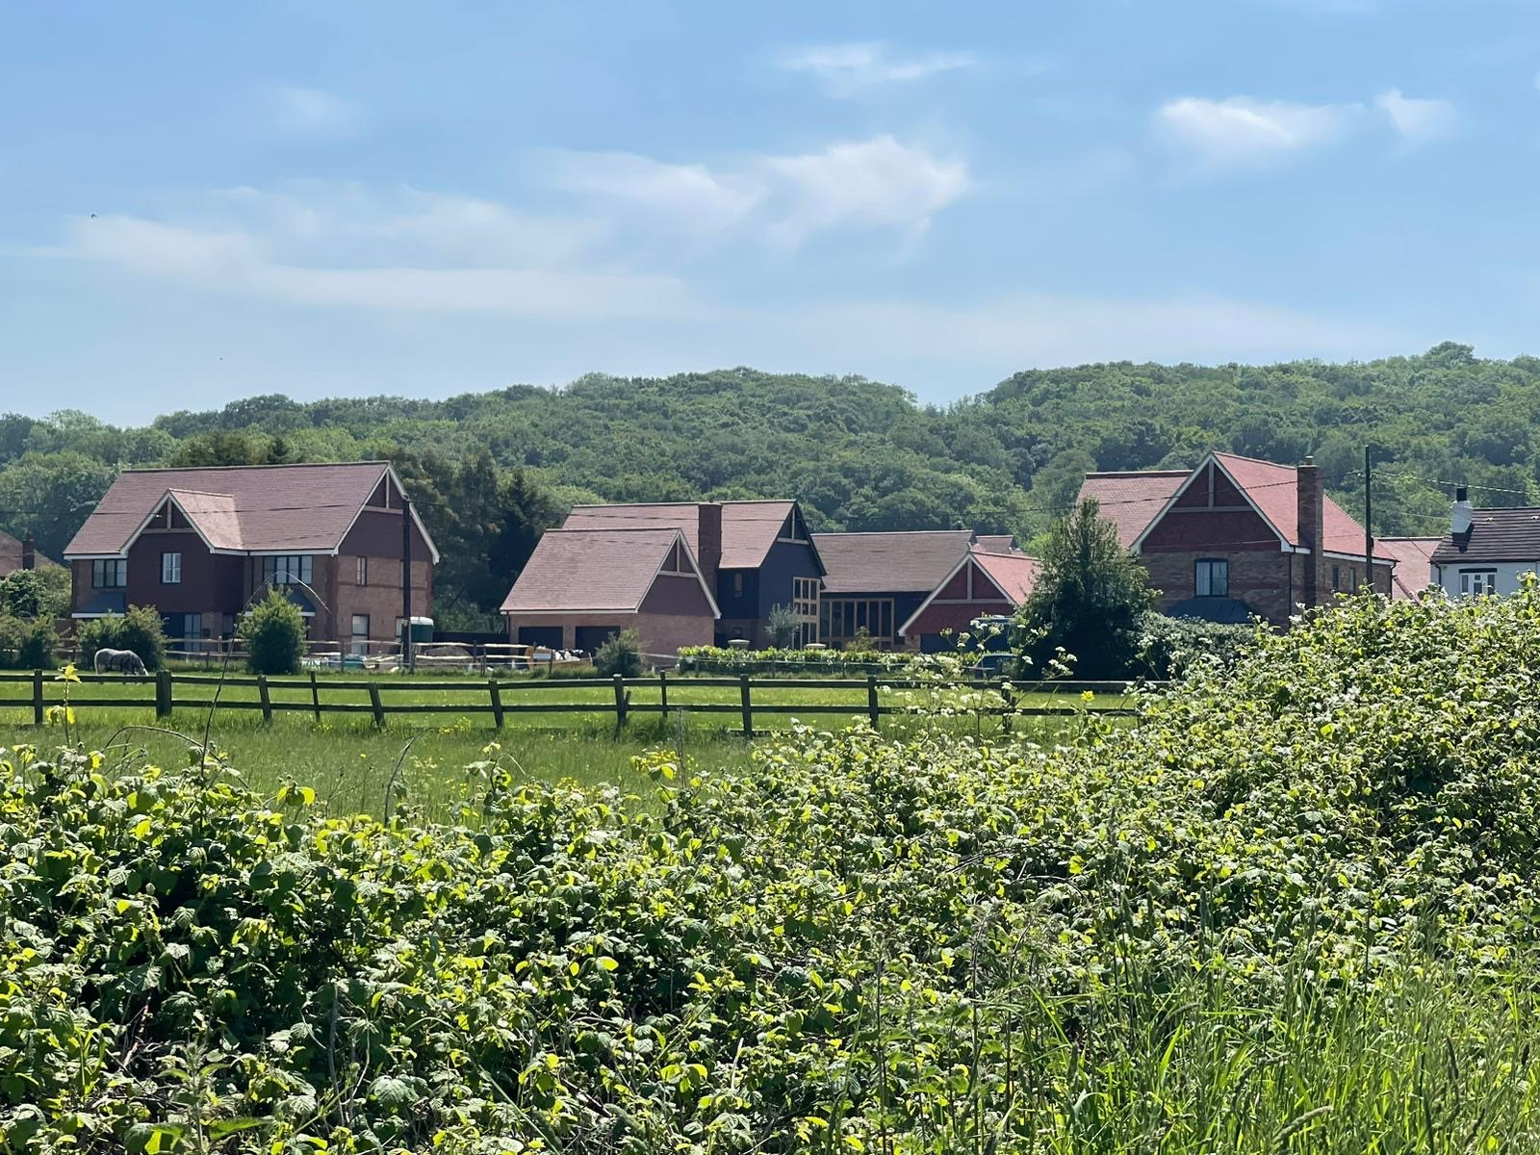
Bluegates self-build development, Cooling Common

Table: Number of applications on the Register – Demand for self/custom build plots

Base Period – table showing number of applications on the Register | Individuals* | Associations | Date Medway need to have enough permissions granted by | Permissions granted within 3 years of end of base period | Shortfall in permissions granted
One (1/4/2016 – 30/10/2016) | 15 | 0 | 30/10/2019 | 11 | 4
Two (31/10/2016 – 30/10/2017) | 39 | 0 | 30/10/2020 | 0 | 39
Three (31/10/2017 – 30/10/2018) | 14 | 1 | 30/10/2021 | 3 | 12
Four (31/10/2018 – 30/10/2019) | 14 | 1 | 30/10/2022 | 0 | 15
Five (31/10/2019 – 30/10/2020) | 17 | 0 | 30/10/2023 | 4 | 13
Six (31/10/2020 – 30/10/2021) | 12 | 0 | 30/10/2024 | 2 | 10
Seven (31/10/2021 – 30/10/2022) | 12 | 0 | 30/10/2025 | n/a | n/a
Eight (31/10/2022 – 30/10/2023) | 9 | 0 | 30/10/2026 | n/a | n/a
Nine (31/10/2023 – 30/10/2024) | 7 | 0 | 30/10/2027 | n/a | n/a
TOTAL PLOTS PERMITTED |  |  |  | 20
TOTAL PLOTS REQUIRED INDIVIDUALS | 139 | -
TOTAL PLOTS REQUIRED ASSOCIATIONS | - | 2
CUMULATIVE SHORTFALL OF PERMISSIONS GRANTED |  |  |  |  | 93
* these numbers may be different to previously reported due to some applicants later requesting to be removed from the Register

To date, 11 applicants have requested to be removed from the Register. However, this does not reduce the reported demand for the relevant base period.

The council promotes opportunities for self-build and custom housebuilding with developers and notifies applicants on the register when plots become available.

The council will have regard to the register when preparing the local plan by introducing a Policy dedicated to self and Custom Housebuilding. The council will also have regard to the register when making decisions on planning applications and in carrying out its housing, land disposal and regeneration functions. Adopted and emerging Neighbourhood Plans in Medway are also promoting policies for self-build and custom housing. Headline data and more information can be found at:

https://www.medway.gov.uk/info/200149/planning_policies/144/self-build_and_custom_housebuilding_register

Economy and Employment

Medway Council supports the development of a diverse, high quality local economy, to provide a wide range of employment options for the community as a whole. Market conditions broadly reflect a combination of national economic circumstances and local supply and demand factors.

The Council’s Regeneration Strategy, Medway 2035 sets out the regeneration aims and objectives for Medway across six priority areas.
- destination and placemaking - putting Medway on the map as a smart and sustainable city
- inward investment - increasing high value businesses and expanding high quality employment
- innovation - continuing to support the creation and growth of businesses
- business accommodation and digital connectivity - providing the right infrastructure for business success
- sector growth - enhancing a strong, mixed economy
- improving employability - matching business demand and supply of skills.
More information on Medway 2035 can be found here:

https://www.medway.gov.uk/info/200177/regeneration/455/medway_regeneration/2

The new Local Plan is addressing the supply of employment land to meet the needs of businesses in Medway up to 2041. An updated Employment Land Needs Assessment was published in October 2021 and employment land will be reviewed again in Winter 2024/25 before the new Local Plan is published.

The planning use classes were updated on 1st September 2020. Class B1 now falls within new use class E(g): uses which can be carried out in a residential area without detriment to its amenity. Use classes B2 and B8 remain the same. For the purpose of monitoring this year 2023/24, we have continued to use the former B1 use class throughout the year which includes any applications which have been made under the new use class E(g).

Amount and type of completed employment floor space

There was only a net loss in B1 floorspace this year 2023/24 the majority due to the loss of offices at Waterside Court, Chatham Maritime to provide 60 flats. The majority of gains in B2 floorspace was at Padacar Cement Casting at Thamesport Isle of Grain and B8 floorspace on land East of Formby Road Halling. See Volume 2 for more information on individual gains and losses.

Table: Amount and type of completed employment floor space (sq.m) – 2023/24

 | B1 | B2 | B8 | Mixed B | Total
Gross | 789 | 2,786 | 905 | 0 | 4,480
Net | -5,763 | 2,786 | 905 | 0 | -2,072

Table: Amount of completed employment floor space (sq.m) 2019/20- 2023/24

 | 2019/20 | 2020/21 | 2021/22 | 2022/23 | 2023/24
Gross | 3,552 | 9,209 | 37,627 | 3,905 | 4,480
Net | -2,429 | -4,478 | 26,504 | -12,235 | -2,072

Amount and type of employment floor space coming forward on Previously Developed Land (PDL)

92% of employment floor space (gross) was completed on previously developed land during 2023/24.

Amount and type of employment land available

Overall the anticipated net gain of employment land uses (B1/B2/B8/Mixed B) stands at over 850,000 sq.m with the majority expected to be delivered within the next 15 years. 315,000 sq.m of this is attributed to a new application (ref MC/21/0979) approved during 2023/24 at Kingsnorth Power Station for flexible employment and energy uses and a lorry park. See Volume 2 for more information on permissions not started and under construction.

Amount of floor space for town centre uses

The monitoring data shows that in the last year there were net losses in retail, financial/ professional services and non-residential institutions. The largest loss of retail floorspace was in the Pentagon Shopping Centre Chatham, where the upper floor is being converted to provide a healthy living centre and innovation hub, making valuable use of vacant retail units following changes to retail patterns.

The new Local Plan will set out a strategy and policies for securing the future of Medway’s town centres, including a mix of land uses. The council’s Regeneration Strategy also promotes the vitality of centres. The council has invested in Chatham and Strood over the last few years to improve the public realm and to increase attractiveness of the town centres. Further work continues with the Future High Streets Fund and SELEP investments in Gillingham.

Table: Floor space (sq.m) completed for town centre uses (A1/A2/B1/D2) – 2023/24
 | A1 | A2 | B1 | D1 | Total
Town Centre Gross | 75 | 14 | 0 | 121 | 210
Town Centre Net | -5,196 | -383 | 0 | -180 | -5,759
Rest of Medway Gross | 620 | 0 | 2,786 | 1,311 | 4,717
Rest of Medway Net | 367 | -303 | 2,786 | -274 | 2,576
Total Gross | 695 | 14 | 2,786 | 1,432 | 4,927
Total Net | -4,829 | -686 | 2,786 | -454 | -3,183

Table: Total floor space (sq.m) for town centre uses (A1/A2/B1/D2) 2019/20-2023/24
 | 2019/20 | 2020/21 | 2021/22 | 2022/23 | 2023/24
Town Centre Gross | 577 | 869 | 1,330 | 865 | 210
Town Centre Net | -3,333 | -1,519 | -1,038 | -7,692 | -5,759
Rest of Medway Gross | 6,848 | 6,602 | 8,734 | 5,310 | 4,717
Rest of Medway Net | -8,089 | -3,990 | -774 | 959 | 2,576
Total Gross | 7,425 | 7,471 | 10,064 | 6,175 | 4,927
Total Net | 7,502 | -11,422 | -5,509 | -1,812 | -3,183

Job Seekers Allowance and Universal Credit claimant rate

The claimant rate in Medway stood at 3.9% in April 2024. This is in line with the national rate, but above the rate for Kent and the South East.

In April 2024 the claimant count in Medway stood at 7,750 claimants, having increased slightly (+160/+2.4%) since April 2023.

Table: Claimant rate – 2019-2024

 | Medway | Kent | South East | Eng & Wales
Apr-19 | 2.8 | 2.4 | 1.7 | 2.6
Jul-19 | 3.0 | 2.5 | 1.8 | 2.7
Oct-19 | 3.1 | 2.7 | 2.0 | 2.8
Jan-20 | 3.2 | 2.7 | 2.0 | 2.9
Apr-20 | 5.3 | 5.0 | 3.9 | 5.0
Jul-20 | 6.8 | 6.1 | 5.2 | 6.3
Oct-20 | 6.6 | 5.8 | 5.1 | 6.2
Jan-21 | 6.5 | 5.8 | 5.0 | 6.1
Apr-21 | 6.8 | 5.8 | 5.1 | 6.3
Jul-21 | 5.9 | 4.9 | 4.2 | 5.4
Oct-21 | 5.2 | 4.3 | 3.6 | 4.7
Jan-22 | 4.7 | 3.9 | 3.3 | 4.3
Apr-22 | 4.3 | 3.5 | 3.0 | 3.9
Jul-22 | 3.8 | 3.2 | 2.8 | 3.7
Oct-22 | 3.6 | 3.2 | 2.8 | 3.6
Jan-23 | 3.7 | 3.2 | 2.8 | 3.6
Apr-23 | 3.8 | 3.4 | 2.9 | 3.8
Jul- 23 | 3.8 | 3.3 | 2.8 | 3.7
Oct- 23 | 3.8 | 3.3 | 2.8 | 3.7
Jan -24 | 3.8 | 3.4 | 2.9 | 3.8
Apr- 24 | 3.9 | 3.4 | 3.0 | 3.9

Chart: Claimant rate 2019-2024

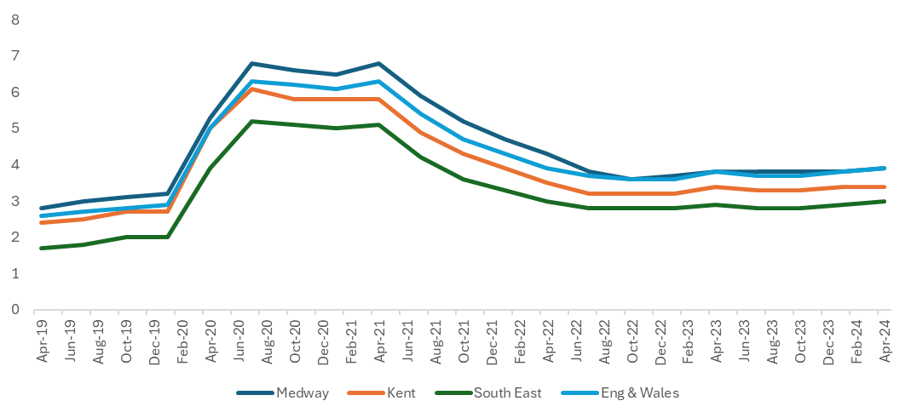

Source - Jobcentre Plus administrative system, via Nomis, ONS.

The Claimant Count is the number of people claiming benefit principally for the reason of being unemployed. This is measured by combining the number of people claiming Jobseeker's Allowance (JSA) and National Insurance credits with the number of people receiving Universal Credit principally for the reason of being unemployed. Claimants declare that they are out of work, capable of, available for and actively seeking work during the week in which the claim is made.

The measure of the number of people receiving Universal Credit principally for the reason of being unemployed is still being developed by the Department for Work and Pensions. Consequently, this component of the total Claimant Count does not yet correctly reflect the target population of unemployed claimants and is subject to revisions. For this reason the Claimant Count is currently designated as ‘Experimental Statistics.’

Employment

In 2024 the employment rate in Medway decreased slightly to 78.8% from 79.3% in the previous year. The employment rate in Medway stood at a five year high in 2023, following a dip in 2021. The employment rate in Medway however remains above the five-year average (77.7%).

The Medway employment rate in 2024 stands above the national level and Kent level, but below the regional level which saw a large increase in 2024.

Table: Employment rate

 | 2019/20 | 2020/21 | 2021/22 | 2022/23 | 2023/24
Medway | 77.3 | 75.1 | 78.1 | 79.3 | 78.8
Kent | 78.5 | 77.9 | 74.2 | 75.9 | 77.2
South East | 79.6 | 77.7 | 78.1 | 78.0 | 79.6
Eng & Wales | 76.1 | 75.0 | 75.3 | 75.6 | 75.6

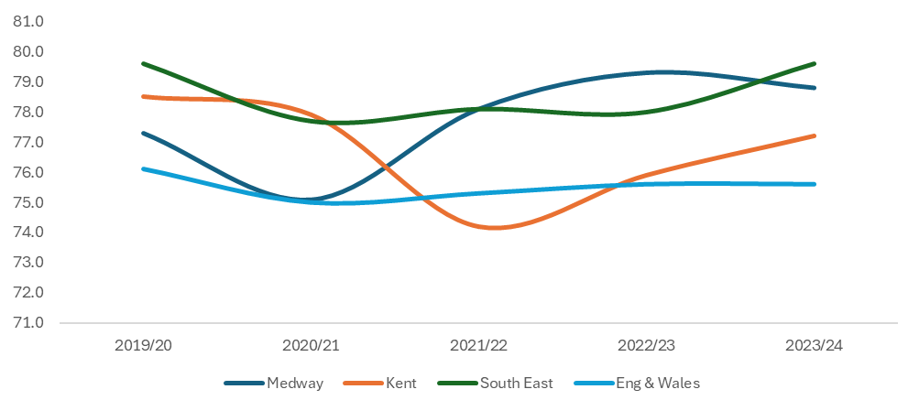

Source: Annual Population Survey, ONS. Available via NOMISweb.

Employment by industry
Medway’s most significant industry sectors for employment are health, education, business administration then retail, with these sectors accounting for proportionally more employment than nationally. As smaller sectors, locally the construction industry and transport & storage also employ significantly more proportionally than nationally.

Conversely Information & communication and Professional, scientific & technical sectors are notably proportionately smaller in Medway than nationally.

Chart: Employment by industry (%) 2022
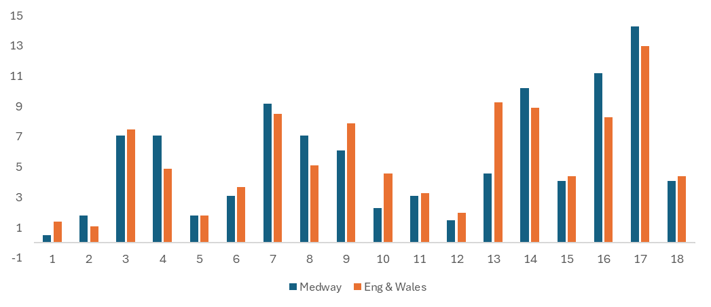
Table: Employment by industry – Medway Employment (job count) and percent England & Wales
 | Medway  Nos | Medway  Percent | Eng & Wales  Percent
Agriculture, forestry & fishing | 500 | 0.5 | 1.4
Mining, quarrying & utilities | 1,750 | 1.8 | 1.1
Manufacturing | 7,000 | 7.1 | 7.5
Construction | 7,000 | 7.1 | 4.9
Motor trades | 1,750 | 1.8 | 1.8
Wholesale | 3,000 | 3.1 | 3.7
Retail | 9,000 | 9.2 | 8.5
Transport & storage (inc postal) | 7,000 | 7.1 | 5.1
Accommodation & food services | 6,000 | 6.1 | 7.9
Information & communication | 2,250 | 2.3 | 4.6
Financial & insurance | 3,000 | 3.1 | 3.3
Property | 1,500 | 1.5 | 2.0
Professional, scientific & technical | 4,500 | 4.6 | 9.3
Business administration & support services | 10,000 | 10.2 | 8.9
Public administration & defence | 4,000 | 4.1 | 4.4
Education | 11,000 | 11.2 | 8.3
Health | 15,000 | 14.3 | 13
Arts, entertainment, recreation & services | 4,000 | 4.1 | 4.4
Total | 98,250 | - | -

Source: Business Register and Employment Survey: open access. ONS Crown Copyright Reserved 2024.

Income and employment deprivation
The Indices of Deprivation (IoD) are a unique measure of relative deprivation at a small local area level (Lower-layer Super Output Areas) across England. The latest set of indices were published in 2019, with the next release expected late 2025.

Medway ranks 103rd most deprived local authority for income deprivation. In the 2019 IoD, 13.4% of the Medway population were estimated to be experiencing income related issues. This was down on the IoD 2015, when 15.3% of the population of Medway were estimated to be income deprived.
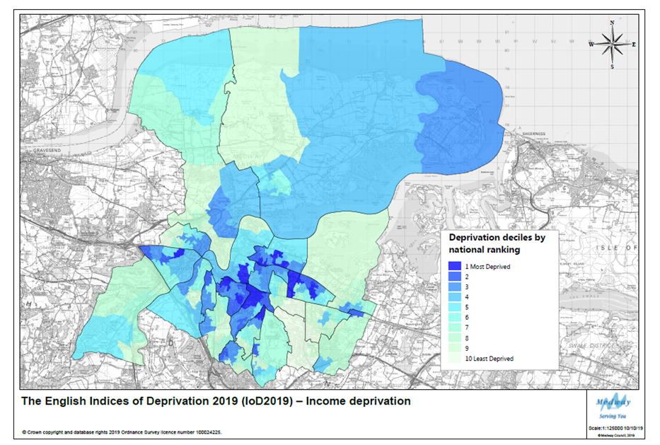
Low income is closely linked to issues of employment deprivation. Medway is the 98th most deprived local authority in England for employment, with 10.4% of the population experiencing employment related issues. Despite a relatively better employment ranking in 2015, at 107th most deprived, a higher proportion of the Medway population experienced employment related issues at 12.3%.
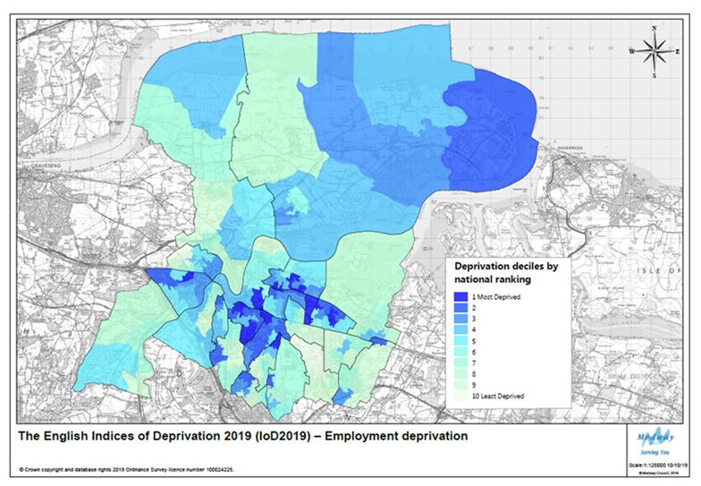
More information on the IoD can be found in the Population, Health and Communities and Infrastructure (Education) sections of this report.

Fuel Poverty

Living in fuel poverty is defined as being on a lower income and living in a home which cannot be kept warm at reasonable cost.

Fuel poverty in England is measured using the Low Income High Costs (LIHC) indicator, which considers a household to be fuel poor if:

• they have required fuel costs that are above average (the national median level); and
• were they to spend that amount, they would be left with a residual income below the poverty line.

Percentage of households living in fuel poverty 2018-2022

 | 2018 | 2019 | 2020 | 2021 | 2022
Medway | 9.0 | 8.9 | 10.3 | 9.5 | 11.5
Kent | 8.9 | 8.5 | 9.8 | 9.7 | 11.4
South East | 7.9 | 7.5 | 8.6 | 8.4 | 9.7
England | 10.2 | 13.4 | 13.2 | 13.1 | 13.1

In 2022 the percentage of houses living in fuel poverty in Medway increased to the highest in the last 5 years at 11.5%. This has happened nationally, regionally and in Kent, although England has remained the same as the year before at 13.1%.

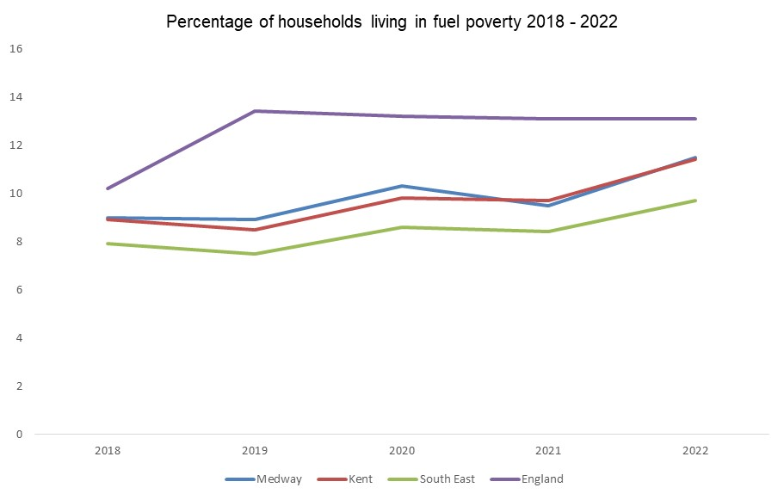

Out of the twelve Kent Authorities, six are worse than Medway’s 11.5%, these being Swale at 11.9%, Canterbury and Gravesham at 12%, Folkestone and Hythe at 13.6%, Dover at 13.7% and Thanet at 15.8%. The authority in Kent with the lowest percentage of fuel poverty is Tonbridge and Malling at 8.6% although like many authorities elsewhere, this has still risen from the previous year.

Source: https://www.gov.uk/government/statistics/sub-regional-fuel-poverty-data-2024-2022-data

The River Medway - Port cargo traffic

Medway built up around the river and its estuary, and its history and industries reflect these links. Although some traditional industries have declined as part of structural changes, there are still a number of marine based businesses active in Medway.

The docks and wharves around Medway support local businesses and provide a strategic role for the movement of goods and materials. This includes the importation of aggregates that support the construction industry. (More information on aggregates importation is available at the end of Volume 2 of the AMR).

London Thamesport on the Isle of Grain can handle a variety of deep and shallow-drafted vessels; other ports in Medway include the Scotline Terminal on the Medway City Estate and the National Grid's Liquefied Natural Gas Importation terminal at Grain.

Data is published for Medway Ports that include Chatham Docks and the port of Sheerness, both managed by Peel Ports. Medway Ports remained 11th out of the top 30 UK ports in 2023 representing 3.2% of all cargo handled in the UK (up from 3% in 2022). The reports do not provide separate information for Chatham.

Medway Ports cargo tonnage increased in 2023 to the highest seen in the past 5 years; however all traffic in England and Wales has fallen to the lowest level seen in the past 5 years. The majority (94%) of cargo traffic transported via Medway Ports is inward, although the outward cargo remains at a high level but slightly lower than the past two years. The majority of cargo imported to Medway is liquid/dry bulk and the majority of cargo exported from Medway is other general cargo which includes forestry products, iron and steel products and containers under 20 feet.

Table: Medway Ports traffic cargo – tonnage (000’s)

 | 2019 | 2020 | 2021 | 2022 | 2023
All traffic | 13,141 | 9,694 | 9,879 | 13,373 | 13,600
Inward | 12,476 | 9,102 | 8,887 | 12,466 | 12,740
Outward | 665 | 592 | 992 | 907 | 860

Table: All Major UK ports traffic cargo – tonnage (000’s)

 | 2019 | 2020 | 2021 | 2022 | 2023
All traffic | 471,739 | 428,994 | 435,386 | 449,597 | 425,859

Table: Medway Ports – Ship Arrivals – all cargo vessels

 | 2019 | 2020 | 2021 | 2022 | 2023
Arrivals | 1,735 | 1,492 | 1,510 | 1,623 | 1,700

Table: Bulk type Medway Ports – 2023

 | Tonnage (000’s)
Liquefied gas | 3,609
Oil products | 2,579
Other liquid bulk products | 52
LIQUID BULK TOTAL | 6,240
Ores | 100
Agricultural Products | 61
Other dry bulk | 3,947
DRY BULK TOTAL | 4,108
Forestry products | 1,790
Iron and steel products | 147
General cargo and containers <20’ | 469
OTHER GENERAL CARGO | 2,407
CONTAINERS TOTAL | 540
ROLL ON/ROLL OFF (self-propelled) Import/export of motor vehicles TOTAL | 303
ROLL ON/ROLL OFF (non self-propelled) TOTAL | 0
TOTAL TRAFFIC | 13,600

In 2023, liquid bulk was the largest cargo type handled by Medway Ports at 6,240,000 tonnes. Liquid bulk includes liquefied gas and oil. Medway Ports has been ranked as a leading facility in the UK for handling forestry products since 2014, with nearly 1,790,000 tonnes processed in 2023, the highest tonnage of forestry products processed in the UK followed by London Ports at 860,000 tonnes.

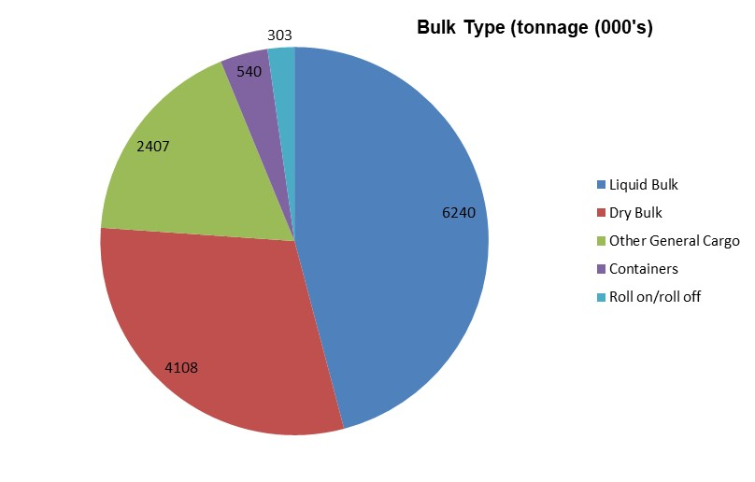

Source: DfT Port Freight statistics, tables Port 0303 (top 30), Port 0602 (arrivals) and Port0400 (bulk type tonnage)
Further information available at:
https://www.gov.uk/government/statistics/port-freight-annual-statistics-2023

Retail and Town Centres

Medway Council seeks to maintain and enhance the vitality and viability of its network of urban and rural centres and support the delivery of appropriate comparison and convenience retail, office, leisure, community, entertainment and cultural facilities. In line with structural changes in retail, the town centres in Medway have faced a number of challenges in recent years, including the rise in online shopping, the Covid pandemic, and the rising costs of living. This has challenged the role of town centres which means they need a refocus, potentially including more community uses and uses that will bring people together – getting back to the root function of it being a place to meet. The emerging Local Plan and our Regeneration Strategy, Medway 2035, promote strategies and policies to secure a vibrant and strong role for Medway’s centres in coming years, recognising the restructuring of retail.

None of the settlements in Medway are regional shopping destinations. The retail and leisure sector is overshadowed somewhat by London and to a lesser extent Maidstone. Additionally, the Bluewater Shopping Centre is a major shopping destination. Beyond the high streets and Hempstead Valley shopping centre, there are several notable features:

- The Dockside Outlet Shopping Centre provides a discount outlet, with a wider leisure offering.
- Gillingham Business Park has several trade counters and larger format retail.
- Horsted and Strood Retail Parks have a range of retail warehouses and stores.
- The new M2 City Link trade/retail unit park is now open with a range of businesses
- The towns are busy with a broad range of local shops and services

Through funding received, Medway Council has prepared a Chatham Design Code and a Supplementary Planning Document (SPD) for the Star Hill to Sun Pier Development Framework High Street Heritage Action Zone, which will play a key role in creating thriving, sustainable environments.

The planning use classes were updated on 1st September 2020. Classes A1/2/3 now fall within new use classes E(a,b,c) and A4/5 are now defined as Sui Generis. Class D1 was split out and replaced by the new classes E(e-f) and F1. Class D2 was split out and replaced by the new classes E(d) and F2(c-d) as well as several newly defined Sui Generis classes. For the purpose of monitoring this year 2023/24, we have continued to use the former use classes to record and present the data.
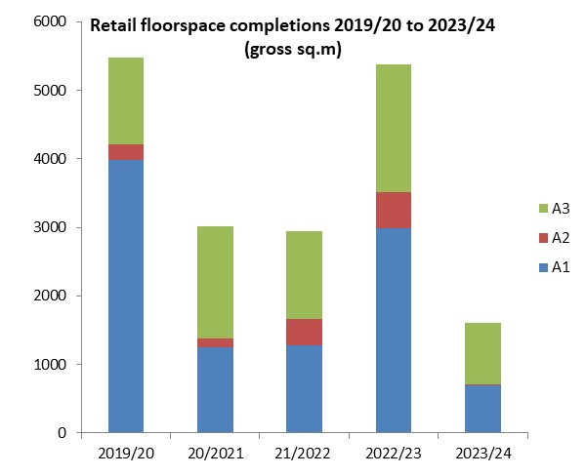

The majority of gross gains in the Town Centres this year were café/restaurants in Strood and Rainham High Streets. Gross gains in town centre floorspace were also made in retail shops, financial/professional services and hot food take aways.

Town Centre (TC) and Non-Town Centre GROSS retail floor space completions 19/20 - 23/24

 | 2019/20 | 2020/21 | 2021/22 | 2022/23 | 2023/24
A1 TC | 235 | 817 | 0 | 88 | 75
A1 Non TC | 3,745 | 436 | 1,282 | 2,902 | 620
A1 Total | 3,980 | 1,253 | 1,282 | 2,990 | 695
A2 TC | 54 | 37 | 106 | 158 | 14
A2 Non TC | 182 | 85 | 273 | 362 | 0
A2 Total | 236 | 122 | 379 | 520 | 14
A3 TC | 550 | 1,163 | 369 | 133 | 472
A3 Non TC | 717 | 471 | 917 | 1,735 | 432
A3 Total | 1,267 | 1,634 | 1,286 | 1,868 | 904
A4 TC | 448 | 147 | 54 | 19 | 0
A4 Non TC | 0 | 401 | 165 | 479 | 69
A4 Total | 448 | 548 | 219 | 498 | 69
A5 TC | 0 | 88 | 203 | 202 | 180
A5 Non TC | 451 | 139 | 115 | 692 | 329
A5 Total | 451 | 227 | 318 | 894 | 509
A1-A5 TC | 1,287 | 2,252 | 732 | 600 | 741
A1-A5 Non TC | 5,095 | 1,532 | 2,752 | 6,170 | 1,450
A1-A5 Total | 6,382 | 3,784 | 3,484 | 6,770 | 2,191

Net completions in town centres

There were gross increases seen in new retail floor space provision of shops, financial/professional services, café/restaurants, hot food take aways and non residential institutions in the town centres, however overall there were net losses in shops, financial/professional services and pubs. The majority of losses were swapping to other town centre uses such as nail salons or restaurants, however just under half of them was to residential use, providing 20 flats and a 13 bed House of Multiple Occupation.

Town centre development – 2023/24
Use | Losses  (sq.m) | Gains  (sq.m) | Net change  (sq.m) | Total development in town and non-town centres Gross (sq.m) | Proportion of gains in town centres (gross) out of total
A1 | -5,271 | 75 | -5,196 | 695 | 11%
A2 | -397 | 14 | -383 | 14 | 100%
A3 | -317 | 472 | 155 | 904 | 52%
A4 | -233 | 0 | -233 | 69 | 0%
A5 | 0 | 180 | 180 | 509 | 35%
D1 | -301 | 121 | -180 | 1,432 | 8%
D2 | -110 | 0 | -110 | 1,576 | 0%
Total | -6,629 | 862 | -5,767 | 5,199 | 17%

In the last few years there has been a steady net loss of drinking establishments/public houses in Medway, although this seems to have tailed off in more recent years. There was a loss of 12 establishments in 2017/18, with all but one of these being lost to residential use. A year later in 2018/19 a further five pubs went, of which only one remained in retail use. In 2019/20 a further two pubs were lost, one to a mixed-use development retaining some retail use (A1/A3) as well as residential; the other pub was lost to residential entirely. However, in 2020/21, although Medway saw the loss of Past and Present micropub to a pasta take-away and The Good Intent pub in Rochester to residential use, there was actually a net gain in A4 use with the completion of 3 new drinking establishments. In 2021/22 although pub floorspace was lost, the pub itself (The Dead Pigeon in High Street Rochester) was not lost, the floorspace was just adjusted to include a hot food take away element to the business. 2022/23 saw the loss of upper floors of two public houses to residential use however the commercial use was retained on the ground floor. A brand new micropub in Rochester High Street ‘Wolfe and Castle’ was opened providing craft beers and Kentish cider. This year 2023/34 saw the loss of just one public house, however that was to restaurant use with the opening of new eatery Punjabi Dhaba.

Non Town Centre Activity

83% of all gross retail floorspace (A1-A5/D1/D2) was completed outside town centres, including locations at St Mary’s Island, Lordswood, Cuxton, Elm Court, Cooling, Hoo and Hempstead Valley Shopping Centre. Over 1,500sq.m (gross) of floorspace was gained at Snodhurst Bottom with the conversion of the former gym to City of David Gospel Church.

Natural and Built Environment

Greenspace regeneration projects

Development of Green Spaces
Working in partnership the aim is to protect and sustain the existing open spaces and create new and improved open spaces by:

- making the best use of Medway’s valued open and green spaces
- identifying how we can improve our existing parks and open spaces. There are currently 148 urban parks and 1,900 hectares of open spaces in Medway.
- developing new partnerships and secure funding to make improvements in the future
- encouraging more community involvement
- celebrating our open and green spaces

Projects in 2023/24 included:

- Play areas improvements
- 8 Green Flag Awards
- Visitor improvements at various sites.
- Public consultation at Town Hall Gardens
- Planning permission for new community parkland at Deangate
- Continuing Medway’s Open Space Study

In 2023-24 developer contributions have funded various projects across Medway. These include play enhancements at the Strand (Gillingham), Beechings Way (Twydall), Capstone Farm Country Park as well as Luton Millennium Green (also part funded by the Levelling Up Parks Fund).

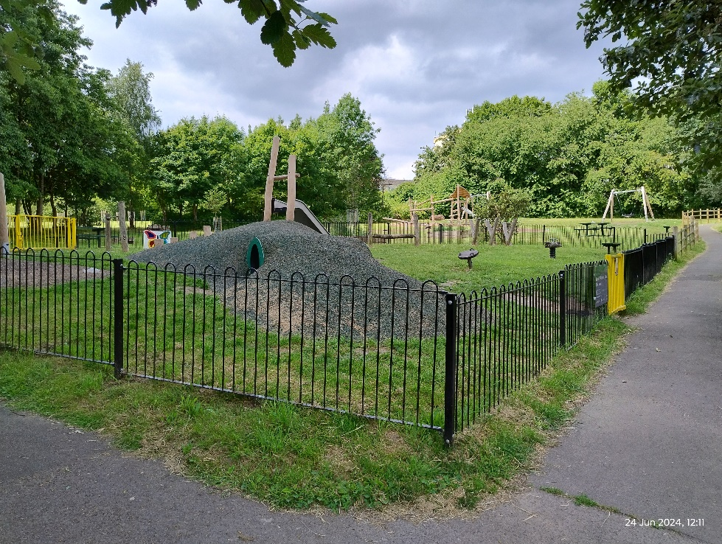
Luton Millenium Green play area enhancements

Footpath improvements took place at Great Lines Heritage Park (pictured below), various improvements at Copperfields Open Space (Rochester), car park improvements at Capstone Farm Country Park and ecological enhancements to Berengrave Nature Reserve.

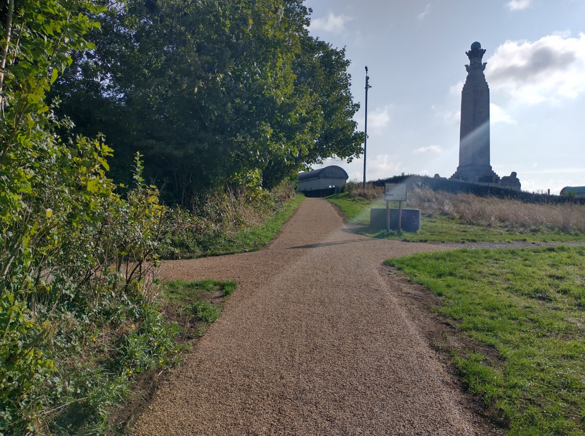
Footpaths at Great Lines Heritage Park

Public consultation took place in late 2023 at Town Hall Gardens to improve this historic garden in the heart of Chatham. Works are due to take place here from 2024 to improve the play area and access.

Deangate Community Parkland received planning permission and plans are underway to progress works on site. More information can be found here:

https://www.medway.gov.uk/info/200369/future_hoo/1788/deangate_community_parklands

Medway’s Open Space Study
Consultants continued their assessment on Medway’s public open spaces. Public open space provides opportunities for sport and recreation, socialising, tourism and wildlife. They make an important contribution to the health and well-being of communities, ecosystems and economies. Up to date information is needed on Medway’s open spaces. This is to ensure that there is suitable provision of accessible, high quality open spaces that meet the needs and aspirations of local communities, local people and people who work in or visit the area. The final study will be used as supporting information for the emerging Local Plan.

Green Flag Awards
The Green Flag Award scheme recognises and rewards well-managed parks and green spaces, setting the benchmark standard for the management of recreational outdoor spaces across the United Kingdom and around the world. The winners of the Green Flag award are announced each year.

Medway retained 8 awards for its Green Flag sites including Broomhill Park, Capstone Farm Country Park, Gillingham Park, Great Lines Heritage Park, Hillyfields Community Park, the Vines, Ranscombe Farm Reserve (in partnership with Plantlife) and Riverside Country Park. Both these schemes are managed by Keep Britain Tidy and are national awards.

Table: Green flag sites – year awarded

July 2019 | 7
July 2020 | 8
July 2021 | 8
July 2022 | 8
July 2023 | 8

Medway’s thriving towns are surrounded by beautiful parks and countryside, which Medway Council works hard to maintain so people can enjoy the area’s open spaces throughout the year. The Council has invested in improving footpaths and cycle routes across Medway, giving people more access to enjoy the impressive green spaces. Recognising beautifully maintained parks the Green Flag international award, now into its third decade, is a sign to the public that the space boasts the highest possible environmental standards, is exceptionally well maintained and has excellent visitor facilities.

http://www.greenflagaward.org.uk/

Making Space for Nature
Making Space for Nature in Kent and Medway is working with partners and stakeholders to collaboratively establish shared priorities for the delivery of nature recovery and environmental improvements, in order to create a network of wildlife-rich places across the county. This local nature recovery strategy will be one of 48 – together these will cover the whole of England, with no gaps or overlaps, to deliver the government’s commitment to ending the decline of nature and supporting its recovery.

More details on this can be found on the following link:

https://www.makingspacefornaturekent.org.uk/

Areas of Outstanding Natural Beauty rebranding
On 22 November 2023, these areas were rebranded as National Landscapes in a bid to bring them in line with the importance our National Parks enjoy.

Kent Downs Area of Outstanding Natural Beauty is now renamed as Kent Downs National Landscape.

Air Quality

Medway has declared four Air Quality Management Areas (AQMAs) - Central Medway, High Street Rainham, Pier Road Gillingham and Four Elms Hill Chattenden; all for exceedances of the annual mean objective for nitrogen dioxide.

Medway Council has developed two Air Quality Action Plans (AQAPs) covering all four AQMAs and these include a wide range of measures to improve air quality in Medway. In January 2018, Medway Council developed the Air Quality Communications Strategy; this plan details a series of recommended communications activities and is designed to support the Medway AQAP by raising awareness and influencing behavioural change.

Medway Council was awarded more than £127,000 in 2022 through the DEFRA Air Quality Grant programme to deliver two projects:

- The use of signage to reduce the incidence of idling in the Rainham AQMA
- A taxi and private hire Ultra Low Emission Vehicle (ULEV) feasibility study

Medway was awarded a further DEFRA air quality grant in 2023 of more than £279,000 for a project focussed on the Four Elms Hill AQMA. This project, which is expected to last for three years, has several parts:

- Installing a network of 15 sensors in/around the AQMA
- A vehicle emissions remote sensing campaign
- Air quality modelling and assessment of scenarios relating to traffic speed

As part of the project the council will also develop and deliver comprehensive engagement and a behavioural programme which include the establishment of a local action group. Sensor data and project related information will be hosted on the KentAir website (www.kentair.org.uk)

Many challenges still lie ahead for Medway Council in terms of making a positive contribution to improving air quality. Road transport is the dominant source of pollution within Medway’s AQMAs, and reducing road traffic emissions is, therefore, the key air quality priority, especially with the AQMAs. Another significant challenge is accommodating the large demand for development in Medway. This is likely to put existing areas of poor air quality under additional pressure and could negate the actions that the Council is implementing to improve air quality. For this reason, continuing the implementation of the Medway Air Quality Planning Guidance is a high priority, prior to the adoption of a new Local Plan of Medway.

The most recently published Annual Status Report was for 2022, which contains further information on monitoring results, trends and action plan progress is available here:

https://kentair.org.uk/report/medway-council-annual-status-report-2022

Medway Council’s priorities for the coming year are to continue with the work on the measures outlined in the AQAPs. Progress on measures included within the Four Elms Hill AQAP will be reported in next year’s Annual Status Report.

Climate Change

Medway Council declared a climate emergency in April 2019 and passed a motion committing to:

- reduce its carbon footprint

- provide the local community with a clean, green future

- be a place people want to work and live, which has a sustainable future

- establish a clear action plan for Medway to deal with climate change, setting out an achievable and clear timeline.

This declaration fits into the Council Plan priority of making Medway a place to be proud of., the main outcome being a 'clean and green environment'.

In June 2023 the council ran three special events in partnership with the University of Greenwich Faculty of Engineering and Science. The events focused on improving properties for sustainable living.

For more information, please see the following link:

https://www.medway.gov.uk/climatechange

Details on activities and measures in implementing the action plan are set out in the council’s Climate Change progress reports:

https://www.medway.gov.uk/info/200517/climate_change_action_plan_summary/1651/climate_change_action_plan_progress

Ultra Low Emission Vehicle Licensing
ULEV refers to vehicles that produce less than 75 grams of CO² per km from the tail pipe. Although it can include other types of fuels, typically the majority of these vehicles are battery electric, plug-in hybrid electric and fuel cell electric vehicles. In 2021 over 30 electric vehicle public charging points were installed in three council owned car parks in Medway following a grant of funding from the Office for Zero Emission Vehicles. The council has an open survey to assess the demand for electric vehicle charging points across Medway, more information can be found here:

https://www.medway.gov.uk/info/200161/travel/1130/electric_vehicle_charging_points

With regards to new residential planning applications, every new dwelling house is now required to have an Electric Vehicle Charging Point and with shared parking (for flats etc…) there should be one rapid Electric Vehicle Charge Point for every 10 units.

The Department for Transport publishes statistics on the number of vehicles licensed every quarter. The following table shows the number of Ultra Low Emission Vehicles (ULEVs) licensed in Medway since 2019/20 compared with Kent, South East and the UK. In the past 5 years the number of ULEVs licensed in Medway has increased by 80%, which is a faster pace than Kent (31%), but much slower than the South East (285%) and the UK (227%). Compared to last year 2022/23 only half the number of ULEVs were licensed in Medway this year 2023/24.

Table: Number of ULEVs licenced

 | 2019/20 | 2020/21 | 2021/22 | 2022/23 | 2023/24 | % increase since 2019/20
Medway | 2,527 | 3,764 | 6,002 | 9,188 | 4,551 | 80%
Kent | 17,581 | 25,377 | 42,247 | 65,228 | 23,142 | 31%
South East | 211,331 | 342,750 | 599,247 | 930,753 | 813,144 | 285%
UK | 1,034,713 | 1,605,847 | 2,779,174 | 4,211,088 | 3,378,705 | 227%

Source: Vehicle Licensing statistics table veh0132
https://www.gov.uk/government/collections/vehicles-statistics#vehicle-licensing-statistics

Built Environment - Heritage at Risk

Historic England compiles an annual Heritage at Risk register which identifies Grade I and Grade II* Listed Buildings, Scheduled Monuments and Conservation Areas which are at risk from neglect:

https://historicengland.org.uk/advice/heritage-at-risk/

There are a number of conditions for each type of designation to be included onto the Register:

- Vacant Listed Buildings: In very bad, poor or fair condition

- Occupied Listed Buildings: In very bad or poor condition

- Scheduled Monuments: Depends on their condition, vulnerability, trend of their condition and their likely future vulnerability

- Conservation Areas: Those that are deteriorating or in very bad condition and are not expected to change significantly in the next 3 years.

Currently Medway has 16 entries on the Heritage at Risk register which has increased from 15 last year with the addition of St John the Divine Church. The 16 entries include 8 Scheduled Monuments, 4 Listed Buildings and 4 Conservation Areas. This number of entries is significantly higher than most of the other Kent local authorities, with a number of the entries comprising more than one building or site per entry.

After a peak of 18 entries on the register in 2015, the number has gradually reduced through work with the owners to undertake repairs and improvements.

The newly added St John the Divine Church is currently having works carried out to restore the building in partnership with the Diocese of Rochester to provide facilities for the local community to use for events and classes, flexible meeting spaces for businesses, a café area and continue as a place of worship. A phased opening is anticipated in Spring 2025 with the subsequent removal of the site from the heritage at risk register.

The National Heritage List for England (NHLE)

The most recent national data available from Historic England indicates that Medway has 733 entries in the national list of buildings of special architectural or historic importance:

- 49 Grade I Listed Buildings
- 78 Grade II* Listed Buildings
- 526 Grade II Listed Buildings
- 77 Scheduled Monuments
- 3 Historic Parks and Gardens

Through collaborative work with Historic England and other stakeholders on the Chatham Intra High Street Heritage Action Zone new sites gave been added to this list in recent years. More information is available about the project is available here:
https://www.medway.gov.uk/info/200177/regeneration/1218/heritage_action_zone
https://historicengland.org.uk/whats-new/in-your-area/south-east/chatham-intra-heritage/
For more information on the National Heritage List for England see:
https://historicengland.org.uk/listing/

Health and Communities

Life expectancy

Life expectancy represents the average number of years a person would expect to live based on contemporary mortality rates.

Lifestyle issues including smoking, obesity and alcohol are key contributors to high mortality rates resulting from the major killers in Medway, particularly, circulatory disease, cancer and respiratory disease. These are the focus of many public health campaigns in Medway.

In both Medway and England for the latest period 2020-2022, life expectancy has fallen marginally. Medway is consistently lower than the average age for England.

Table: Medway life expectancy (years)

 | 2015-17 | 2016-18 | 2017-19 | 2018-2020 | 2020-2022
Male | 78.8 | 79.0 | 79.1 | 78.3 | 77.6
Female | 82.5 | 82.6 | 82.6 | 82.4 | 81.9

https://fingertips.phe.org.uk/profile/health-profiles

Table: England life expectancy (years)

 | 2015-17 | 2016-18 | 2017-19 | 2018-2020 | 2020-2022
Male | 79.6 | 79.6 | 79.8 | 79.4 | 78.9
Female | 83.1 | 83.2 | 83.4 | 83.1 | 82.8

Public Health England
https://fingertips.phe.org.uk/search/life%20expectancy

Ward Data

Life expectancy at birth is calculated from deaths from all causes and mid-year population estimates (MYEs) for each respective time period.

The rebasing of MYEs were postponed by the Office for National Statistics due to currently having to manage operational dependencies as part of the process to create and deliver outputs, with an aim to finalise the publication date as soon as possible. Therefore we have been unable to report on ward level data in this year’s AMR. It is anticipated that they can be published in the next AMR 2024/25.

Mortality

The death rate in Medway as measured by the Age-Standardised Mortality Ratio (ASMR – see glossary for definition) stands above the Kent, regional and national levels. Rates in all areas apart from Medway have decreased since last year. Medway increased from 1022.4 deaths per 100,000 to 1042.4. Although all areas have reduced since the levels seen in 2020 and 2021, none have reduced to the pre-pandemic levels seen in 2019.

In 2023 in England and Wales ischaemic heart diseases were the leading cause of deaths at 10%, followed by dementia (7%) then cerebrovascular diseases at 5%. Covid-19 caused 2% of deaths in 2023.

Table: Age-Standardised mortality rates (per 100,000 population)

 | 2019 | 2020 | 2021 | 2022 | 2023
Medway | 1,003.3 | 1,148.0 | 1,148.2 | 1,022.4 | 1,042.4
Kent | 928.1 | 1,050.1 | 1,001.4 | 960.0 | 942.7
South East | 856.9 | 956.3 | 931.8 | 889.6 | 885.7
England/Wales | 937.3 | 1,065.5 | 1,014.2 | 978.7 | 971.6

Table: Medway – Age-Standardised mortality rate by gender (per 100,000 population)

 | 2019 | 2020 | 2021 | 2022 | 2023
Male | 1,205.3 | 1,398.7 | 1,378.1 | 1,206.6 | 1,227.7
Female | 856.1 | 945.8 | 974.4 | 880.5 | 891.5

Source table 2:
https://www.ons.gov.uk/peoplepopulationandcommunity/birthsdeathsandmarriages/deaths/datasets/deathsregisteredinenglandandwalesseriesdrreferencetables

For more detailed information on health in Medway go to:
https://www.medway.gov.uk/jsna

Hot food takeaway guidance
In order to promote a healthier Medway, in February 2014 Medway Council produced a Hot Food Takeaway Guidance Note for use in considering planning applications:

https://www.medway.gov.uk/downloads/file/2333/hot_food_takeaways_in_medway_-_a_guidance_note

The purpose of this guidance was to manage the potential proliferation of hot food takeaways, to help reduce obesity particularly among children, create a healthier environment, more vibrancy in town centres and to assist the creation of a more diverse offer in retail areas. The guidance supports a 400m buffer around schools to manage the siting of takeaways and the restriction on hours of operation. It is part of a wider package of measures to improve health.

Childhood obesity in Medway
Childhood obesity in Medway is a significant challenge and can lead to serious health issues for the local population. Recent trends are similar to the England average. The rate has fallen from a high of 31.5% in the past 5 years in 2020/21 to 22.4% in 2022/23 of Medway reception-age children were overweight or obese, of whom 10% were obese, which is similar to the England average. There are significant inequalities within Medway, with Year 6 obesity levels in poorer wards such as Chatham Central and Gillingham North more than double the levels in less deprived wards such as Hempstead and Wigmore. Among Year 6 children, 37.3% were overweight or obese, of whom 23.1% were obese, again similar to the England average (National Child Measurement Programme). This has also fallen from a high of 44.2% in 2020/21 in Medway.
Adult overweight and obesity prevalence in Medway
Over the past four decades, there has been a substantial rise in the percentage of adults in England living with obesity. 68.1% of adults were overweight or obese in Medway 2022/23 which is similar to the England average

Table: Percentage classified as overweight or obese
 | 2018/19 | 2019/20 | 2020/21 | 2021/22 | 2022/23
Medway Reception  (age 4/5) | 24.0 | 25.5 | 31.5 | 23.7 | 22.4
South East Reception  (age 4/5) | 21.2 | 21.9 | 25.7 | 20.3 | 20.1
England Reception  (age 4/5) | 22.6 | 23.0 | 27.7 | 22.3 | 21.3
Medway Year 6  (age 10/11) | 36.2 | 36.9 | 44.2 | 41.3 | 37.3
South East Year 6  (age 10/11) | 30.3 | 31.7 | 35.9 | 34.0 | 33.0
England Year 6  (age 10/11) | 34.3 | 35.2 | 40.9 | 37.8 | 36.6
Medway Adult 18+ | 69.6 | 71.6 | 69.4 | 67.2 | 68.1
South East Adult 18+ | 60.9 | 61.5 | 62.4 | 62.7 | 62.8
England Adult 18+ | 62.3 | 62.8 | 63.5 | 63.8 | 64.0

Sources:
https://fingertips.phe.org.uk/search/obesity
https://fingertips.phe.org.uk/search/obesity#page/1/gid/1/pat/6/par/E12000008/ati/501/iid/20601/age/200/sex/4/cat/-1/ctp/-1/yrr/1/cid/4/tbm/1

Medway Council has set out ambitions to improve the health and associated life chances of local people. The Hot Food Takeaway guidance sits within a wider programme promoting health and well-being. The aim is to reduce the concentration and clustering of hot food takeaways in core retail areas/town centres and reduce the prevalence of takeaways to prevent proliferation. The proposals apply only to new hot food takeaways seeking planning permission.

Use of guidance:

The planning guidance note has been used in 1 application during 2023/2024.

The application was refused.

Table: Application theme 2019/20 – 2023/24

 | New takeaway | Change of use | To extend hours | Other | Total number of applications
2019-20 | 0 | 1 | 0 | 0 | 1
2020-21 | 0 | 3 | 0 | 0 | 3
2021-22 | 0 | 3 | 0 | 0 | 3
2022-23 | 0 | 3 | 0 | 0 | 3
2023-24 | 0 | 1 | 0 | 0 | 1

Table: Application outcome – 2019/20 - 2023/24

 | Approved | Approved with conditions | Refused | Total number of applications
2019-20 | 0 | 0 | 1 | 1
2020-21 | 0 | 1 | 2 | 3
2021-22 | 0 | 0 | 3 | 3
2022-23 | 0 | 1 | 2 | 3
2023-24 | 0 | 0 | 1 | 1

A Better Medway

This supports the local population to live a healthier lifestyle. Current programmes include:
- Get Active – health walks, Nordic Walking, cycling groups and Man vs Fat – a football league for men who have a body mass index (BMI) that is 27.5 or higher
- Quit smoking – services to assist and support smokers with specialist advice and pharmacotherapy prescriptions
- Healthy Way - healthy way is a free programme that supports residents to adopt a healthier lifestyle through diet, stress management and behaviour change
- Oviva Digital Weight management – supporting overweight adults to lose weight
- Healthy Mind – supporting mental health and promoting the 5 ways to wellbeing
- Healthy eating – range of family and adult cookery courses and workshops
- Healthy child – breastfeeding, school programmes, early years support
- Suicide prevention (Ask. Listen. Stop suicide)
- Adult and young people substance misuse support - Treatment and Recovery Services and digital support
- NHS Health checks for 40-74 year olds
- Oral health campaigns and training
- Sexual health services – contraception, testing, advice and support
- Family weight management services – courses and programmes to help children and families achieve a healthy lifestyle (Tri for you and FitFix)
- Healthy Workplace – this programme helps businesses of all sizes become healthier places to work
- Medway Go – Holiday Activity Food programme for children in receipt of free school meals through holiday periods.

Further details on the programmes, information and support are available at:
https://www.medway.gov.uk/homepage/48/a_better_medway

To read The Director of Public Health for Medway’s Annual Report 2022-23 ‘Power of the crowd’ click on the link below:

https://www.medway.gov.uk/downloads/file/8795/annual_public_health_report_2022_to_2023_accessible_version

Health Deprivation
The Indices of Deprivation are a unique measure of relative deprivation at a small local area level (Lower-layer Super Output Areas) across England. The latest set of indices were published in 2019, with the next release expected late 2025.

Medway ranks in the 38 % most deprived local authorities nationally for health. Seven areas rank in the most deprived 10% nationally for health and 20 rank in the most deprived 20% nationally.

Health deprivation is measured as the risk of premature death and the impairment of quality of life through poor physical or mental health.

There has been a relative worsening in health deprivation, with Medway seeing an extra four areas in the most deprived 10% nationally and an extra eight areas in the most deprived 20% nationally. While the most severely affected areas for health deprivation are spread across a number of wards in Gillingham, Chatham and Rochester, Gillingham North stands out as having two areas in the most deprived 10% for health, while River stands out as having the most deprived area for health in Medway. Medway’s most deprived area – located in River Ward overall for multiple deprivation is ranked in the most deprived 1% of neighbourhoods for health nationally.

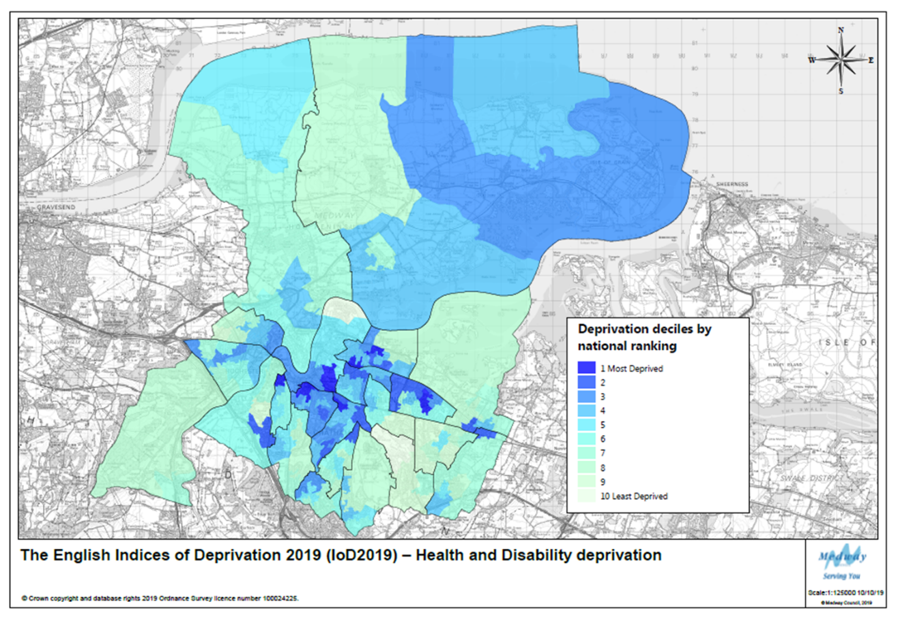

More information on the IoD can be found in the Population, Economy & Employment and Infrastructure (Education) sections of this report.

Infrastructure

Education

GCSE attainment scores

A new grading system was introduced in 2017; for further information see link below:

https://assets.publishing.service.gov.uk/government/uploads/system/uploads/attachment
_data/file/800507/GCSE_factsheet_for_parents__final_.pdf

A school's attainment 8 score is the average of all of its students' scores. Students do not have to take 8 subjects, but they score zero for any unfilled slots. For comparison the England and Medway scores are set out below. Both England and Medway have worsened slightly from pre-covid levels, with Medway performing slightly above the England average. It should be noted however that a different grading approach was used in 2022 to take account of the impact of the pandemic but returned to pre-pandemic grading in 2023 with grading protection in place to recognise the disruption that students have faced. This means that allowances were made where national performance was weaker than before the pandemic, part of a two year, two step plan to return to normal grading arrangements.

Table: Average attainment score 8 per pupil

 | 2019 | 2020 | 2021 | 2022 | 2023
Medway | 46.6 | * | * | 49.4 | 45.4
England | 44.7 | * | * | 48.9 | 44.6

* Due to the impact of the Covid pandemic, most exams and assessments did not take place in 2019/20. As a result of this, the government announced that it would not publish school or college level results data for 2020 or 2021.

Source:
https://www.compare-school-performance.service.gov.uk/download-data

Planning Applications for Schools

During the year a number of schools have submitted and had approved planning applications to improve and upgrade their buildings and facilities, these are set out in the table below.

As well as these schools listed, a number of others have ongoing schemes and have had amended plans and details approved to existing schemes. They include:

- Strood Academy
- Rochester Riverside
- Land off City Way Chatham
- The Howard School Rainham
- Fort Pitt Grammar School, Fort Pitt Hill, Chatham
- The Hundred of Hoo School, Main Road, Hoo St Werburgh
- Abbey Court School, Cliffe Road, Strood, Rochester
Application Number | Address | Works/Description
MC/22/1617 | Halling Primary School | Construction of a detached single storey nursery building to the front/side
MC/23/0889 | Wayfield Community Primary School | Construction of a single storey extension to provide three classrooms and an overspill car park
MC/23/2002 | The Victory Academy Chatham | Construction of a two storey detached x 4no. classroom SEN Unit, connecting corridor, outdoor playground and social area with entrance canopy. Construction of a single storey detached 6th Form centre with outdoor social area and associated landscaping
MC/23/2594  MC/23/0476  MC/23/1733 | Mid Kent College Campus Gillingham | Installation of air source heat pumps, thermal store, pump enclosure, battery storage and solar PV facades to front elevation of the three main building stairwells  Installation of boundary fencing and gates to various parts of the site  Installation of solar panels to three main roofs
MC/23/1289 | St Nicholas C/E Voluntary Controlled Infant School Strood | Construction of a new 2 storey teaching wing and single storey pupils toilet block, together with alterations to existing parking and landscaping.
MC/23/1058 | Bradfields School Wayfield Chatham | Proposed siting of 2no. temporary classrooms and ancillary accommodation
MC/23/2830 | The Hundred of Hoo Academy, Hoo St Werburgh | Two-storey flat roofed new-build teaching block at Hundred Hoo Academy with associated external works. The accommodation comprises 8 no. classrooms, a pupil break-out room, staff room and offices. The external works consist of extensions to the existing pedestrian path network, paved entrance area, outside breakout space and soft landscaping co-ordinated with the arboricultural and ecology reports.
MC/24/0156 | Holcombe Grammar School Chatham | Change of use of former caretaker's accommodation use Class (C3a) to office space use Class E(g)(i)
MC/24/0252 | Greenacre Academy Walderslade | Construction of a detached two-storey science block to the rear of Walderslade Girls School

Education, Skills and Training Deprivation

The Indices of Deprivation are a unique measure of relative deprivation at a small local area level (Lower-layer Super Output Areas) across England. The latest set of indices were published in 2019, with the next release expected late 2025.

Medway ranks in the 22% most deprived local authorities nationally for education, this is Medway’s second weakest theme after crime. Eighteen areas rank in the most deprived 10% nationally for education and forty-two rank in the most deprived 20% nationally.

Wards most severely affected by education deprivation are Luton & Wayfield, Strood South, Chatham Central, Gillingham North and Twydall.

Luton & Wayfield stands out as having five areas ranked in the most deprived 10% nationally, while Chatham Central contains the most educationally deprived area (LSOA 022B), which ranks in the 1% most deprived areas nationally.

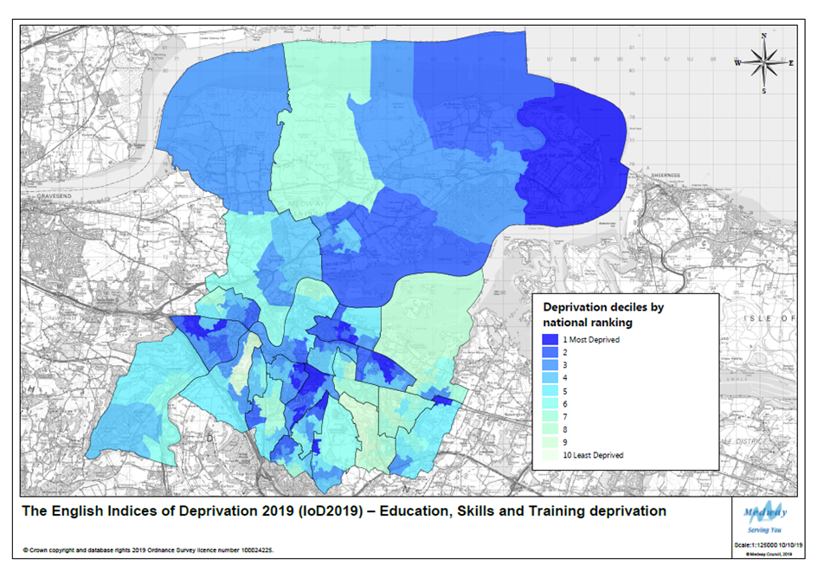

More information on the IoD can be found in the Population, Economy & Employment and Health & Communities sections of this report.

Infrastructure

Developer Contributions

The government requires all local authorities to publish an Infrastructure Funding Statement (IFS) on an annual basis. This covers information on developer contributions/obligations relating to Section 106 agreements.

The IFS will be published by the end of December 2024.

- All developer contributions received 01/04/2023 – 31/03/2024
- All expenditure of developer contributions during 01/04/2023 – 31/03/2024
- Information on Affordable Housing provision
- Information on future infrastructure provision

The IFS will be published on the Medway Council website Planning Policy pages:

https://www.medway.gov.uk/info/200149/planning_policy/597/local_development_scheme_and_monitoring/5

Transport

As a transport authority, Medway Council is responsible for the local highway network, public rights of way and other transport related infrastructure. This includes 840 km of adopted highway and 293 km of public rights of way, plus the Medway Tunnel.

Local Transport Plan

Medway’s third Local Transport Plan (LTP) provides the transport strategy for the period 2011 to 2026. The LTP contains five priorities, with key actions for the Council and partners under each priority:

1. Regeneration, economic competitiveness and growth
2. The natural environment
3. Connectivity
4. Equality of opportunity
5. Safety, security and public health

More information can be found here:

https://www.medway.gov.uk/info/200161/travel/545/transport_plans_and_policies/2

External Funding

As outlined within the Development and Regeneration section, Medway successfully secured funding for various local schemes. Updates on some of the key transport projects are set out below:

Medway Tunnel
Nearly £5m secured from the Department for Transport to replace and upgrade critical assets relating to the Medway Tunnel. These include new ventilation fans, crash barriers, a vehicle monitoring system and slip road improvements over the next five years. These works will be carried out over the next 5 years.

Emergency Active Travel Fund

Tranche 1: £242,500 in 2020/21
The Active Travel Fund (ATF) provides an opportunity for Medway to build upon the success of Medway’s Cycling Action Plan:

https://www.medway.gov.uk/downloads/file/1029/cycling_action_plan

The following improvements have been made to Medway’s cycle network as part of Tranche 1:
- New advanced stop line and segregation via wands of the advisory on-carriageway cycle lane on Dock Road junction with Khartoum Road.
- Wand segregation, resurfacing and widening of the two mandatory on-carriageway cycle Lanes on Dock Road between Wood Street and Western Avenue.
- Dropped kerb/tactile paving installations on strategic routes, 18 junction improvements in total.
- Installation of approximately 20 cycle storage hoops across various sites in Medway.

Tranche 2: £927,000 in 2021/22
Originally involved five schemes identified for additional walking and cycling measures, one of which includes the A228 Four Elms Hill; see below. Another potential scheme, providing an active travel link between Cuxton railway station and Medway Valley Park is also being considered for design; also below.

A228 Four Elms Hill:
This scheme comprises the resurfacing and widening of the existing shared cycle/pedestrian footway and junction accessibility/visibility improvements at Beacon Hill Lane. Construction commenced in August 2023 but was subject to some delay due to contractor availability and weather so the completion date was extended. To minimise the impact of the traffic management required to construct the scheme, the remaining junction accessibility/visibility improvements at Beacon Hill Lane including accompanying signage were undertaken during October 2023 half-term.

Cuxton - Medway Valley Park active travel scheme
Investigations on a suitable active travel connection between Cuxton & Medway Valley Park remain ongoing.

Tranche 4: £486k in 2023/24
A proforma bid, totalling £486,418, was approved by Active Travel England in March 2023, in line with the next round of ATF capital scheme funding (ATF4). This helped facilitate the introduction of a series of School Streets sites in Medway during the 2023/24 academic year and coincides with other active travel to school workstreams.
The School Streets Scheme initiative involves timed restriction and temporary closures of roads outside schools, preventing vehicular access by non-residents. This is intended to coincide with school drop-off and collection times and would effectively introduce a pedestrian and cycle zone during the applicable times, promoting safer routes to school by active modes of travel. Seven sites were introduced in Medway as part of the first tranche in March 2024, with a further nine locations being considered as part of the second phase later in the year, including ANPR enforcement of School-Keep-Clear restrictions. Further details, including updates, can be viewed here:

https://www.medway.gov.uk/schoolstreets

Capability Fund: £382k between 2021-23
In 2021-22, the Council was awarded £232,107 in revenue funding by the Department for Transport to support active travel workstreams in Medway. The Council was also successful in securing an additional £100,381 revenue allocation in December 2022 and a further £50,191 in September 2023. This will continue to fund capability building activities linked to the outputs required by Medway's emerging Local Cycling and Walking Infrastructure Plan (LCWIP), including mapping a desire network, early feasibility scheme design to the point of bidding for capital funds, public consultation and further evidence and data modelling, audits and counts to support the LCWIP outputs. It will also support behaviour change activities, including travel planning and engagement, communications and marketing materials and school street audits.

CAF workstream outputs to date have included:
- The development of Medway’s Local Cycling and Walking Infrastructure Plan (LCWIP). A public consultation took place on this between January and March 2024 with the completion anticipated summer 2024. There are now over 80 miles (130 km) of cycle routes in Medway, with many corridor schemes linking up with longer distance routes forming part of the National Cycle Network. The LCWIP will build upon the successes of Medway’s Cycling Action Plan, which provided an additional 8.5 miles (13.8km) of new cycle routes and improvements to 1.7 miles (2.8km) of existing cycle routes.
- The appointment of a Transport Initiatives Coordinator, to progress active travel initiatives in Medway in accordance with the CAF on a two-year fixed contract to be employed during 2024/25.
- Production of an asset register project, signage improvements and new resources linked to the Council’s Rights of Way Improvement Plan (ROWIP)
- Maintenance and upgrades to Medway’s 16 cycle counters, including quarterly performance monitoring.
- A national Modeshift subscription. Membership of Modeshift STARs continues and serves as an online platform for schools to develop their travel plans, with the support of Medway Council.
- Development of a new 'Think Smart, Park Safe' initiative, introduced to school communities in April 2023.
- A proposed pupil mode of travel data capture to help identify and target modal shift progress across Medway.
- Walk Once a Week (WOW) initiative – 15 Primary Schools continued to take part in the WOW (Walk Once a Week) initiative. Realising a gap in active travel initiatives for younger years (2-5 yrs), the council will collaborate with Living Streets to deliver Little Feet Elmer, a fun campaign to get children to walk from a young age.
- Walking and cycling campaign resources, active travel workplace engagement, volunteer led walks and cycle ride investment, including an Explore Medway digital route planning tool which can be found here:
https://explorekent.org/explore-medway/

Section 106 contributions linked to active travel accessibility improvements and safer routes to school.

Bikeability Course Delivery Funding, with claims made to The Bikeability Trust on a quarterly basis, based upon the number of children receiving training courses. During 2023/2024 Bikeability has allowed 657 children to take part in Level 1 and Level 2 training up until the end of March. This is 33% uplift from last year’s delivery levels, achieved through a combination of better resource planning and the introduction of a new Bikeability instructor. In response to a recent instructor’s retirement and Active Travel England’s targets to increase the level of pupils trained (min 50% of YR 6 pupils), the council will be looking to recruit an additional 1-2 instructors for the new academic year.

Estimated traffic flows for cars and all vehicle types

Table: Car and Taxi Traffic – Million miles

 | *2019 | *2020 | 2021 | 2022 | 2023 | % change 2022–2023
Medway | 693 | 552 | 598 | 649 | 662 | 2.0%
Kent | 7,239 | 5,496 | 6,068 | 6,719 | 6,937 | 3.2%
South East | 43,211 | 31,855 | 35,285 | 39,320 | 40,594 | 3.2%
England | 225,160 | 169,561 | 189,675 | 208,816 | 215,057 | 3.0%
* Estimates for the period since 2000 have been revised following the minor road review so will therefore be different to the figures published in previous AMRs. Figures in 2020, 2021 and 2022 are affected by the covid pandemic, so caution would be taken when interpreting this data and comparing with other time periods. Further details available at:
https://www.gov.uk/guidance/road-traffic-statistics-information

After 2019 when both the car traffic figure and the motor vehicle traffic figure in Medway had risen to the highest levels since records began in 1993, they then fell to the lowest levels for the past 20 years due to the effects of the lockdown restrictions during the Covid pandemic. Traffic flows continued to increase again this year but are still lower than they were five years ago (in Medway approximately 4% lower for cars/taxis and 3% for all motor vehicle traffic) This is broadly consistent on a national and regional level.

Motor Vehicle Traffic – Million miles

 | *2019 | *2020 | 2021 | 2022 | 2023 | % change 2022 - 2023
Medway | 879 | 728 | 782 | 839 | 851 | +1.4%
Kent | 9,579 | 7,616 | 8,385 | 9,165 | 9,383 | +2.4%
South East | 54,888 | 42,419 | 46,905 | 51,620 | 52,823 | +2.3%
England | 289,473 | 228,152 | 254,369 | 276,345 | 282,460 | +2.2%
* Estimates for the period since 2000 have been revised following the minor road review so will therefore be different to the figures published in previous AMRs. Figures in 2020, 2021 and 2022 are affected by the Covid pandemic, so caution would be taken when interpreting this data and comparing with other time periods. Further details available at:
https://www.gov.uk/guidance/road-traffic-statistics-information

This is a measure of the level of usage of roads in Medway, rather than a reflection of vehicle ownership amongst Medway residents.

Source: DfT transport statistics
Traffic (www.gov.uk/government/organisations/department-for-transport/series/road-traffic-statistics)
Tables TRA8901 & TRA8902

Passenger journeys on local bus services

In 2022/23 6.7 million bus passenger journeys were made in Medway, a rise of 15.5% in bus usage over the previous year. Kent, South East and England all saw significant rises following the dip in 2020/21 due to the Covid pandemic lockdown restrictions. However, no areas are yet back up to the miles seen before the pandemic in 2019; they are on average 22% lower locally, regionally and nationally.

Table: Passenger journeys on local bus services - millions

 | 2018/19 | 2019/20 | 2020/21 | 2021/22 | 2022/23 | % change 2021/22 - 2022/23
Medway | 8.2 | 8.1 | 5.6 | 5.8 | 6.7 | +15.5%
Kent | 53.8 | 51.9 | 14.9 | 35.5 | 40.2 | +13.2%
South East | 347.9 | 333.5 | 112.9 | 220.3 | 272.1 | +23.5%
England | 4,310.7 | 4,072.6 | 1,580.0 | 2,835.3 | 3,383.2 | +19.3%

Source: DfT transport statistics. Please note there have been some adjustments to the figures published so will not match those figures shown in previous Authority Monitoring Reports.
https://www.gov.uk/government/collections/bus-statistics
Table BUS01 (BUS01e)

Bus Service Improvement Plan
Medway’s Bus Service Improvement Plan was first published in 2021, and has since been revised in 2022 and 2024, and in conjunction with Medway’s Commercial Bus Operators have entered into an Enhanced Partnership (EP).

In 2023/24, and 2024/25 Medway received £1.4million for its BSIP. This has been used for increasing the frequencies on evening and Sunday services, and to reintroduce a Sunday service to Borstal.

Two free bus weekends have been held to date when all passengers travel for free. One weekend in December 2023 experienced a 54% uplift in passengers compared to a normal Sunday. Three more weekends are planned in September and December.
Children got free bus travel in summer 2024 when travelling with an adult, and a bus service linking leisure destinations was operated attracting over 5,000 passengers.

Upgrades to over 40 shelters with new LED lighting, and refurbishment are taking place, and CCTV coverage has been upgraded with £21K worth of funding.

A new officer has been employed to support initiatives, and to work with operators going forward.

https://www.medway.gov.uk/bsip

Railway Stations
Medway has seven train stations within the borough.

Cuxton and Halling are on the Medway Valley line that runs between Strood and Tonbridge and connections at Strood station provide for onward journeys to London or east Kent.

Rainham, Gillingham, Chatham, Rochester and Strood are served by the north Kent line, with links to London. These are the busiest trains and take the bulk of passengers during the early morning and evening rush hours to and from the capital.

Usage has continued to increase from the lows of the Covid Pandemic but has not yet returned to pre-pandemic levels. Gillingham is the busiest at 2.12 million passengers using the station during 2022/23 and ranks 224 busiest out of 2,575 stations recorded in Great Britain.

Table: Passenger usage per annum - millions

Station | 2018/19 | 2019/20 | 2020/21 | 2021/22 | 2022/23 | % change 2021/22 - 2022/23
Chatham | 2.73 | 2.62 | 0.826 | 1.73 | 2.01 | +16%
Cuxton | 0.06 | 0.06 | 0.03 | 0.05 | 0.05 | 0%
Gillingham | 2.75 | 2.52 | 0.94 | 1.86 | 2.12 | +14%
Halling | 0.1 | 0.09 | 0.03 | 0.06 | 0.06 | 0%
Rainham | 1.93 | 1.87 | 0.46 | 1.16 | 1.39 | +20%
Rochester | 2.06 | 2.12 | 0.56 | 1.46 | 1.78 | +22%
Strood | 1.19 | 1.16 | 0.45 | 0.87 | 0.99 | +14%
TOTAL | 10.82 | 10.44 | 3.30 | 7.19 | 8.40 | +17%

Source:
https://dataportal.orr.gov.uk/statistics/usage/estimates-of-station-usage/
Table 1410 Station usage 2021/22 data

Minerals, Waste and Energy

Minerals

As the Minerals Planning Authority for Medway, Medway Council provides planning policy, and determines planning applications, related to the supply of minerals in Medway.
Saved policies concerning the suitability of development associated with the supply of minerals are set out in the following plans:

- Brickearth May 1986 local plans and maps
- Kent minerals local plan: Construction aggregates December 1993
- Kent minerals local plan - construction aggregates December 1993 (Medway)
- Kent minerals local plan - Chalk and Clay December 1997
- Kent minerals local plan - Chalk and Clay December 1997 - Medway
- Kent minerals local plan - Oil and gas December 1997
Minerals of ‘local and national importance’ that exist within Medway are sharp sand and gravel (aggregates), chalk and brickearth.

There are currently no sites, or extant planning permissions, for working chalk and brickearth in Medway. The position with regard to sharp sand and gravel, and supply of aggregates, more generally, is reported annually in the Council’s Local Aggregates Assessment (LAA). The latest draft LAA, that reports in the supply of aggregates in 2023, is to be considered by the South East Aggregates Working Party and is published in Volume 2 of the AMR.

The supply of aggregates in Medway is currently sufficient, with the existing importation facilities providing a high percentage of aggregates for the wider London and South East area. Total annual sales of aggregates from wharves in 2023 continued to notch up (3.377Mt) exceeding the level in any one of the last fifteen years.

Extraction of sand and gravel from the only productive quarry at Kingsnorth has continued and while reserves remain limited operator survey returns suggest an increase which is likely due to a reassessment. The landbank is 9.25 years based on the 3-year sales average. The relatively small reserve at the other permitted sand and gravel quarry may be sterilised by impending non mineral development.

In common with much of the South East, there is high demand for housing in Medway and there have been relatively high rates of delivery in recent years.

Other major construction projects proposed in the wider South East region which may place demands on aggregate supplied from Medway include Ebbsfleet Garden City, Lower Thames Crossing, Thames Tideway Tunnel, Crossrail 2, HS2 and Silvertown Tunnel.
Aggregate Infrastructure Sales | 2023 Sales (Mt)  & Trend¹ | Average  (10-yr) Sales  & Trend¹ | Average  (3-yr) Sales  & Trend¹ | APR² (Mt) | Reserve (Mt) | Landbank (years) | Allocations (years) | Capacity  (Mtpa) | Comments³
Recycled / Secondary Aggregates | 54,173 | 41,624 | 47,451 | n/a |  |  |  | 0.150 | New operator producer reported sales of RA for the first time...  2021 & 2022 sales recalculated. Closed Kingsnorth Power has a stock of approx. 1.4mt m³ coal derived fly ash
Marine Sand & Gravel | 1.867 | 1.663 | 1.853 | n/a |  |  |  | 4.3 | Established importation and distribution facilities with potential for growth. The capacity is combined total for all wharves across all aggregate types
Rock Imports by Sea | 1.509 | 1.215 | 1.433 | n/a |  |  |  | 4.3 | Established importation and distribution facilities with potential for growth. The capacity is combined total for all wharves across all aggregate types
Rail Depot Sales (Sand & Gravel) | n/a | n/a | n/a | n/a |  |  |  | 0.56 | Established aggregates rail depot linked to wharf used to export aggregate. Sand and gravel is not imported by rail
Rail Depot Sales (Crushed Rock) | n/a | n/a | 0.000 | n/a |  |  |  | 0.100 | Established aggregates rail depots linked to wharf used to export aggregate. Crushed Rock is not imported by rail

Quarry  Sales | 2023 Sales (Mt)  & Trend¹ | Average  (10-yr) Sales  & Trend¹ | Average  (3-yr) Sales  & Trend¹ | APR (Mt)² | Reserve (Mt) | Landbank (years) | Allocations (years) | Capacity (Mtpa) | Comments³
Soft Sand |  |  |  |  |  |  |  |  | No known reserves
Sharp Sand & Gravel | c | 57,259 | 47,671 | 0.048 | 0.441 | 9.25 | n/a | >0.200 | Two quarries, one inactive. APR taken as 3 year average in light of sales pattern. Reserves at inactive quarry may be sterilised.
All Sand & Gravel⁴ | c | 57,259 | 47,671 | 0.048 | 0.441 | 9.25 | n/a | >0.200 | See above
Crushed Rock |  |  |  |  |  |  |  |  | No known reserves

See notes on next page
General Comments⁶

The supply of aggregates in Medway is currently sufficient, with the existing importation facilities providing a high percentage of aggregates for the wider London and South East area. Total annual sales of aggregates from wharves in 2023 continued to notch up (3.377Mt) exceeding the level in any one of the last fifteen years.

A revised assessment of permitted recycled aggregate production capacity indicates a slight increase to 150ktpa from a 2020 estimate of 135ktpa.

Extraction of sand and gravel from the only productive quarry at Kingsnorth has continued and while reserves remain limited operator survey returns suggest an increase which is likely due to a reassessment. The landbank is 9.25 years based on the 3 year sales average (the APR rate). The relatively small reserve at the other permitted sand and gravel quarry may be sterilised by impending non mineral development. The Local Plan allows for additional reserves but no interest has been shown by industry for some time. The Regulation 18 consultation document seeks to safeguard resources and infrastructure and identify Areas of Search for sand and gravel extraction.

In common with much of the South East, there is high demand for housing in Medway and there have been relatively high rates of delivery in recent years.

Other major construction projects proposed in the wider South East region which may place demands on aggregate supplied from Medway include Ebbsfleet Garden City, Lower Thames Crossing, Thames Tideway Tunnel, Crossrail 2, HS2 and Silvertown Tunnel.

Notes:
- Trend – indicates whether the average sales are (compared with the previous year’s LAA average sales) increasing (upwards arrow), declining (downwards arrow) or no change (level arrow).
- APR = ‘Aggregate Provision Rate’ – The APR is the level of sales used to estimate future requirements and is based on historic sales and other relevant local information. The term ‘LAA Rate’ has previously been used for the Aggregate Provision Rate.
- Comments – Comments explain possible anomalies e.g. peculiarities about current sales, landbank limitations, important infrastructure changes, soft sand sales at wharves, origins of aggregate imports by sea/rail etc.
- All sand and gravel – soft sand and sharp sand and gravel taken together.
- Shading applied where aggregate supply source is not relevant.
- General Comments – this provides the overall picture with reference to demand, factoring in export requirements and sustainability of supply – landbank, allocations, infrastructure capacity – to meet this. This includes whether an appropriate contribution is being made to what are understood to be the aggregate supply that is required of the area and an analysis of the adequacy of the current local plan and whether this should be reviewed.
- ‘c’ denotes where sales data is not published due to commercial confidentiality.

Waste
As a Waste Planning Authority, Medway has a responsibility to ensure that the need for waste management facilities is considered alongside other spatial planning concerns, recognising the positive contribution that waste management can bring to the development of sustainable communities.

Saved policies concerned with the suitability of development associated with the management of waste are set out in the Kent Waste Local Plan 1998. Details of which policies are saved can be found here:

https://www.medway.gov.uk/downloads/file/619/kent_waste_local_plan_march_1998_-_medway

The main types of solid waste produced and managed in Medway are as follows:

- Local Authority Collected Waste (LACW);
- Commercial and Industrial Waste (waste from businesses) (C&I waste);
- Construction, Demolition and Excavation Waste (CDEW); and,
- Hazardous Waste from various sources.

Medway Council also has responsibility for the collection and management of LACW that includes household waste collected from homes in Medway and delivered by Medway residents to the three Household Waste and Recycling Centres provided by the Council.

The Council commissioned an updated Waste Needs Assessment (WNA) for the period up to 2041, which can be found here:

https://medway.oc2.uk/document/20

In summary, there appears to be sufficient existing consented capacity to meet requirements for recycling/composting capacity and ‘other recovery’ as well as inert waste management. The only predicted shortfall in management capacity relates to the disposal of non-inert waste by landfill.

Addressing the shortfall up to 2041 will rely on utilisation of non-inert waste landfill capacity available in adjacent or nearby areas. This approach is consistent with initial findings which show that capacity is available in proximate (including neighbouring) areas. It is recommended that findings regarding the availability of capacity elsewhere be verified through direct engagement with relevant host Waste Planning Authorities to ensure compliance with the Duty to Cooperate.

Energy
Energy Performance
A quarterly series of official statistics is published by the Department for Levelling Up, Housing and Communities, presenting information about certificates on the energy efficiency of domestic and non-domestic buildings in England and Wales that have been constructed, sold, or let since 2008, and of larger public authority buildings recorded since 2008.

Energy Performance Certificates (EPCs)
Two types of EPCs are issued on the completion of new dwellings – Energy Efficiency (based on fuel costs) and Environmental Impact (based on CO2 Emissions). An EPC gives a property an energy efficiency rating from A (most efficient) to G (least efficient) and is valid for 10 years.

New dwellings - Energy Efficiency (based on fuel costs)
In the last five years the majority of dwellings have been constructed to a B energy efficiency rating (based on fuel costs) - 2021/22 was highest at 91.4%. reducing to 76.7% this year. This is consistent with the rest of England, although England’s overall percentage of B ratings is higher (80.5%). Medway’s C ratings rose this year and for the first time in 5 years there was 0.1% of F rated dwellings completed which is consistent with England. However, the highest % of A rated dwellings were also completed in 2023/24 at 0.7%.

Table: % Medway Number of lodgements by energy efficiency rating (based on fuel costs)

Year | A% | B% | C% | D% | E% | F% | G%
2019/20 | 0.2 | 89.6 | 6.2 | 3.6 | 1.4 | 0.0 | 0.0
2020/21 | 0.1 | 84.4 | 12.6 | 2.7 | 0.2 | 0.0 | 0.0
2021/22 | 0.0 | 91.4 | 7.2 | 1.1 | 0.2 | 0.0 | 0.0
2022/23 | 0.1 | 78.6 | 17.7 | 3.5 | 0.1 | 0.0 | 0.0
2023/24 | 0.7 | 76.7 | 20.3 | 1.7 | 0.5 | 0.1 | 0.0
England  2032/24 | 4.7 | 80.5 | 11.6 | 2.2 | 0.8 | 0.1 | 0.1
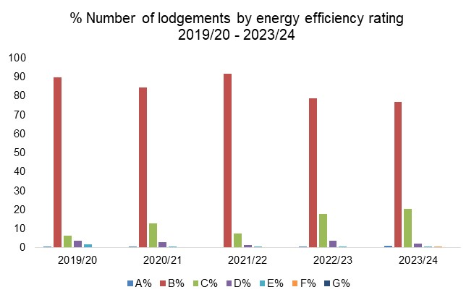

New Dwellings - Environmental Impact (based on CO² Emissions)
Similar to the energy efficiency rating based on fuel costs, and comparable to England for 2023/24, most new dwellings produced in Medway had a B rating for environmental impact (based on CO² emissions). A ratings dropped again from last year to the lowest percentage in the previous 5 years at 4%. No F or G rated buildings were built in the last 5 years in Medway; indeed no G ratings have been built in Medway since records began in 2008. England has produced a higher percentage of A rated dwellings, although it has also produced a small percentage of F and G rated dwellings, compared to Medway’s zero percentage.

Table: Medway New Dwellings - Environmental Impact (based on CO2 Emissions)

Year | A% | B% | C% | D% | E% | F% | G%
2019/20 | 8.0 | 85.5 | 4.1 | 2.2 | 0.2 | 0.0 | 0.0
2020/21 | 4.1 | 87.3 | 5.8 | 2.8 | 0.0 | 0.0 | 0.0
2021/22 | 7.0 | 87.5 | 4.3 | 0.9 | 0.2 | 0.0 | 0.0
2022/23 | 5.1 | 78.8 | 13.9 | 2.2 | 0.0 | 0.0 | 0.0
2023/24 | 4.0 | 81.6 | 10.9 | 3.3 | 0.2 | 0.0 | 0.0
England 2023/24 | 15.4 | 75.4 | 6.6 | 2.0 | 0.4 | 0.2 | 0.1

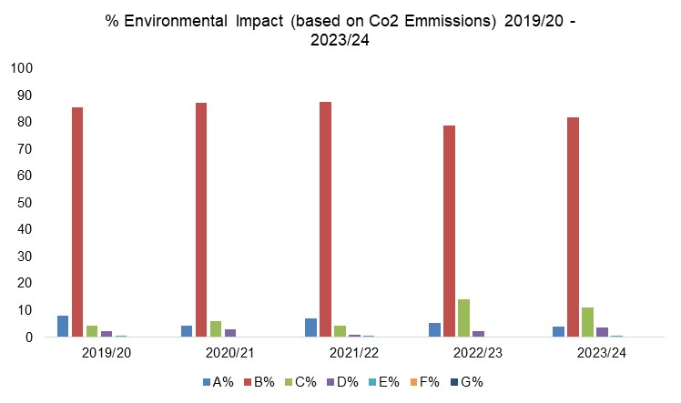

Source:
Tables NB1 and NB2
https://www.gov.uk/government/statistical-data-sets/live-tables-on-energy-performance-of-buildings-certificates

Renewable energy installations

Table: Medway renewable electricity number of installations
 | Photo voltaics | Onshore Wind | Hydro | Anaerobic Digestion | Offshore Wind | Wave/Tidal | Sewage Gas | Landfill Gas | Municipal Solid Waste | Animal Biomass | Plant Biomass | Confiring | Total
2019 | 377 | 0 | 0 | 0 | 0 | 0 | 0 | 0 | 0 | 0 | 0 | 0 | 377
2020 | 75 | 0 | 0 | 0 | 0 | 0 | 0 | 0 | 0 | 0 | 0 | 0 | 75
2021 | 94 | 0 | 0 | 0 | 0 | 0 | 0 | 0 | 0 | 0 | 1 | 0 | 95
2022 | 326 | 0 | 0 | 0 | 0 | 0 | 0 | 0 | 0 | 0 | 0 | 0 | 326
2023 | 563 | 0 | 0 | 0 | 0 | 0 | 0 | 0 | 0 | 0 | 0 | 0 | 563
TOTAL | 1,435 | 0 | 0 | 0 | 0 | 0 | 0 | 0 | 0 | 0 | 1 | 0 | 1,436

The majority of renewable energy installations in Medway have been Photovoltaics (solar), with 1,435 new installations over the past 5 years – these include domestic installations.

Source:
https://www.gov.uk/government/statistics/regional-renewable-statistics

Glossary

Affordable Housing - Social rented, affordable rented and intermediate housing, provided to eligible households whose needs are not met by the market. Eligibility is determined with regard to local incomes and local house prices. Affordable housing should include provisions to remain at an affordable price for future eligible households or for the subsidy to be recycled for alternative affordable housing provision.

Age-Standardised mortality rates – (ASMRs) are used to allow for comparisons to be made between populations that may contain different overall population sizes and proportions of people of different ages. They allow for differences in the age structure of populations and therefore allow valid comparisons to be made between geographic areas, over time and between sexes. It is a statistical measure to allow more precise comparisons between two or more populations by eliminating the effects in age structure by using a "standard population". The higher the number, the higher the mortality rate.

Biodiversity - The whole variety of life encompassing all genetics, species and ecosystem variations, including plans and animals.

Change of Use - A change in the way that land or buildings are used (see Use Classes Order). Depending on the specifics of any proposed change of use, including any building work associated with the proposal, an application for planning permission or prior approval may be required.

Commitments (or committed development) - All land with current planning permission or allocated in adopted development plans for development (particularly residential development).

Community Infrastructure Levy (CIL) - is a system of securing developer contributions from planning permissions which local authorities are empowered but not required to charge on new development in their area. The levy is to be used to support growth.
Completed dwelling – for monitoring purposes, a dwelling is counted as complete when the structure is finished and ready to be lived in (not once it has been sold or occupied).
Duty to cooperate - was introduced in the Localism Act 2011 and amends the Planning and Compulsory Purchase Act 2004. It places a legal duty on local planning authorities, county councils in England and public bodies to engage constructively, actively and on an ongoing basis to maximise the effectiveness of Local and Marine Plan preparation relating to strategic cross boundary matters.

Economic activity - A person is economically active if they are either employed or unemployed i.e. in work or looking for work. A person is economically inactive if they are either not seeking work or are unavailable to start work. This includes people who are looking after a family and people who are on long term sick leave.

Employment Land Availability (ELA) - The total amount of land reserved for industrial and business use awaiting development.

Employment rate - The number of people in employment in the UK is measured by the Labour Force Survey (LFS) and consists of people aged 16 and over who did paid work (as an employee or self-employed), those who had a job that they were temporarily away from, those on government-supported training and employment programmes, and those doing unpaid family work.
English indices of deprivation - identify the most deprived areas across the country. The indices combine a number of indicators, chosen to cover a range of economic, social and housing issues, into a single deprivation score for each small area in England. The indices are used widely to analyse patterns of deprivation, identify areas that would benefit from special initiatives or programmes and as a tool to determine eligibility for specific funding streams.
Greenfield Land or Site - Land (or a defined site) usually farmland, that has not previously been developed.

Greenbelt – areas of land which has been set aside near urban or developed land which is protected from most forms of development. The Greenbelt policy checks the unrestricted sprawl of large built up areas, prevents neighbouring towns merging into one another, assists in safeguarding the countryside from encroachment, preserves the setting and special character of historic towns and assists in urban regeneration by encouraging the recycling of derelict and other urban land.

Life expectancy - at birth is chosen as the preferred summary measure of all-cause mortality as it quantifies the differences between areas in units (years of life) that are more readily understood and meaningful to the audience than those of other measures. All-cause mortality is a fundamental and probably the oldest measure of the health status of a population. It represents the cumulative effect of the prevalence of risk factors, prevalence and severity of disease, and the effectiveness of interventions and treatment. Differences in levels of all-cause mortality reflect health inequalities between different population groups, e.g. between genders, social classes and ethnic groups.

Localism Act 2011 - introduced in November 2011. The aim of the act was to devolve more decision-making powers from central government back into the hands of individuals, communities and councils.

Outline application - A general application for planning permission to establish that a development is acceptable in principle, subject to subsequent approval of detailed matters. Does not apply to changes of use.

Mixed Use - Developments or proposals comprising more than one land use type on a single site.

National Planning Policy Framework – first published in 2012, revised in 2018, updated in 2019, 2021 and again in 2023, it sets out the government’s planning policies for England.

Neighbourhood Plans - A plan prepared by a Parish Council or Neighbourhood Forum for a particular neighbourhood area (made under the Planning and Compulsory Purchase Act 2004, as amended).

Planning Permission - Formal approval sought from a local planning authority allowing a proposed development to proceed. Permission may be sought in principle through outline planning applications or be sought in detail through full planning applications.

Previously Developed Land or 'Brownfield' land - Land which is or was occupied by a permanent structure, including the curtilage of the developed land (although it should not be assumed that the whole of the curtilage should be developed) and any associated fixed surface infrastructure. This excludes: land that is or was last occupied by agricultural or forestry buildings; land that has been developed for minerals extraction or waste disposal by landfill, where provision for restoration has been made through development management procedures; land in built-up areas such as residential gardens, parks, recreation grounds and allotments; and land that was previously developed but where the remains of the permanent structure or fixed surface structure have blended into the landscape.

PROW – Public Rights of Way

Renewable and Low Carbon Energy - Includes energy for heating and cooling as well as generating electricity. Renewable energy covers those energy flows that occur naturally and repeatedly in the environment – from the wind, the fall of water, the movement of the oceans, from the sun and also from biomass and deep geothermal heat. Low carbon technologies are those that can help reduce emissions (compared to conventional use of fossil fuels).

Reserved matters application – details the matters which were reserved from the original outline planning application

S106 - A Section 106 is a legal agreement between an applicant seeking planning permission and the local planning authority, which is used to mitigate the impact of a new home on the local community and infrastructure.

Self-Build and Custom Housebuilding - Self-build is generally where the owner is directly involved with/manages the design and construction of their new home, whereas custom housebuilding means the owner commissions the construction of their home from a developer/builder/contractor/package company who builds the property to the owner’s specifications. With custom build the occupants do not usually carry out any of the physical construction work but still make key design decisions. In considering whether a home is a self-build or custom build home, relevant authorities must be satisfied that the initial owner of the home will have primary input into its final design and layout.

Site of Special Scientific Interest (SSSI) - A site designated by Natural England under the Wildlife and Countryside Act 1981 as an area of special interest by reason of any of its flora, fauna, geological or physiographical features (plants, animals and natural features relating to the Earth's structure).

Super Output Areas (SOAs) - a geography designed for the collection and publication of small area statistics. They are used on the Neighbourhood Statistics site and across National Statistics. Lower Super Output Areas (LSOAs) which are used as the unit to present data on deprivation, were originally built using 2001 Census data from groups of Output Areas and contain on average 1,500 residents.

Supplementary planning document (SPD) - provides additional information on planning policies in a development plan.

Land Availability Assessment (LAA) - assesses the suitability, availability and deliverability of sites to meet a requirement for residential, employment, retail and other uses.

Sustainable drainage systems (SUDS) - surface water drainage systems which consider quantity, quality and amenity issues.

ULEV – Ultra Low Emission Vehicle – emits extremely low levels of motor vehicle emissions compared to other vehicles.

Use Class - classes of land and building use as categorised by the Town and Country Planning (Use Classes) Order 1987 as amended.

Current use classes
On 1st September 2020, the following use classes were updated to replace those which had gone before:

Class B
B2 General industrial - Use for industrial process other than one falling within class E(g) (previously class B1) (excluding incineration purposes, chemical treatment or landfill or hazardous waste)
- B8 Storage or distribution - This class includes open air storage.

Class C
- C1 Hotels - Hotels, boarding and guest houses where no significant element of care is provided (excludes hostels)
- C2 Residential institutions - Residential care homes, hospitals, nursing homes, boarding schools, residential colleges and training centres
- C2A Secure Residential Institution - Use for a provision of secure residential accommodation, including use as a prison, young offenders institution, detention centre, secure training centre, custody centre, short term holding centre, secure hospital, secure local authority accommodation or use as a military barracks
- C3 Dwellinghouses - This class is formed of three parts
  - C3(a) covers use by a single person or a family (a couple whether married or not, a person related to one another with members of the family of one of the couple to be treated as members of the family of the other), an employer and certain domestic employees (such as an au pair, nanny, nurse, governess, servant, chauffeur, gardener, secretary and personal assistant), a carer and the person receiving the care and a foster parent and foster child
  - C3(b) covers up to six people living together as a single household and receiving care e.g. supported housing schemes such as those for people with learning disabilities or mental health problems
  - C3(c) allows for groups of people (up to six) living together as a single household. This allows for those groupings that do not fall within the C4 HMO definition, but which fell within the previous C3 use class, to be provided for i.e. a small religious community may fall into this section as could a homeowner who is living with a lodger
- C4 Houses in multiple occupation - Small shared houses occupied by between three and six unrelated individuals, as their only or main residence, who share basic amenities such as a kitchen or bathroom.

Class E - Commercial, Business and Service
In 11 parts, Class E more broadly covers uses previously defined in the revoked Classes A1/2/3, B1, D1(a-b) and ‘indoor sport’ from D2(e):
- E(a) Display or retail sale of goods, other than hot food
- E(b) Sale of food and drink for consumption (mostly) on the premises
- E(c) Provision of:
  - E(c)(i) Financial services,
  - E(c)(ii) Professional services (other than health or medical services), or
  - E(c)(iii) Other appropriate services in a commercial, business or service locality
- E(d) Indoor sport, recreation or fitness (not involving motorised vehicles or firearms or use as a swimming pool or skating rink,)
- E(e) Provision of medical or health services (except the use of premises attached to the residence of the consultant or practitioner)
- E(f) Creche, day nursery or day centre (not including a residential use)
- E(g) Uses which can be carried out in a residential area without detriment to its amenity:
  - E(g)(i) Offices to carry out any operational or administrative functions,
  - E(g)(ii) Research and development of products or processes
  - E(g)(iii) Industrial processes

Class F - Local Community and Learning
In two main parts, Class F covers uses previously defined in the revoked classes D1, ‘outdoor sport’, ‘swimming pools’ and ‘skating rinks’ from D2(e), as well as newly defined local community uses.
- F1 Learning and non-residential institutions – Use (not including residential use) defined in 7 parts:
  - F1(a) Provision of education
  - F1(b) Display of works of art (otherwise than for sale or hire)
  - F1(c) Museums
  - F1(d) Public libraries or public reading rooms
  - F1(e) Public halls or exhibition halls
  - F1(f) Public worship or religious instruction (or in connection with such use)
  - F1(g) Law courts
- F2 Local community – Use as defined in 4 parts:
  - F2(a) Shops (mostly) selling essential goods, including food, where the shop’s premises do not exceed 280 square metres and there is no other such facility within 1000 metres
  - F2(b) Halls or meeting places for the principal use of the local community
  - F2(c) Areas or places for outdoor sport or recreation (not involving motorised vehicles or firearms)
  - F2(d) Indoor or outdoor swimming pools or skating rinks
Sui Generis
'Sui generis' is a Latin term that, in this context, means ‘in a class of its own’.
Certain uses are specifically defined and excluded from classification by legislation, and therefore become ‘sui generis’. These are:
- theatres
- amusement arcades/centres or funfairs
- launderettes
- fuel stations
- hiring, selling and/or displaying motor vehicles
- taxi businesses
- scrap yards, or a yard for the storage/distribution of minerals and/or the breaking of motor vehicles
- ‘Alkali work’ (any work registerable under the Alkali, etc. Works Regulation Act 1906 (as amended))
- hostels (providing no significant element of care)
- waste disposal installations for the incineration, chemical treatment or landfill of hazardous waste
- retail warehouse clubs
- nightclubs
- casinos
- betting offices/shops
- pay day loan shops
- public houses, wine bars, or drinking establishments – from 1 September 2020, previously Class A4
- drinking establishments with expanded food provision – from 1 September 2020, previously Class A4
- hot food takeaways (for the sale of hot food where consumption of that food is mostly undertaken off the premises) – from 1 September 2020, previously Class A5
- venues for live music performance – newly defined as ‘Sui Generis’ use from 1 September 2020
- cinemas – from 1 September 2020, previously Class D2(a)
- concert halls – from 1 September 2020, previously Class D2(b)
- bingo halls – from 1 September 2020, previously Class D2(c)
- dance halls – from 1 September 2020, previously Class D2(d)

Other uses become ‘sui generis’ where they fall outside the defined limits of any other use class.
For example, C4 (Houses in multiple occupation) is limited to houses with no more than six residents. Therefore, houses in multiple occupation with more than six residents become a ‘sui generis’ use.

Revoked Use Classes

Class A was revoked from 1 September 2020. Class A 1/2/3 were effectively replaced with Use Class E(a,b,c). A4/5 uses were not covered by Use Class E and became defined as ‘Sui Generis’

- A1 Shops - Shops, retail warehouses, hairdressers, undertakers, travel and ticket agencies, post offices, pet shops, sandwich bars, showrooms, domestic hire shops, dry cleaners, funeral directors and internet cafes
- A2 Financial and professional services - Financial services such as banks and building societies, professional services (other than health and medical services) and including estate and employment agencies. It does not include betting offices or pay day loan shops - these are now classed as “sui generis” uses (see below)
- A3 Restaurants and cafés - For the sale of food and drink for consumption on the premises - restaurants, snack bars and cafes
- A4 Drinking establishments - Public houses, wine bars or other drinking establishments (but not night clubs) including drinking establishments with expanded food provision
- A5 Hot food takeaways - For the sale of hot food for consumption off the premises.

B1 Business was revoked from 1 September 2020. It is effectively replaced with the new Class E(g).
- B1 Business – Uses which can be carried out in a residential area without detriment to its amenity. This class was formed of three parts:
  - B1(a) Offices - Other than a use within Class A2 (see above)
  - B1(b) Research and development of products or processes
  - B1(c) Industrial processes
Use Classes B2 and B8 remain valid (see 'Current Use Classes' above).
Use Classes B3 (revoked in 1992), and B4 to B7 (revoked in 1995) were used to call out specific industrial uses'

Class D was revoked from 1 September 2020. D1 was split out and replaced by the new Classes E(e-f) and F1. D2 was split out and replaced by the new Classes E(d) and F2(c-d) as well as several newly defined ‘Sui Generis’ uses.
- D1 Non-residential institutions - Clinics, health centres, crèches, day nurseries, day centres, schools, art galleries (other than for sale or hire), museums, libraries, halls, places of worship, church halls, law court. Non-residential education and training centres
- D2 Assembly and leisure - Cinemas, music and concert halls, bingo and dance halls (but not night clubs), swimming baths, skating rinks, gymnasiums or area for indoor or outdoor sports and recreations (except for motor sports, or where firearms are used).

Windfall Site - Sites not specifically identified in the development plan (definition from revised National Planning Policy Framework 24 July 2018.

Briefing: Net Migration to the UK, The Migration Observatory, available at: https://migrationobservatory.ox.ac.uk/resources/briefings/long-term-international-migration-flows-to-and-from-the-uk/
The approximate figure previously quoted (1,200,000 sq.m) has changed due to a post Cabinet approval in March 2025 to correct a factual error relating to the permission at Kingsnorth Power Station.
Lower Output Area 015E

